

SOVRANO

Vinisha Vekaria



April 28, 2021

CLAREMONT HIGH SCHOOL ACADEMY

A-LEVEL COMPUTER SCIENCE COURSEWORK

Content:

**Computation**: 4

**Stakeholders**: 5

**Limitations**: 6

**THINKING CONCURRENTLY:** 7

**Decomposition:** 7

**Projected system requirements:** 8

Success criteria: 9

**RESEARCH GAME COMPARISON:** 11

Functions: 13

18

18

18

18

**Usability features:** 20

**Methodology:** 21

**Depth-First Search (DFS)** 22

**Programming techniques** 22

**Sovrano placement:** 23

**Questionnaire**: 27

**Questionnaire results:** 28

**Interview:** 29

**Proposed solution:** 31

**User interface:** 32

**A-STAR ALGORITHM:** 38

**undo a move** 76

**testing moves:** 77

**creating the guards first move:** 78

**Capturing a piece:** 78

79

80

**Valid all possible moves:** 81

83

83

**A capture or draw:** 84

**Using colour to generate possible moves:** 85

**RESET AND EXIT THE GAME:** 87

**ARTIFICIAL INTELLIGENCE:** 90

TESTING: 94

EVALUATION: 99

Unmet criteria and how it can be fixed: 101

Usability features: 102

Maintenance issues and limitations: 104

Final overall code: 111

**References:** 127

Introduction:

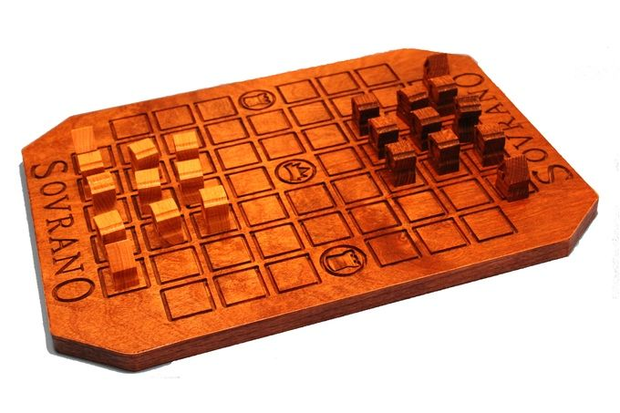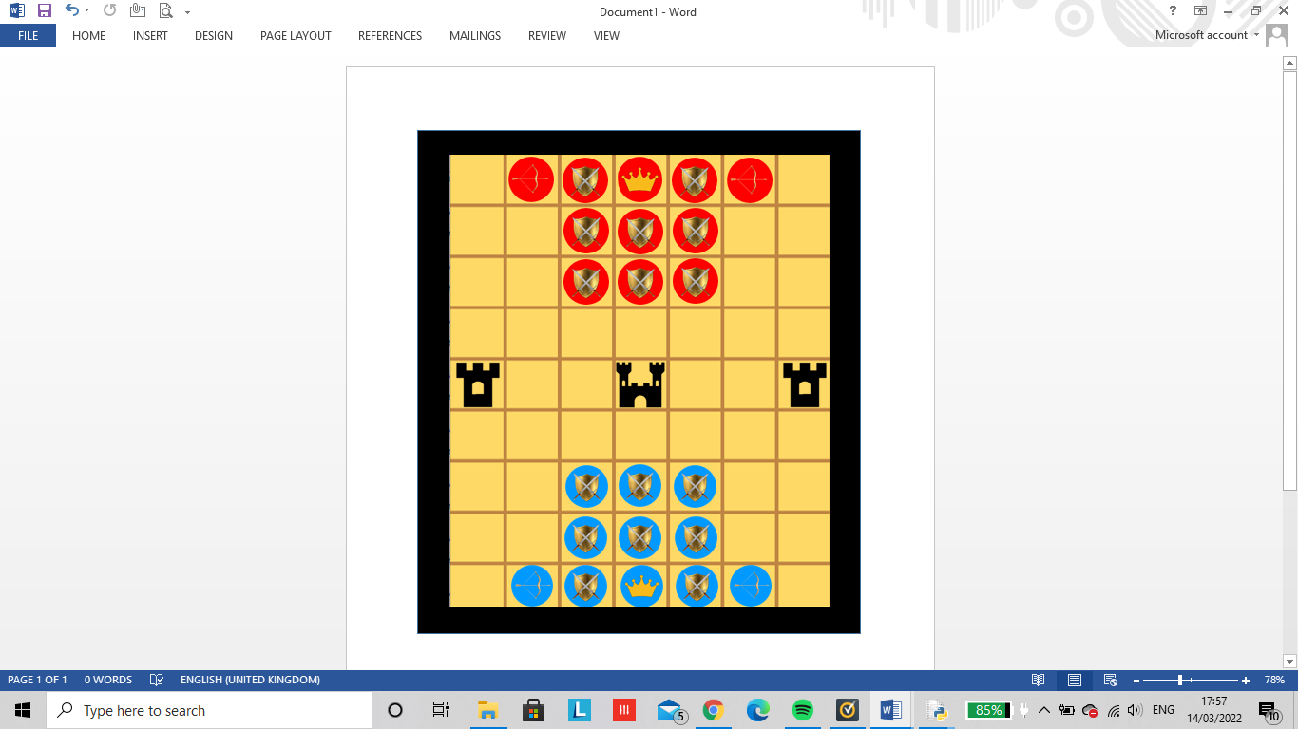“SOVRANO!” The word you shout when the game is about to be won. It’s an exciting battle of wits that can take hours of concentration for a single game. Sovrano is a 2D strategy board game in which the players assemble the guards and prepare to lead the emperor to the throne and to absolute power! It is a two player game that typically lasts between 15 to 30 minutes. Each player has 11 pieces (1 Emperor, 8 Guards and 2 Archers). The center space of the board is the throne where the emperor aims to get to in order to win the game, while on opposite ends of the center row lie the Tower-spaces where each piece aims to get to in order to win the most gems. The objective of the game is to be the player who scores the most points by capturing the Tower-spaces (1 gem each). The second objective of Sovrano is to be the first player to move their Emperor onto the center space (the Throne), this grants that player 3 gems and ends the match.

Figure 1(Beyondsolitaire.net, 2021)

# Computation:

* The computer can set up the initial board state with the pieces already located in its initial position for every round. When the game is loaded, the emperor, 2 archers and 8 guards are added to the game as well as to the opposition’s side. This means that the grid can contain either a piece or can be left empty, so the computer is able to move them around when needed.
* Using computation, the computer is able to calculate and add up the points that each player has received in order to bring about a winner at the end of each round. The total points would then be allocated onto the leaderboard through implementing a SQL table. This well help see all the users’ progress and be ranked globally.
* When a player has attacked the oppositions piece that individual piece would disappear off the board and be removed from the game.
* The player’s pieces move according to the games rules similarly to chess. In this instance all player can move either 1 step forward, backward, left or right. The emperor can move the same as the guards however diagonally as well. And the archer moves the same as the guard but can attack from 2 spaces diagonally.
* The computer counts the amount of goes a player takes. Each player can take up to two go’s on a turn but can’t move the same piece. This allows the user to logically think ahead in order to make the best move for themselves.
* The initial game load up is imported through using computational thinking, this consists of the boards state layout and the pieces( i.e. emperor, guard and archers) which is already saved onto the game file. There is then a score system where each players gems are counted when they’ve captured the tower, incrementing their score each time. This way time is being saved from having to place the pieces onto the board and keeping in mind the scores when playing in real life.
* Using A-star algorithm, the computers AI can figure out the shortest path available for the emperor to reach the throne.

# Stakeholders:

The stakeholders of this game would be:

* Owners of a laptop or computer. Due to the simplicity of the user interface and being able to easily interact with the games implications, sovrano ranges from expert gamers who are familiar with playing games often to the elderly who may find it difficult to catch up with the new technology. This would extent from my family members who are experienced in experimenting new games to play (including my 8 year old brother and elderly grandparents). This age range would help me identify my target audience for this game.
* My school colleagues experienced in creating databases or game graphics as well as current year 13 students undertaking their own project in which they’ll help give me knowledgeable suggestions in improving my game. They’ll beta test my working code and help me find errors I was perhaps unable to see. (Other suitable stakeholders could include year 12 experienced programmers who may also need suggestions for their future project.)
* My computing teacher, Mr. Sisulu, who can assist me and inspect certain aspects of my work and help me identify points of error to help me achieve a good project.
* The ocr exam board in order to mark and assess my work in a fair manner.

The users of my game will find sovrano a relatively simple game to implement and understand alternately, can be portrayed as a very challenging game by being able to teach strategy through thinking about your next few moves in advance. As a result, I will develop a fun game to help teach patience to the younger audience to help enhance their planning skills towards the future. Whilst playing chess your brain is challenged to exercise logic and develop pattern recognition to be able to test your memory. This can be experienced by ages from 6 and above to help exceed their brains health.

# Limitations:

* If the user is just a beginner and finds it difficult to understand the complex rules of the game or if the user is experienced in playing this game and needs an extra challenge, It’s quite tough to execute difficulty levels through artificial intelligence onto this game as it is very time consuming to code.
* Sovrano isn’t accessible to play on any other device apart from a pc or laptop due to the source code of the game being written in python language. This limits the access to games on mobile phones, tablets etc.
* All inputs are withdrawn from a keyboard and mouse meaning those with visual impairments and disabilities will find it complex to use this software.
* All progress made in between each move won’t be saved so every time you exit the game, your results would be volatile so will be unable to start from where you left of.
* The total number of possible moves during a game of sovrano are almost infinite. This is would be impossible for me to calculate the amount of possible moves needed for a player to win a game therefore the AI wouldn’t be as efficient and be able to figure out the most optimum move.

## **THINKING CONCURRENTLY:**

* This is the process of completing more than one task at any given time .As the leaderboard and points are being incremented once a piece has been captured or reached a throne, the timer starts at the same time simultaneously. This will mean that the number of tasks completed in a given time slice is increased as well less time being wasted waiting for user interactions.

# Decomposition:

The process of breaking down a problem into smaller sub-problems. This aims to reduce the complexity of a problem by splitting it up making it easier for me to understand and plan my steps for my coursework. This will help me acknowledge and implement modules or libraries needed for my code which will help save me time from testing and debugging.

Sovrano

Game- control

Game-play

Review game board /history

Modify game state

Configuration

Select Piece

Guard

Timer

Input

Profile

Output

Restore game

Save game

New game

End game

Move piece

Archer

Emperor

Gems

Player

Selected piece

Contents

Undo/redo

# Projected system requirements:

Sovrano contains simple graphics and animations which may use up much memory and also slow down the game due to the many opponents required. The greatest number of opponents on the screen is 22 which may not slow down the whole computer system but instead the loading screen may take a while to load.

* Python 3.10 IDE – what the game runs on
* Windows 7 or above/ MacOs to be able to fully optimize the gaming features.
* Pygame- used to create my game layout with the pieces uploaded to the board. It also allows the user to use hardware such as the mouse and keyboard to select and move pieces, undo pieces/ reset board.
* Notebook- to create my SQL tables for the leaderboard.
* 3-4 GB of RAM and 2 GHz of cpu space to ensure that the game runs efficiently on the users operating system. Similarly the use of a large memory space help the game load faster which will increase the users satisfaction.
* 720p -1080p screen quality is recommended to fully visualize all details of the game.
* A working speaker (30-60Hz) to allow the users hear the background animation sounds when a player loses, wins or draw. However this hardware piece isn’t as important and can still be played without it.
* The Keyboard functions moves the pieces either upwards, downwards, left and right and allows the piece to be placed upon its required spot.
* A mouse or touchpad helps select the piece you want to move and gives easy access to the main menu and game menu.

# Success criteria:

My success criteria is essentially a checklist of what I would like to implement into my algorithm and code to achieve a successful project. This project will require easy accessibility to the players so they are easily able to navigate around the game. The main requirement for me is that the artificial intelligence is able to capture an opponent’s piece by thinking at least 1 move ahead. The AI shouldn’t capture any piece within its distance but think strategically before making a move.

* **For the user interface:**

|  |  |
| --- | --- |
| **Success criteria** | **Description** |
| Main menu | The main menu will be the first to load onto the players screen with the options to start, quit, leaderboard, instructions and entering your game play name. |
| Clear user interface | The game works and does what the player thinks it will do. The user is also able to easily navigate around the game. |
| Instructions | A screen will appear for the player to help them gain a clear understanding on how the game works as well as the sovrano rules so the player can acknowledge when making an invalid move. |
| Leaderboard | The players’ points are temporarily stored for a day and gets added up together from each game played. This score then gets uploaded onto the leaderboard in order of whose scored the most points. |
| Start | Once clicked, The initial sovrano board is loaded onto the players screen with the pieces put into position. |
| Quit | The quit button will close the running application. |
| Easy to use game controls | Keyboard buttons are used to undo a move, navigate through main menu options or move a piece left, right, up or down. The mouse is also used to navigate through the main menu and to allow a player to select a piece that they want to move. |
| Win / loss/ draw | A clear message will be outputted when the player wins, loses or draws against the opposition. |

* **For the game logic:**

This is what I would like to implement into my sovrano game play. Sovrano must be functional to the player and play by obeying the rules to move a piece in order to beat the artificial intelligence.

|  |  |
| --- | --- |
| **Success criteria** | **Description** |
| Functional Artificial Intelligence | The AI will be able to make a move against the player as well as being able to capture a piece that will lead to the best outcome to gain the most points. |
| Pieces meet its game rule | Each piece has its own rules on how they are able to move and must make a valid move to be able to capture the opponent’s pieces. |
| Player is able to select a piece | The player is able to click on the piece they want to move. |
| Player is able to move their piece | Once the player has selected their piece they’ll click on the square for where they want to place their piece. |
| Pieces are able to be removed off the board | When the opposition captures a piece, the piece is removed off the game board to increase the total score. |
| The game can result in a capture | A capture occurs when an emperor is attacked by the opposition’s pieces. This means that it is impossible for the current player to attack the enemy’s opponents, block the capture or more the emperor to safety. |
| The game can result in a draw | A draw occurs when the emperor is not attacked, however no pieces including the emperor are able to move anywhere. |
| Win | The win screen will appear if the opposition’s emperor is captured, if a players’ emperor has reached the middle throne or if a players has gained the most points. |

# **RESEARCH GAME COMPARISON:**

Chess is a very similar game to sovrano where the ultimate aim is to capture the opponent’s pieces. On the online user vs computer chess game (*Play chess online against the computer* (no date) *Chess.com*) I was able to obtain ideas to include into my game.

For instance, implementing a timer for how longer a player can take to make a legal move. This will increase competition levels making it more fun and enjoyable for users to play.

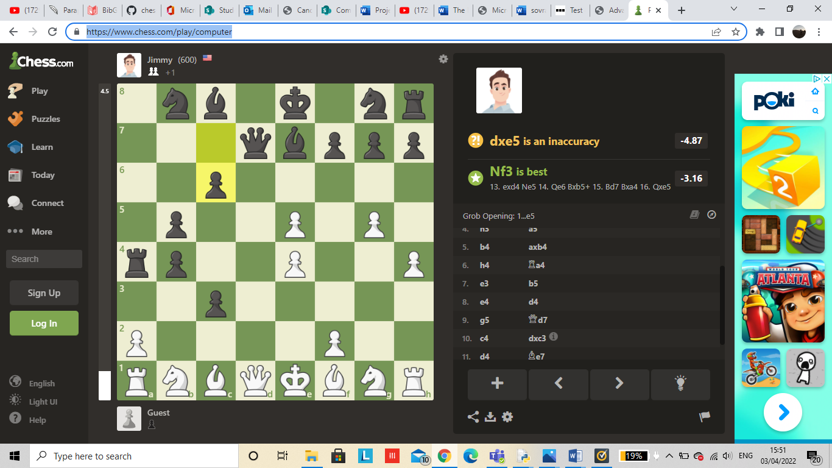

As soon as the bar reaches the bottom the timer has ran out meaning the next user will take their turn.

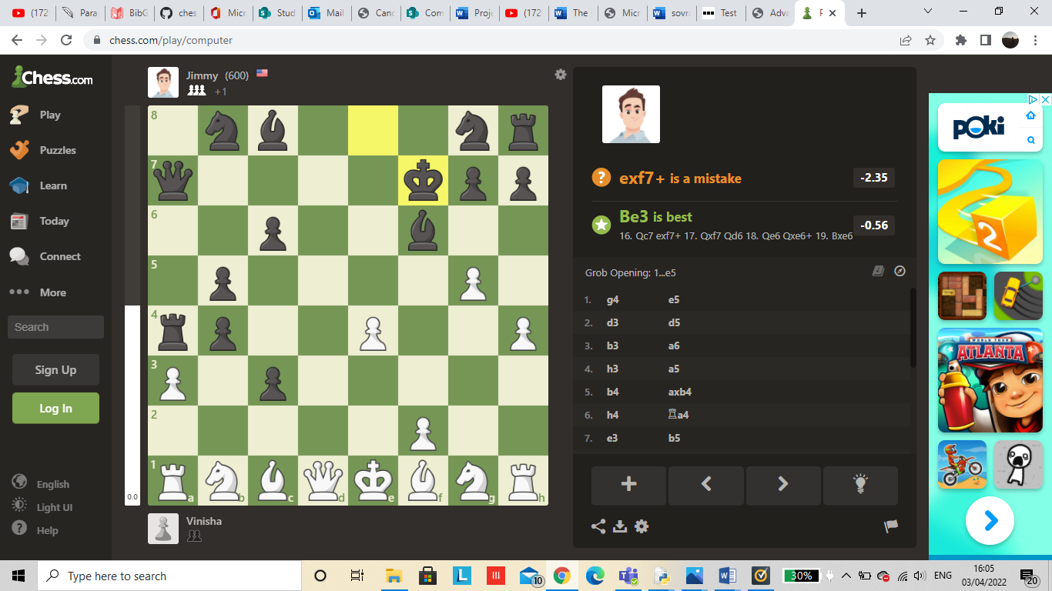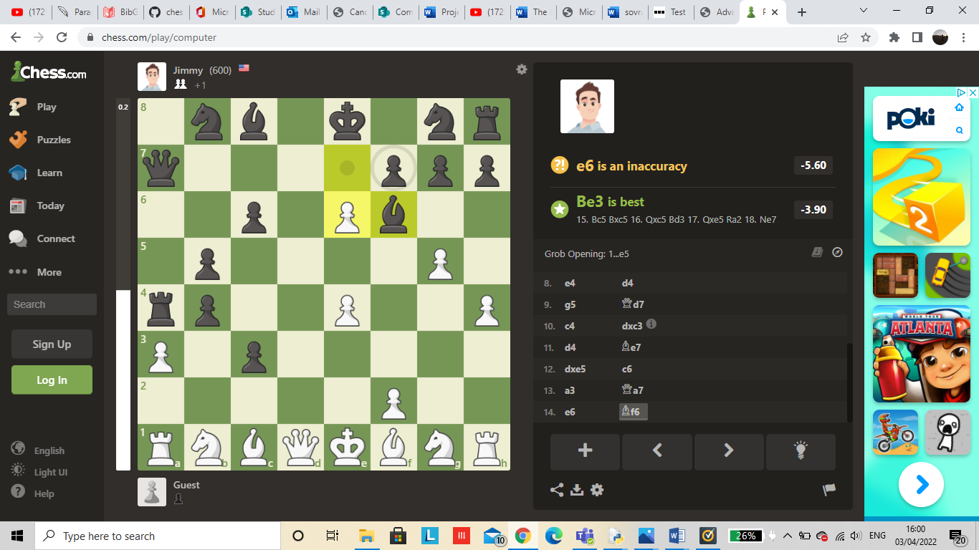Also this online chess game helps the user know where to place their piece by using dots on an available square. These dots will give the player ideas of where to place their piece in a legal move. The dot represents where the pawn can move and the circle highlights the piece the white pawn can capture. Once captured the score gets updated and next to the users name and illustrates a small picture of the pieces you’ve captured and the computer has captured.

I’ve captured 2 pawns (user/ player) and jimmy (The AI) has captured 3 pawns.



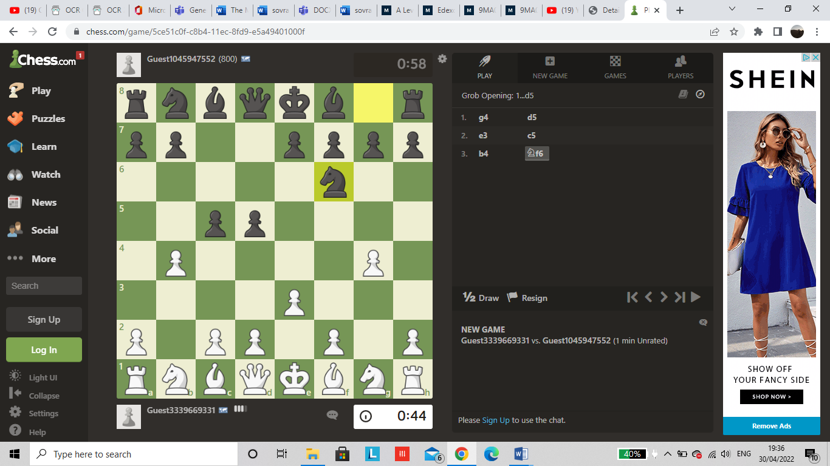

Another concept I want to implement from the chess online game is that when a move is made, the coordinates from the 2D array is outputted on the side of the board as to where the player puts their new piece. This is demonstarted by the images above when the artificial intellegence placed the knight in position ‘f6’ making it more clear for the user to see where a piece has been position.

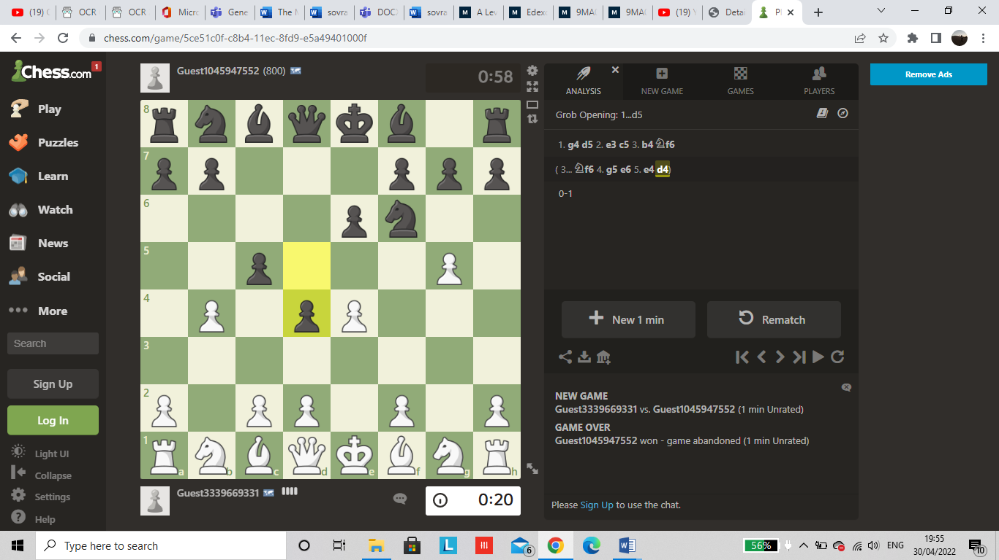

The user interface is very clear by giving the player options to start a new game, want to restart the board and also give an option if they want to play against a friend or the computer. This adds to the functionality of the game and increases the user satisfaction as they are given a choice on how they want to play.

In addition if the user feels their timer is too short they also have the option to add additional minutes onto the board when wanted.

# Functions:

The functions below are what I want to implement in my working code:

* **PIECE CLASS:**

This class concentrates on all the sovrano board pieces such as its position on the initial board state, its legal moves etc. This class module is then imported onto the main code.

|  |  |
| --- | --- |
| **FUNCTION NAME** | **DESCRIPTION- WHAT IT DOES** |
| createMove | Will figure out whose turn is next after a piece has been moved and swaps the current player to the next player. |
| undo | If the player doesn’t like the position they have chosen to put a piece, the board can go back to its previous state. |
| validMoves | Makes sure that all pieces only move to a square that is legal to move to. |
| check | Checks if a capture or draw has taken place. |
| attackSquare | Checks if the opponent is able to attack a piece legally. |
| possibleMoves | Checks to see whose turn is next and places the piece is (row, column) notation. |
| getGuardMoves | The guard is given certain moves they can only move to i.e. up, down, left, and right (one place) then returns the new position if the move made is legal. |
| getArcherMoves | The archer is given certain moves they can only move to i.e. up, down, left, right, diagonal (one place) and diagonal(2 places) then returns the new position if the move made is legal. |
| getEmperorMoves | The emperor is given certain moves they can only move to i.e. up, down, left, right and diagonal(one place) then returns the new position if the move made is legal. |
| boardstate | Gives a 2D array representation of what the board will look like with the pieces on them. |

* **ARTIFICIAL INTELLIGENCE:**

This part of the code allows the users to play against the computer by calculating their best move to win against the user.

|  |  |
| --- | --- |
| **FUNCTION NAME** | **DESCRIPTION- WHAT IT DOES** |
| aiMove | Using the greedy algorithm, the computer generates the next move. |
| totalScore | Check to see which player has received the most points making them the winner. |
| bestMove | Calculates which move will allow the AI to receive the most points. |

* **MAIN SOVRANO BOARD:**

This section is where the main board is created and played on by the users using the imported piececlass and AI modules.

|  |  |
| --- | --- |
| **FUNCTION NAME** | **DESCRIPTION- WHAT IT DOES** |
| loadImages | Uses the compressed png pictures of the sovrano board pieces and loads them into their position on the board( into the 2d array in the piececlass module). |
| drawLines | Creates the grid of the board 7x9 |
| colourSqaure | Uses colour to highlight to the user where they can place their next legal move. |
| drawGameState | Outputs the pieces, the board, the valid moves and square selected by the user. |
| drawPieces | Outputs the pieces loaded into the correct row and column |
| drawText | Outputs a text message when the game has been finished to notify the user if there has been a win, loss or a draw. |
| main | Fills the background colour, loads the images, flags a variable when a move is made so you know who has the next turn, notifies when the game is over, allows the user to quit / undo/ reset, notifies user when there has been a capture/ draw, adds a timer and adds background sounds. |

Decomposing sovrano using a top-down diagram:

Decomposition is the process of continuously breaking down a problem into smaller problems. This will continue until each sub- problem can be represented as a subroutine. This aims to reduce the complexity of a problem by splitting it up into smaller section that are easier to understand. Through identifying a sub- problem, certain parts of code can be implemented using libraries or pre coded modules which saves time from having to debug, which will be implemented within my project.

**GAME PLAY**

.Select piece to play

.Move piece to play

.Output a win screen

.Output a loss screen

.Output a draw screen

.Start

.Instructions

.Leaderboard

.Quit

. Username input

BOARD

MAIN MENU

.Generate the AI’s ideal game play move

.check if the play made is valid

.Update board- state

.Takes users input

.check if the play made is valid

.Update board- state

AI PLACEMENT

USER PLACEMENT

.Generate the AI’s ideal game play move

.check if the move made is valid

. Check if there’s a capture

.Check if there’s a draw

.Update board- state

.Takes users input

.Checks if the move made is valid

.Check if there’s a capture

.Check if there’s a draw

.Update board- state

AI MOVE

USER MOVE

PIECE PLACEMENT

USER INTERFACE

PIECE MOVEMENT

Best suitable algorithm:

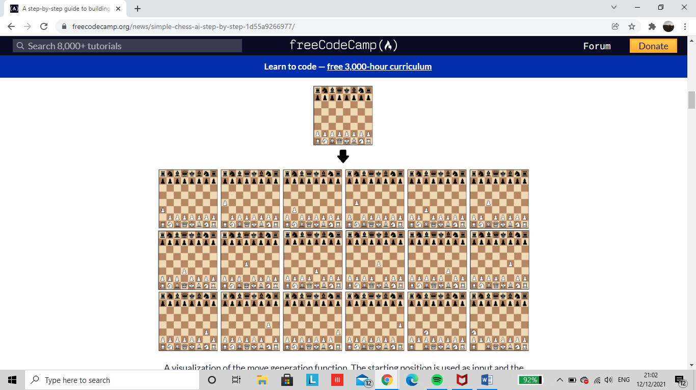

Figure 2 All possible initial moves for each piece in a game of chess

I’ll adapt the chess library for move generation which implements all the rules of chess which are similarly used in sovrano. Based on this, we can calculate all legal moves for a given board state.

Next I’ll create a search tree from which the algorithm can chose the best move. This is done by using the [‘minimax](https://en.wikipedia.org/wiki/Minimax)’ algorithm which minimizes the possible loss for a worst case scenario.

Alpha beta pruning is a minimax algorithm optimization strategy that allows us to ignore some branches in the search tree. This allows us to go further into the minimax search tree while still using the same resources. It is based on the idea that if we uncover a move that leads to a worse scenario than a previously discovered move, we can cease assessing that area of the search tree.

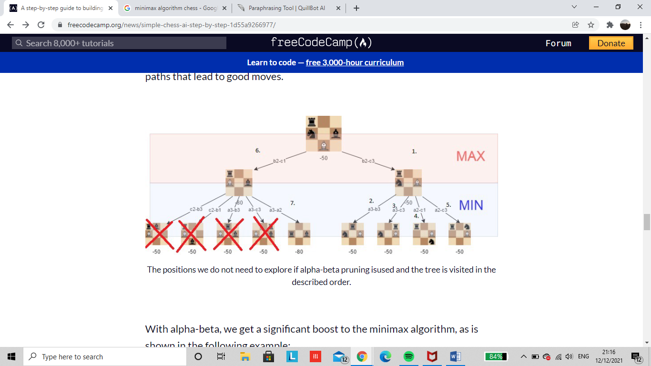

Figure 3: The positions we don’t need to visit if alpha beta pruning is implemented and the tree is visited in the order above.

Through implementing a greedy algorithm in sovrano, each piece and capture method will have allocated points. This algorithm will capture the piece that is worth the most points. The problem with this is that the algorithm will always capture a piece if it is able to. This limits the artificial intelligence from thinking more than one step ahead making it an ineffective game. This is why the minimax algorithm would have to be set in order for the computer to capture a piece thinking at least two steps ahead and making its aim to capture the oppositions emperor.

USING SQL LANGUAGE:

For my game to be efficient the use of SQL must be implemented within my python code as this is what I learnt during school. I need to understand how to use Python to get and edit SQL entries (with the use of libraries). The main goal is to keep track of leaderboard of all users playing my game (as they can easily be added into a dynamic database, which can be edited later). Although a text or database can be used for this issue, SQL is more effective for searching, making it easier to execute with large inputs of data. In order to implement this the use of MySQL will help me execute my leaderboard. The entity will be named leaderboard. The attributes (fields) would be: position, username and score. The username will be the primary key which is a unique identifier for each record in a table. The data type for username will be string, whereas the data type for position and score will be an integer.

# 

0 1 2 3 4 5 6

# 

Figure 4: shows a digitized version of the board game indexed from 0-6 (on the x axis) and 0-8 (on the y axis). This helps give a clearer envision where each piece is placed.

# 

0

1

2

3

4

5

6

7

8

# 

PLAYER 1’S GO

All possible new positions to place each piece after player 1s first move tree:

ARCHER:

[1, 8], [5, 8]

[4 possible first moves for the archer]

[0, 8] [1, 7] [5, 7] [6, 8]

GUARD:

[2,6], [3,6], [4,6], [2,7], [3,7], [4,7], [2,8], [4,8]

[7 possible first moves for the guard]

[1, 7] [1, 6] [2,5] [3,5] [4,5] [5,6] [5,7]

EMPEROR:

The emperor is in position [3, 8] and is surrounded by guards therefore has no free space to move to within the first move.

[0 possible first moves for the emperor]

Overall I’ve gathered that on player 1s first turn they get a choice of 11 possible moves they can chose from. In a game of chess ‘Americas Foundation Of Chess’ discovered that there are 318, 979, 564, 000 potential ways to play the first 4 moves of chess. In addition, there are 169, 518, 829, 100, 544, 000, 000, 000 000, 000 ways to play the first 10 moves of chess. For a computer to solve a game of chess, it would have to get through every possible scenario and assess every potential position. It has been stated that an average game of chess, if played optimally, can take up to a possible of 40 moves all together.

# Usability features:

Buttons:

Buttons are an essential component of graphical programming since they are a very basic kind of input for a user to comprehend. Much of this is likely due to most operating systems relying on clicking the left mouse button to execute user commands, and the mouse is ergonomically designed in such a way that holding down the mouse button is slightly uncomfortable. As a result, buttons will be abundant in this game, which favors simplicity.

They will be used to change screens through the main menu option. In the game placement screen, the main menu will consist of 5 buttons: start, quit, instructions, leaderboard and entering your username. This allows easy accessibility to users making it less complicated to access important buttons needed.

Sliders:

In order to regulate the game speed and volume, I want to use a slider entirely in the options menu. These are both numerical numbers, thus a widget that allows the player to obtain a sense of scale is appropriate: by dragging the slider left and right, the user can get a sense of how much the volume or game speed is growing. It's also less unclear than, example, a text box, as to when the value is stored in the widget (as it could only possibly be saved when the mouse button is released). Above each slider, a header will display to explain what the slider controls. I don't want to use a text box for this because, as I explained in the text box program, the player can freely insert stuff into a textbox, and it's tough to keep track of that.

# Methodology:

In my project my preferred method of research for my interviews and project is the waterfall method. Waterfall project management splits my project into distinct phases, such as requirements collecting, analysis and design, coding and unit testing, system and user acceptance testing, and deployment.

Only once the preceding step has been finished can the next phase begin. A deliverable or a document must be signed off in between phases. Clearly, the agile development model would be the most effective, since it would save money and time that would otherwise be wasted, while also ensuring that earlier stages of development are compatible with new requirements (which are often dynamic). This refers to a collection of methodologies which aim to improve the flexibility of software development and adapt to changes in user requirements faster. It is also easier to make improvements or changes to the software. The problem is broken down into sections which are developed in parallel. The design and analysis phase often occur together. Different sections of software can be at different stages of development. A working prototype is delivered early on and prototypes are built upon and improved in an iterative manner so that new prototypes are delivered regularly throughout the course of the development cycle. In agile development methodologies, there is less of a focus on documentation and more priority is given to user satisfaction.

However critics may argue the need for agile development is less important because the concept of sovrano is relatively static, which would be suited for a strategy for a program with a more unique design (i.e. one that is custom designed for a particular client). Due to the number of modifications that may be required, developing a program in H446 (or any other A-Level Computer Science NEA, for that matter) using agile development would probably be relatively challenging.

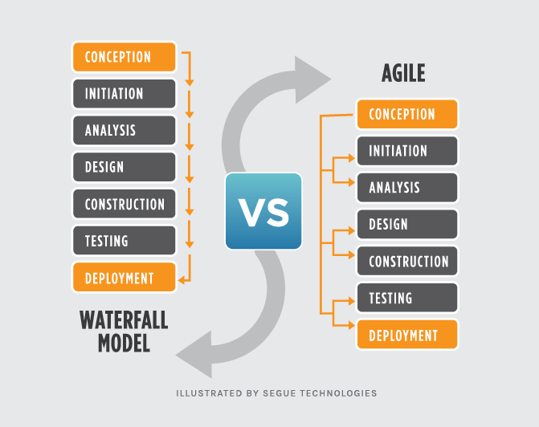

Figure 5 agile methodology - Google Search (no date)

Looks at the difference between a waterfall and agile methodology

# Depth-First Search (DFS)

Depth first search is used to search through the Minimax game tree to discover the best move to make on a particular turn, under the assumption of optimal play.

The game tree for sovrano would have a root node, representing the current board state. This root node would then have edges to all other possible boards accessible in a turn by the current play and this continues until:  
- The endgame state has been reached  
- The search can’t be continued as the game tree has become too large.

Each of these leaf nodes represents a board, and we use a heuristic (the score) then assign a value to the board. Then depth first search is used in Minimax to find the best move to make under optimal play.

# Programming techniques

Arrays and Matrices:

There will also be a lot of lists and/or arrays (Python implements dynamic lists rather than arrays, but I'll be using lists in the same way I'll be using arrays in most cases, so switching to another language isn't an option for this scenario.) A two-dimensional matrix would be used to create the map, with each grid element storing information on what (if anything) is going on inside it: for example, the index of the piece that is inside it, whether it is busy (i.e. a piece is about to move into it), or whether it is vacant. Level data is another key application.

Object orientated procedure classes:

Object orientated programming will be implemented through inheritance classes. All three of my pieces have the same main movements such as going up, down, left and right as well as the archer and emperor gaining their own attributes.

The main classes will be:

1. **Square:** One square represents one block of the 7×9 grid and an optional piece.
2. **Piece:** Every piece will be placed on one square. Piece class is an abstract class which consists of a guard, archer and emperor.
3. **Board:** Board is a 7×9 set of boxes containing all active playing sovrano pieces.
4. **Player:** Player class represents one of the participants playing the game.
5. **Move:** Represents a game move, containing the starting and ending spot. The Move class will also keep track of the player who made the move.
6. **Timer:** Each player has a maximum of 1 minute and 30 seconds to implement their each move.
7. **Position:** shows the position of each piece on the initial board state and its new position.

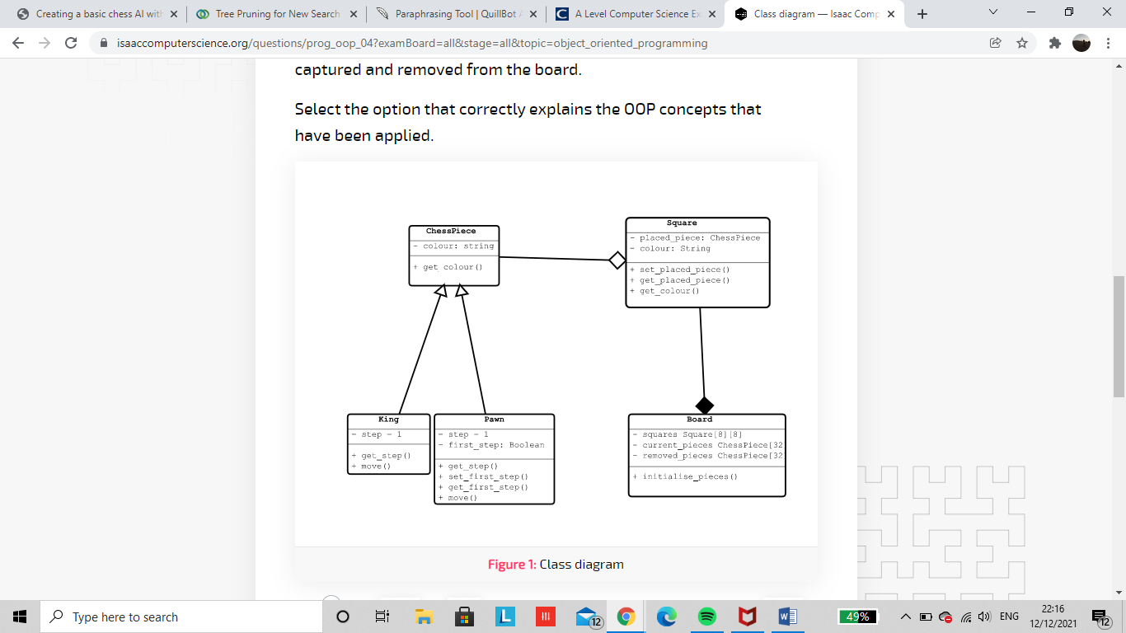

Figure 6https://isaaccomputerscience.org/questions/prog_oop_04?examBoard=all&stage=all

# Sovrano placement:

All pieces get loaded onto the screen in the initial start such as:

* Guards- move either one step forward, backwards, left or right
* Archer- move either one step forward, backwards, left, right and attack from 1 or 2 spaces diagonally
* Emperor- move either one step forward, backwards, left, right and diagonally

At the top of the load screen, the user receives a choice to either play against a computer or play with a two player game.

**Grid**:

|  |  |  |  |  |  |  |
| --- | --- | --- | --- | --- | --- | --- |
|  | A | G | E | G | A |  |
|  |  | G | G | G |  |  |
|  |  | G | G | G |  |  |
|  |  |  |  |  |  |  |
|  | [1] |  | [3] |  | [1] |  |
|  |  |  |  |  |  |  |
|  |  | G | G | G |  |  |
|  |  | G | G | G |  |  |
|  | A | G | E | G | A |  |

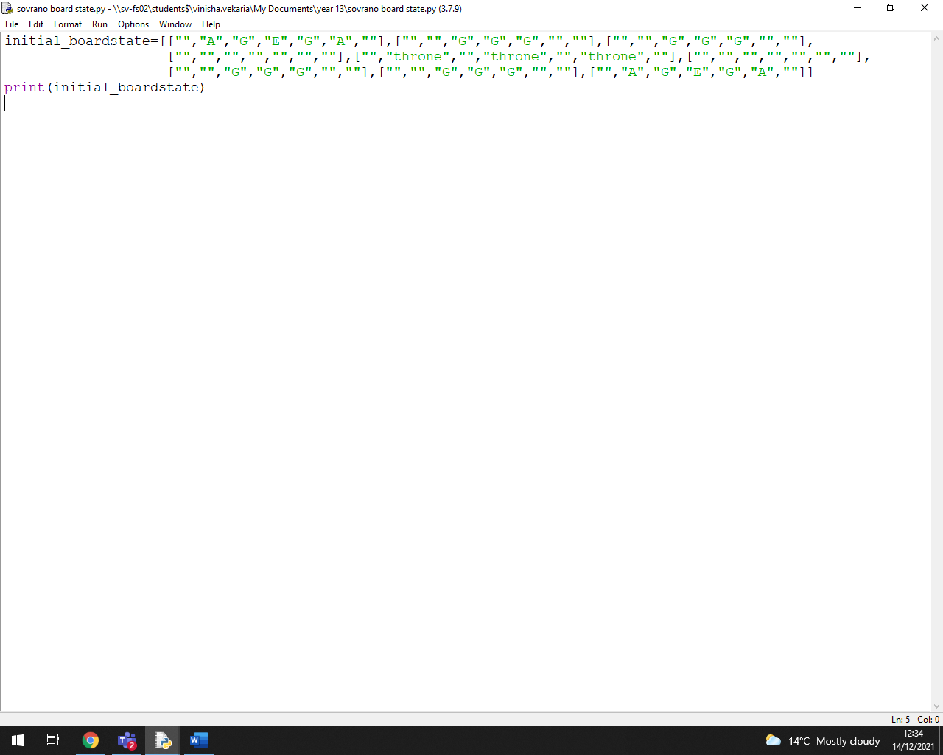**2D Array:**

USING OBJECT OORIENTED PROGRAMMING:

OOP attempts to capture or group information, data and related functionality into structured items called objects.

|  |
| --- |
| board |
| scoreForRed():int  scoreForBlue():int |
| makeMove(move)  checkMove(move)  getScoreForRed()  getScoreForBlue()  setScoreForRed()  setScoreFor1Blue()  resetBoard() |

Class name

Attributes – all the information shared by the object of the class (variables)

Methods - the code associated with the class that allows you to access or change its attributes (subroutines)

|  |
| --- |
| player |
| Name:string  newGame() |
| getName  setName |

|  |
| --- |
| piece |
| Colour:(red,blue)  Type:String  Position: string |
| getColour()  setColour()  getPosition()  setPosition() |

|  |
| --- |
| position |
| Guard: int  Archer: int  Emperor: int |
| getGuard()  getArcher()  getEmperor()  setGuard()  setArcher()  setEmperor() |
|  |

|  |
| --- |
| square |
| placedPiece: sovranoPiece  colour: String |
| setPlacedPiece()  getPlacedPiece  getColour()  setColour() |

|  |
| --- |
| ai |
| r_pos : int  b_pos: int |
| get R_pos  getB_pos  set R_pos  setB_pos |

In this example I have board set as the super class therefore, every object I instantiate from this class template will also gain the same attributes known as inheritance. In this example I will have to define the square, piece, player and ai sub-class that will inherit the details of the board class as well as add the additional attributes and methods that are required. Similarly, the position subclass will inherit the attributes and methods of the piece sub-class as well as the board superclass.

However, the issue with this is that I will need the getcolour() method inherited from the board class to be more specific. This will have to be improved by using the method of the same name in the sub class to contain a more specific code relevant to that class. Furthermore, the method from the parent class will be overridden. Overriding occurs automatically when you call a method from an object that shares the same name as a method in the class tree. In this example the getcolour() and setColour() methods are both visible in the piece and square class.

Encapsulation is used to hide the values or internal state of an object, preventing direct access by unauthorised parties. Encapsulated attributes of an object can only be accessible or changed by the methods provided by the objects. This will help keep my data safe so it cant be accidently altered by another part of the program without using the code provided in the methods, keeping me in control.

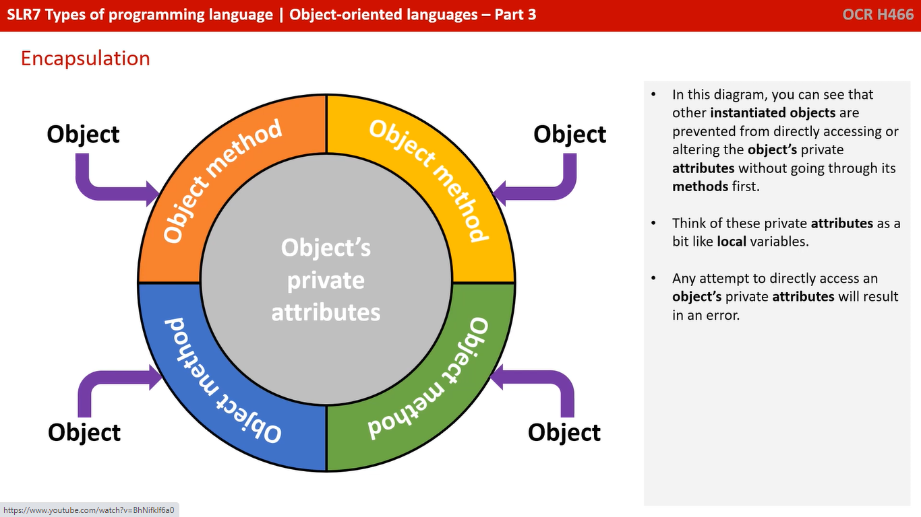

In the diagram you can see that other instantiated objects are prevented from directly accessing/ altering an objects private attributes without having to go through the methods first. These can be known as the private attributes or as known as the local varibales needed for the code. Any attempt to directly access an objects private attributes will lead to an error.

# Questionnaire:

# Questionnaire results:

The purpose of this questionnaire is to help me acknowledge the users requirement for this game so it is much more suitable for the audience playing my game. Most questions helped me to decide on the aesthetic part of my board and the colour scheme to go for such as the brown blues and red to fit into my ancient theme. However other questions such as question number 6, there were mixed responses which made it quite confusing for me to implement a leaderboard onto my game or not. To solve this I will use SQL to create my leaderboard for those who were most likely to be intrigued by this added element.

# Interview:

This interview helped me to receive some opinions in further detail on how to improve my initial plan of my game, the things they like and think I should keep as well as giving me new ideas from a different point of view which they think would be beneficial to me. I asked the same people I gave my questionnaire to who already have a brief idea about sovrano. In my interview I plan to ask about the games graphics (such as the style and appearance of the display screen ) menus, leaderboard and use of hardware’s.

Questions I asked:

**Interview**

1. Would an instruction menu help users understand the games main goal?
2. How many points should you receive for a win, draw or a loss?
3. How long do you think it will take you to make the best possible move?
4. What options should there be on the main menu?
5. Is the layout of the sovrano board suitable for you?
6. Would you play to get onto the leader board or is that not important to you?
7. Would you prefer to use your keyboard to move the pieces into the new position or your mouse?
8. Would you like to play with other players or just against the computer?
9. Would you like to collect the gems to get onto a new level or just use the gems to calculate a win in the one game?

10) How would you want this game to work for you?

11) Should the game have sound effects?

12) Does the look of the game determined if you want to play the game or not?

13) Which background aesthetic do you prefer?

A.  B. 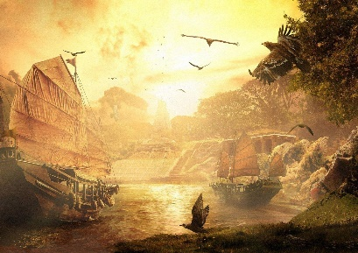 C.

**Interview Results:**

I interviewed 10 people from an age range of 6 to 65 who have played many ancient board games as well as the modern games which have a very similar game layout as sovrano. Through this interview I was able to gather up information and opinions on my game which differed such as question number 2 which had a varied range of results. Whereas for question number 4 the options for my menu buttons were very similar. This feedback helped me understand which features I should keep from my game.

**The majority answers:**

Q1. Yes (x10) Q10. “The AI must work efficiently and

Q2. Win = 10, Draw=5, Loose = 0 (x4) be able to make the best move”

Q3. Range between 40 – 60 seconds (majority answered similarly to

Q4. Start, quit, instructions and leaderboard (x9) this.)

Q5. Yes (x10) Q11. Yes(x10)

Q6. Would play (x6) Would not (x4) Q12. Yes(x9)

Q7. Mouse (x9) Q13. A(x6), B(x1), C(x3)

Q8. Both (x8)

Q9. Win in one game (x6)

# Proposed solution:

The initial main menu the user will see when they first click onto the game is:

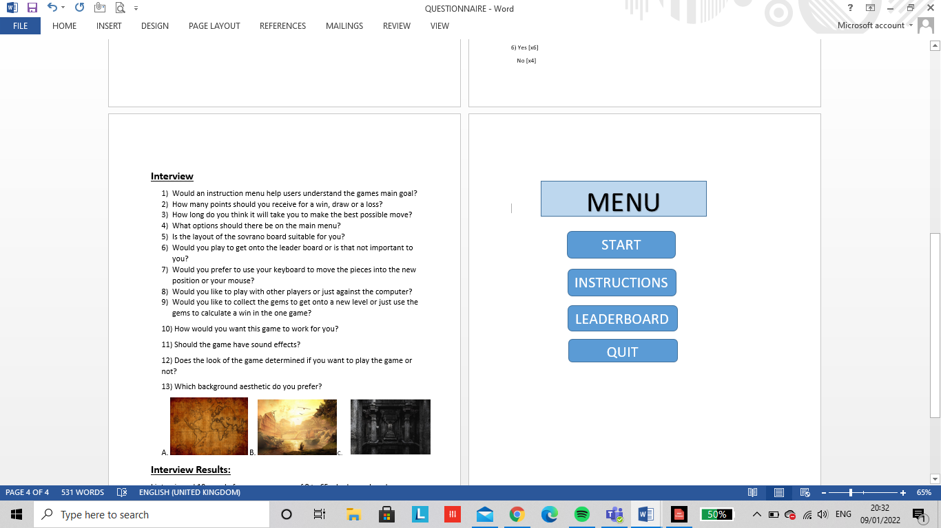

The game menu is the menu that appears whilst the player is in a middle of a game:

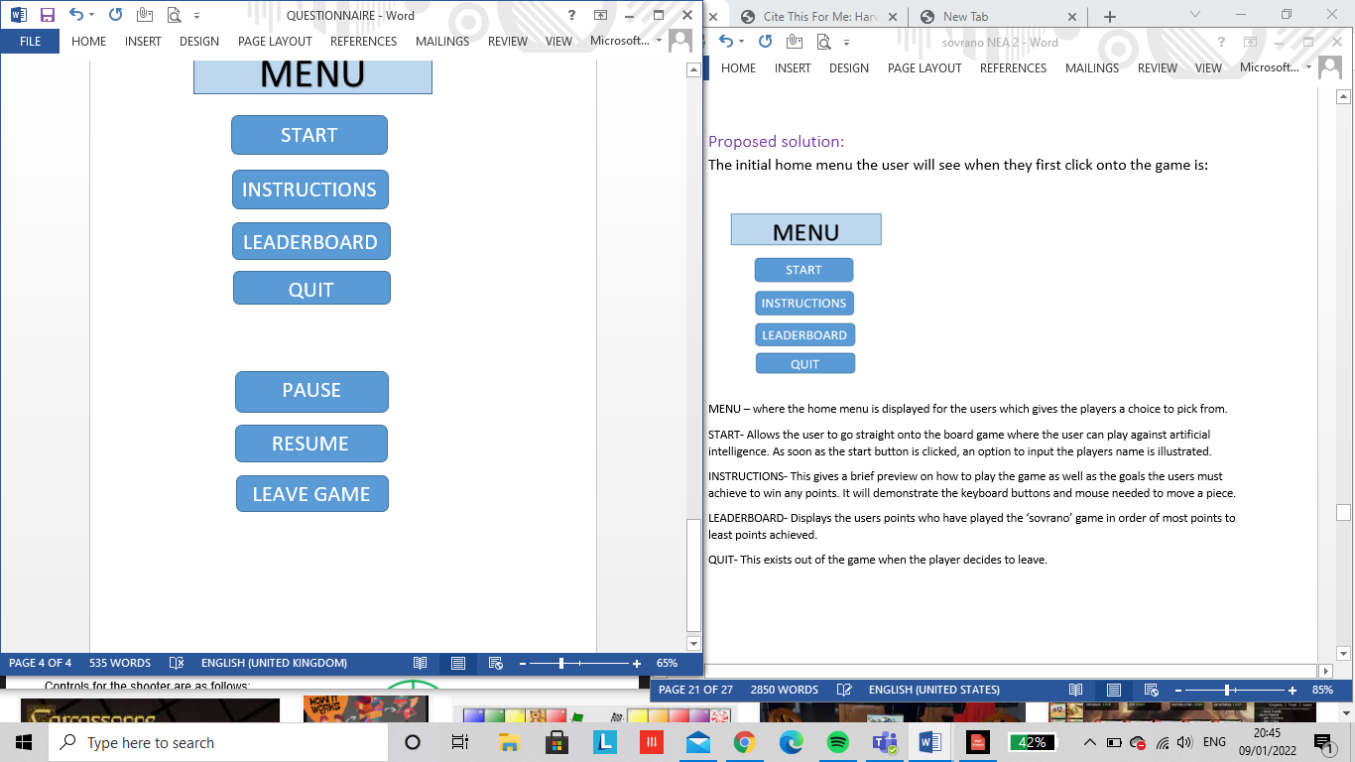

MENU – where the home menu is displayed for the users which gives the players a choice to pick from.

START- Allows the user to go straight onto the board game where the user can play against artificial intelligence. As soon as the start button is clicked, an option to input the players name is illustrated.

INSTRUCTIONS- This gives a brief preview on how to play the game as well as the goals the users must achieve to win any points. It will demonstrate the keyboard buttons and mouse needed to move a piece.

LEADERBOARD- Displays the users points who have played the ‘sovrano’ game in order of most points to least points achieved.

QUIT- This exists out of the whole game when the player decides to leave.

PAUSE- Allows the user to stop the game in the middle of the games progress and gives the user a choice to continue playing and resume or to leave the game.

RESUME- Starts the game from when they left of if they had just paused it.

LEAVE GAME- This stops the game completely and takes the user back to the home menu.

# User interface:

5.

4.

SOVRANO

“SOVRANO!” The word you shout when the battle has been won. It’s an exciting game of wits in which the players assemble the guards and prepare to lead your emperor to the throne and win absolute power! The aim of the game is to get the emperor to the center throne and gain the most gems.

3.

2.

1.

A 2-player game suitable for ages 6 and over.

**MAIN MENU**

QUIT

LEADERBOARD

INSTRUCTIONS

START

1. The main menu is made up of the start, instructions, leaderboard and quit options. These options are explored in much further detail above.
2. A little comment is made at the bottom of the user’s first initial screen to give information on the game. It states that sovrano is only suitable for 2 players to play as well as the minimum age the players have to be. They must preferably be 6 years old and over due to this game needing difficult skills and strategy being imposed.
3. This section gives a brief summary on sovrano to the users to help them understand the objectives needed in order to win the game.
4. A big bold title at the top of the page catches the users attention and makes them remember the name of the game quite quickly.
5. The background gold colour (255, 217, 102) gives the idea of an ancient rustic game which links back to the deep-rooted origins of the board game. The vibrant pastel colour paradigms such as the uses of blues greens and oranges help to create an initial impression and captivate first time users playing the game.

Gaming Controls:

Sovrano requires inputs from the user’s keyboards:

‘A’ allows the user to move a piece to the left

‘D’ allows the user to move a piece to the right

‘W’ allows the user to move a piece upwards

‘S’ allows the user to move a piece downwards

‘P’ Pauses the game

‘R’ Resumes the game

‘Q’ Quits the game

‘U’ Undo a move

‘Enter’ places the piece in the required spot

Other input methods:

‘Left click from the mouse’ – helps to select the piece you want to move as well as to have another option to access the game menu.

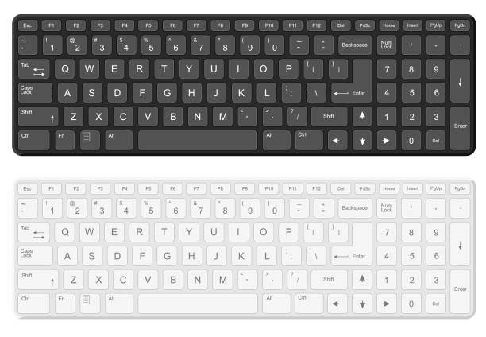

Sound effects:

As soon as a player receives the one gem reward from the center of the board there will be a cheering noise. When the player receives the three gem reward there will be a drum roll sound to announce the winner.

Point system:

The gems would be collected on the top right of the gaming screen. It will show amount of gems the player has and the amount of gems the computer has.

The maximum gems a player can score in one game is 5.

Score board at the start of the game:

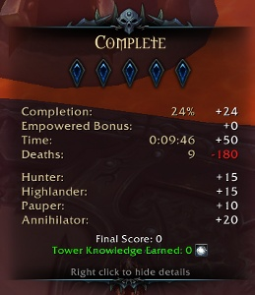

Computer

‘Player Name’

Possible score board at the end of the game:

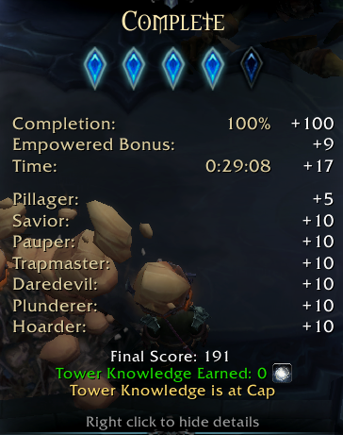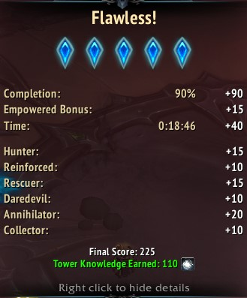

‘Player Name’

Computer

Due to the player being able to input their name at the start of the game, their name is inputted onto the screen table where they play against the computer.

Leaderboard:

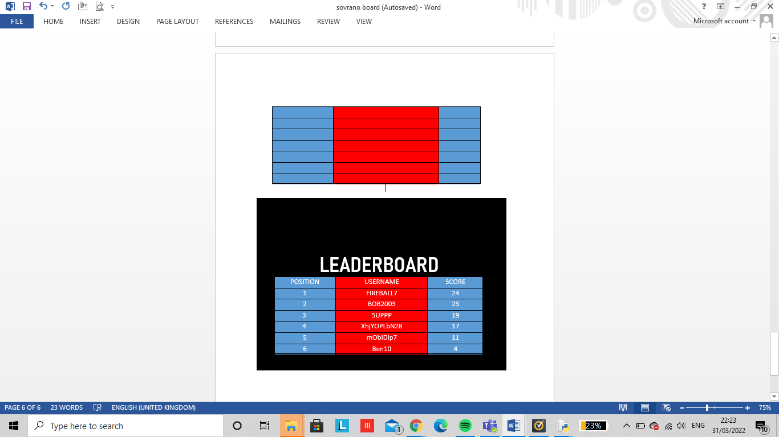The leaderboard shows the added rolling total result of each player onto the table. The results are in order of the most collected gems / points to the least. An example I created would be:

The first column shows the position the user has come in. The second column shows the username they inputted for the game. The third column demonstrated the points that each user has received in order from the most to the least.

Once the user has selected the instructions button on the main menu this is what would output for the user:

Figure 7 instructions.png

INSTRUCTIONS:

**There are three pieces in this game in which they all have different movements:**

* **Guard – moves up, down, left, right**
* **Archer – moves up, down, left, right, diagonal (can capture from 2 places)**
* **Emperor – moves up, down, left, right and diagonal (note: can only capture from one place)**

**The objectives of the game:**

* **Get your emperor to the middle throne to win**
* **Get your pieces onto the two side thrones to earn more points**
* **Capture opponents emperor to win**

**If none of your pieces are able to move you will be at a draw where no player will earn any points.**

# **A-STAR ALGORITHM:**

A-star is a path finding algorithm and is an improvement of Dijkstra’s algorithm. It is made up of two functions:

* The cost between two nodes(same as Dijkstra)
* The approximate cost from the initial node to the final node which is known as the heuristic. I was able to calculate this using the Euclidean distance (using trigonometry Pythagoras).

Although this algorithm can’t be used for the whole project it may be useful towards the end of a match when there are less pieces on the board. This approach will be used for finding the best path to get the emperor to the middle thrown.

Final node

√5

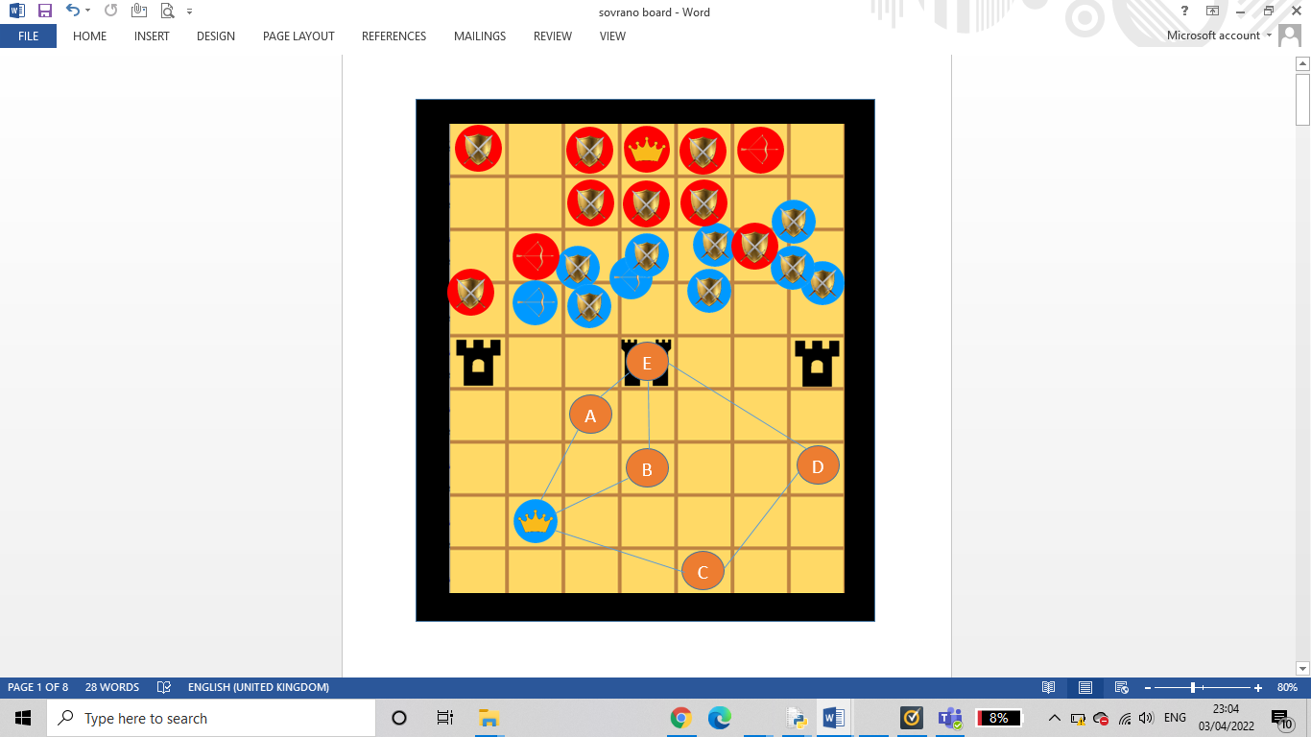

1

Starting node

2√10

2√5

2√2

√13

9

12

2

8

6

6

|  |  |  |  |  |  |
| --- | --- | --- | --- | --- | --- |
| vertex | visited | Shortest distance from start (f) | Heuristic (h) | F = g + h | Previous vertex |
| Emperor | yes | 0 | 0 | 0 | - |
| A | yes | 6 | √13 | 9.60 | Emperor |
| B | yes | 6 | 2√2 | 8.83 | Emperor |
| C | yes | 8 | 2√5 | 12.47 | Emperor |
| D | yes | 17 | 2√10 | 19.83 | C |
| E | yes | 7 | √5 | 9.24 | A |

Although the moves from the emperor to the nodes are invalid for a first move, this a star abstraction shows the emperors move after 2 or more valid moves and how they’ll end up reaching to the final node by finding the shortest path.

So the shortest path from emperor to E is:

Emperor -> A -> E

Using thinking ahead to generate all Input, process and outputs:

function boardstate

boardstate (2d array)

self.playerToMove (string)

b_pos (integer)

r_pos (integer)

INPUT

OUTPUT

Updates board- state

Outputs board in the given positions

The board- state is updated into the position given by the red piece (r_pos) and by the blue piece (b_pos) which determines the next player to move.

The boardstate function will get updated depending on whose turn it is. If the red player makes a move and choses to select a piece as well as select a square where they want to place the piece, the board will make the changes and output the new board for the player. The b_pos variable takes the position of the blue player and the r_pos variable takes the position for the red player. The self.playerToMove decides whose turn it is next depending on whose made the last move( or as known as the current player.)

function undo_move

boardstate (2d array)

self.playerToMove (string)

b_pos (integer)

r_pos (integer)

INPUT

OUTPUT

Updates board- state

Outputs board in its previous board state before game play.

The board is updated back to the previous board state depending on the players turn to move. The previous pieces are also loaded back into its previous red/ blues position.

When a player has made their move but wants to undo their current play or reselect a new piece, the user will press ‘u’ on their keyboard to allow this function to occur. The function boardstate will get updated back into its previous game state and the player to move will have another time to select and move a new piece within the time frame.

function possibleMoves

boardstate (2d array)

self.blueToMove (string)

self.redToMove (string)

self.getGuardMove

self.getEmperorMove

self.getArcherMove

INPUT

OUTPUT

Updates board- state

Outputs board in the given positions if move made is valid.

Checks to see which players turn is next and places the piece in(row, column) notation.

Checks that each move is valid for each piece

All players are assigned its valid moves on where they can move along the sovrano board. The pieces are then placed upon the board in the row column notation. This can be tested using black box testing with different variables using coordinates.

function AIMove

boardstate (2d array)

validMove

createMove

userMove

INPUT

OUTPUT

Updates board- state

Piece moved into a new position

Depending on the users move they make, the AI will select the best possible move to make. This is only possible if it’s a valid move.

The AI uses greedy algorithm to make a next move. Once the player plays their piece, the AI will make a move and try to capture a piece worth the most points if possible. If the computer is blocked, the game will lead to draw if the player is also unable to move. Hopefully my AI will be able to think at least one step ahead so the function will work effectively and become a challenge for the player.

Game menu flowcharts:

Username requirements flowchart:

no

no

yes

yes

yes

yes

yes

yes

Does username= required name?

stop

Username invalid try again

Playgame = true

Is username valid?

Input username

Enter a username between 6-15 characters

start

Valid usernames:

The user must have a unique string username that hasn’t been taken by anyone else, this is due to the usernames being updated onto the leaderboard when a game has been played. A unique username destroys any confusion on where you are placed upon the leaderboard. What the username must include:

* 6 – 15 characters
* At least one digit
* At least one capital letter
* At least one lowercase letter
* A symbol if they want but not necessary
* 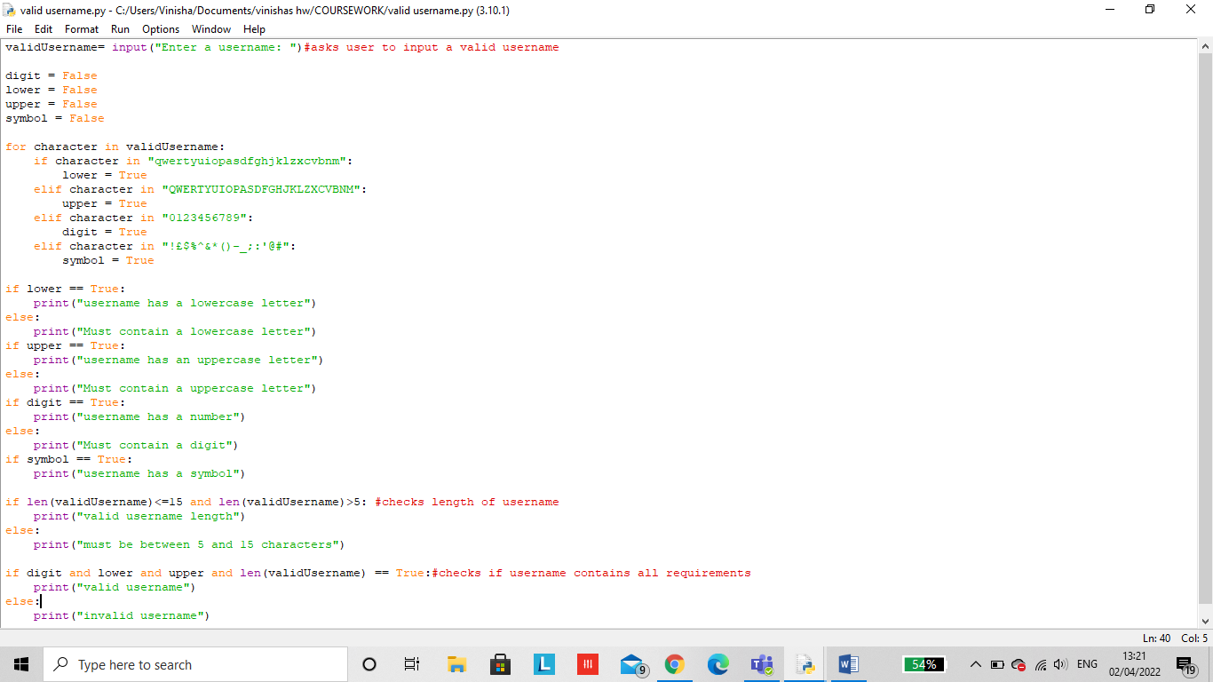A unique name

Checking length of username(invalid):

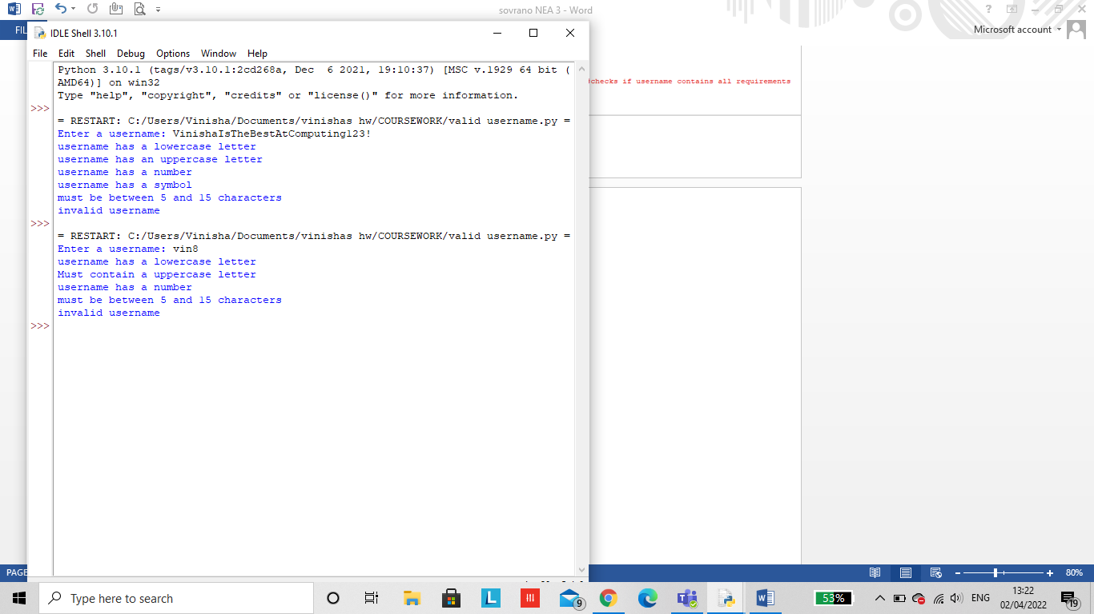

Checking if username has a lowercase, uppercase and digit(invalid):

The output warns the user on an aspect they’re missing from their username

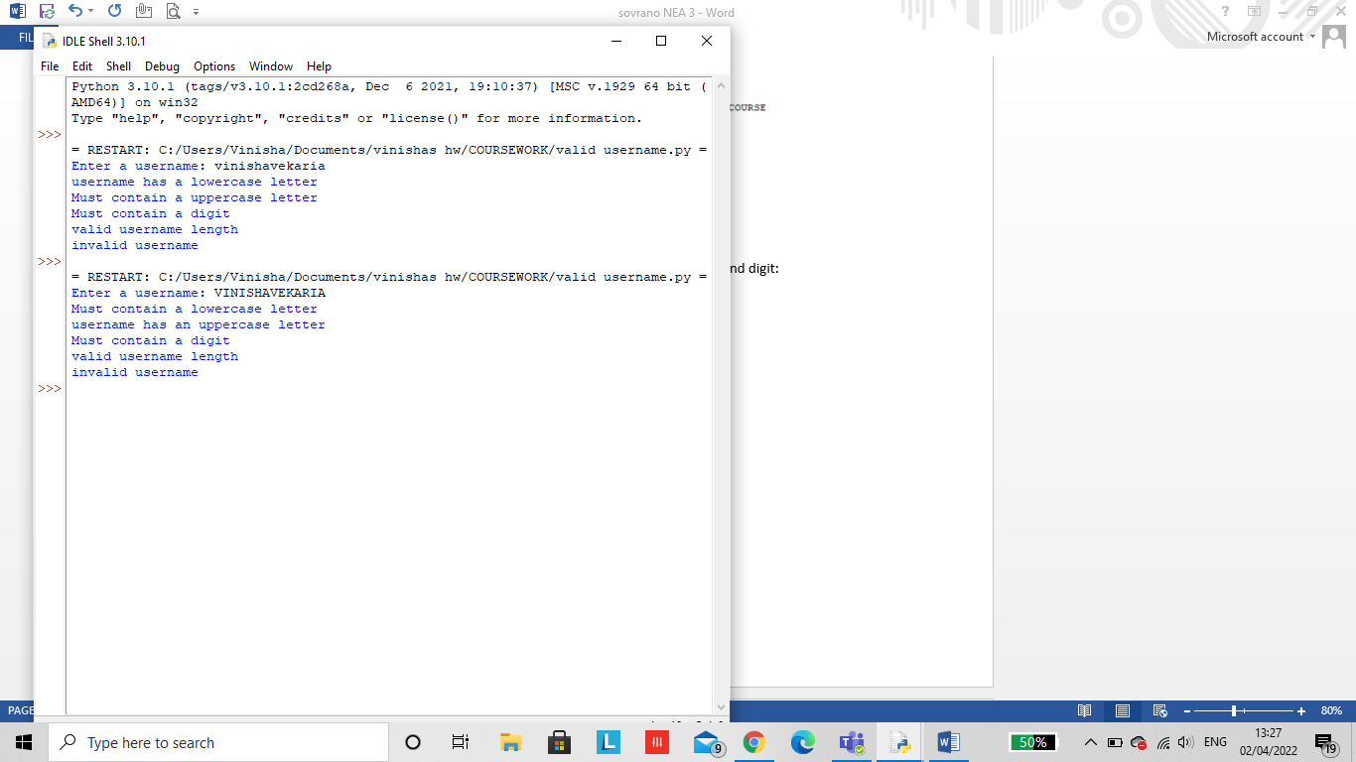

**Note!** Extreme data is valid data that falls at the boundary of any possible ranges. This will be unlikely to occur as the username has many requirements to reach so can be either valid or invalid.

Valid usernames:

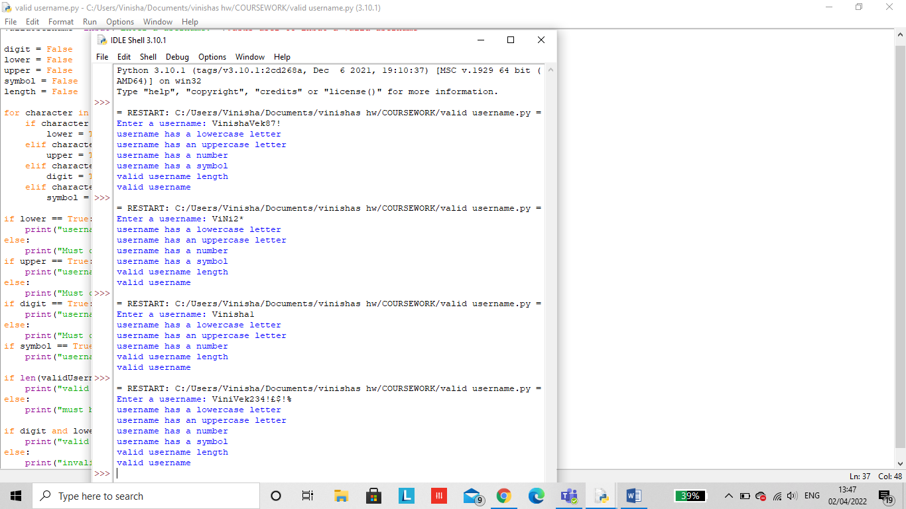

The username would still be valid with or without any symbols as it’s not a necessity

Game menu pause flowchart

start

no

Check if Playgame is true

yes

User presses ’p’ (pause)

yes

Playgame is false and gamestate is paused

yes

Resume game

no

yes

yes

yes

Resume game

Playgame = true

no

yes

Playgame= false

Gamestate goes onto main menu screen

Quit game

yes

yes

Return to main menu

stop

Game menu quit flowchart

no

no

yes

yes

yes

yes

yes

yes

Resume game

stop

Return to main menu

Quit game

Playgame is false and gamestate has been terminated

User presses ’Q’ (quit)

Check if playgame is true

start

|  |  |  |
| --- | --- | --- |
| **VARIABLE NAME**  Variable names that I can implement into my overall development stage. This decomposition will allow me to have a checklist on all the variables I should use within my overall code to ensure my project is up to high standards. | **JUSTIFICATION** | **DATA TYPE** |
| Screen | Adjusts the screen size of the game given by the variable. | integer |
| Square_size | How big you want the size of each square on the sovrano board . | integer |
| Bg_colour | The background colour of the bored( ie. In sovrano the gold colour) | integer |
| pieces | The blue archer, red archer, blue guard, red guard, blue emperor, red emperor, middle throne, throne gets loaded into its given position in the 2d array. | string |
| createMove | blueToMove and redToMove decides whose turn it is next to play. | boolean |
| gameOver | Checks to see if the game is over, if its true the points will be calculated. | boolean |
| p.mousebutton | If ‘u’ is pressed the piece will undo, if ‘r’ is pressed the board is reset, if ‘p’ is pressed the game play will be paused. | boolean |
| createMove | Allows the AI to make a move once the player has made a move. | boolean |
| capture | Checks if the oppositions emperor has been captured | boolean |
| draw | Checks if the opposition and current player can not make a better move and are stuck at stalemate. | boolean |
| s.set.alpha | Sets a transparent colour to indicate to the user when they can position their next piece. | integer |
| self.board | A 2d array to show the position of all the pieces on the board | array |
| archerMoves | All valid positions the archer can move | integer |
| guardMoves | All valid positions the guard can move | Integer |
| emperorMoves | All valid positions the guard can move | Integer |
| piecePoints | How much each piece is worth | string |
| capture | How much a capture is worth | string |
| draw | How much a draw is worth | string |
| depth | How many steps the AI can think ahead | Integer |
| totalPoints | The amount of points the users score all together. | Integer |

Pygame:

Importing pygame onto python meant I was able to create a gui and include sound libraries for my game. MY gui consists of using vibrant colours for my game menu as well as for creating my board in order to engage the users of my game.

Creating my main menu:

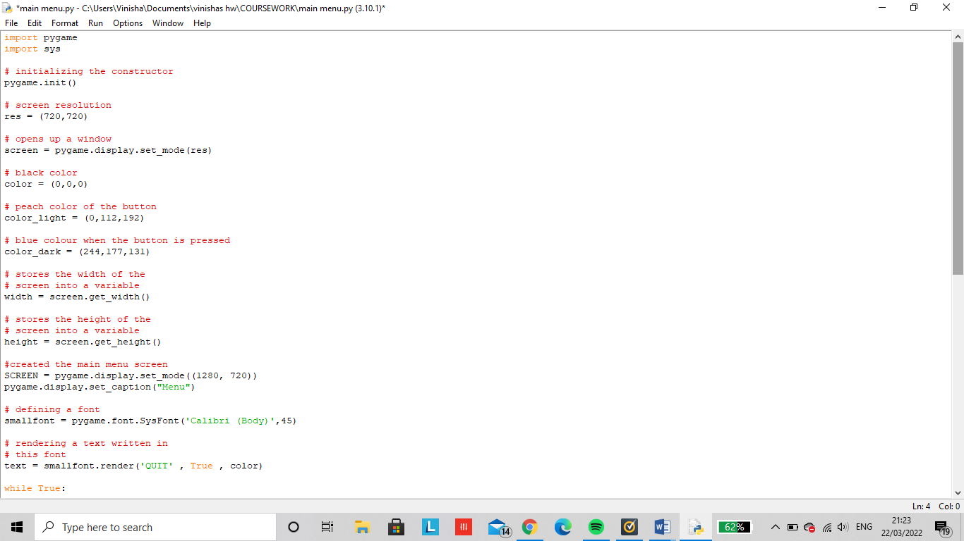

Provides functions and variables used to manipulate different parts of python runtime environment

Gets the current window caption

Creates a font object from the system fonts

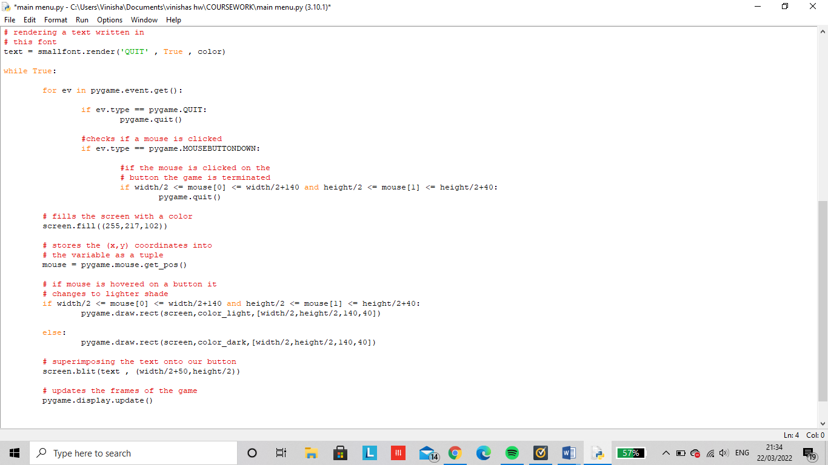

Output of the code when clicking the quit button on my main menu:

The quit button is placed in the peach coloured box in a bold font when it has not been clicked by the user.

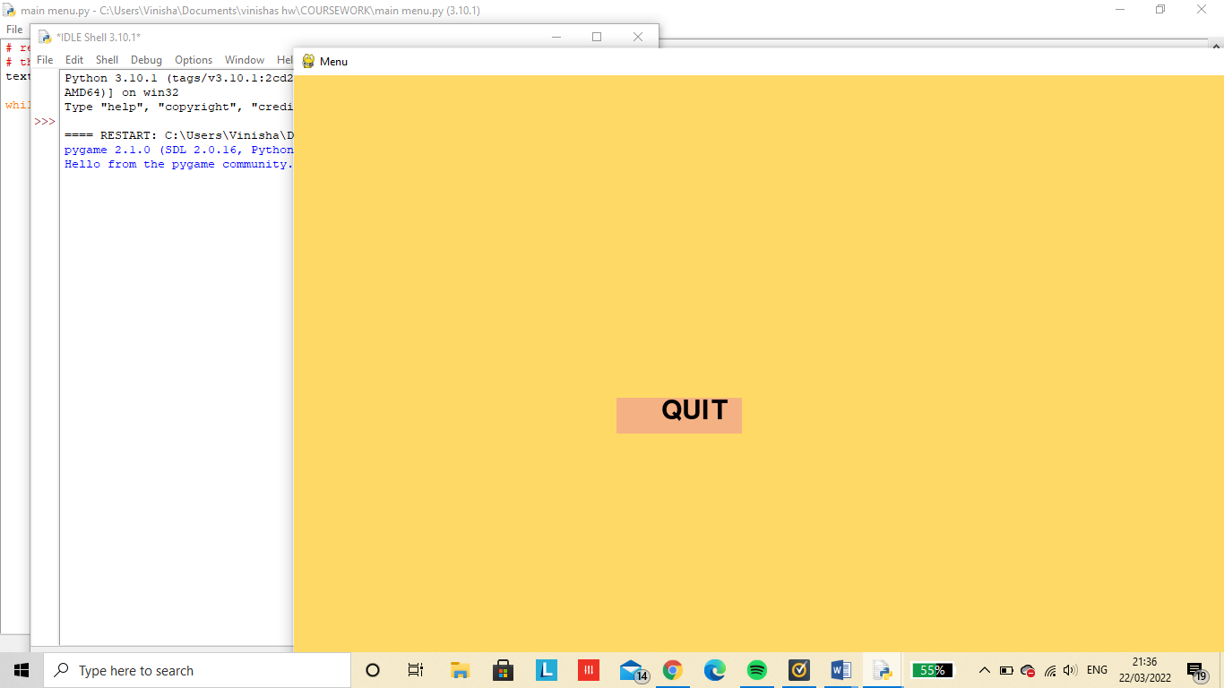

Once a mouse is hovered onto the peach textbox, the textbox turns into a blue box to altert the user which option has been chosen.

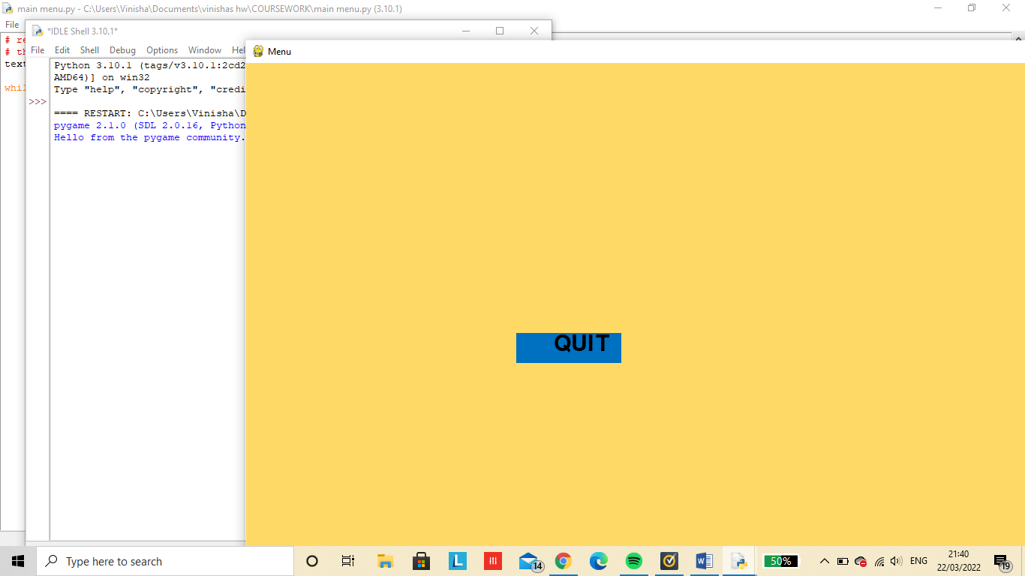



The python code is ended and the main menu is quit as soon as the user clicks on the quit box, allowing the user to exit the game.

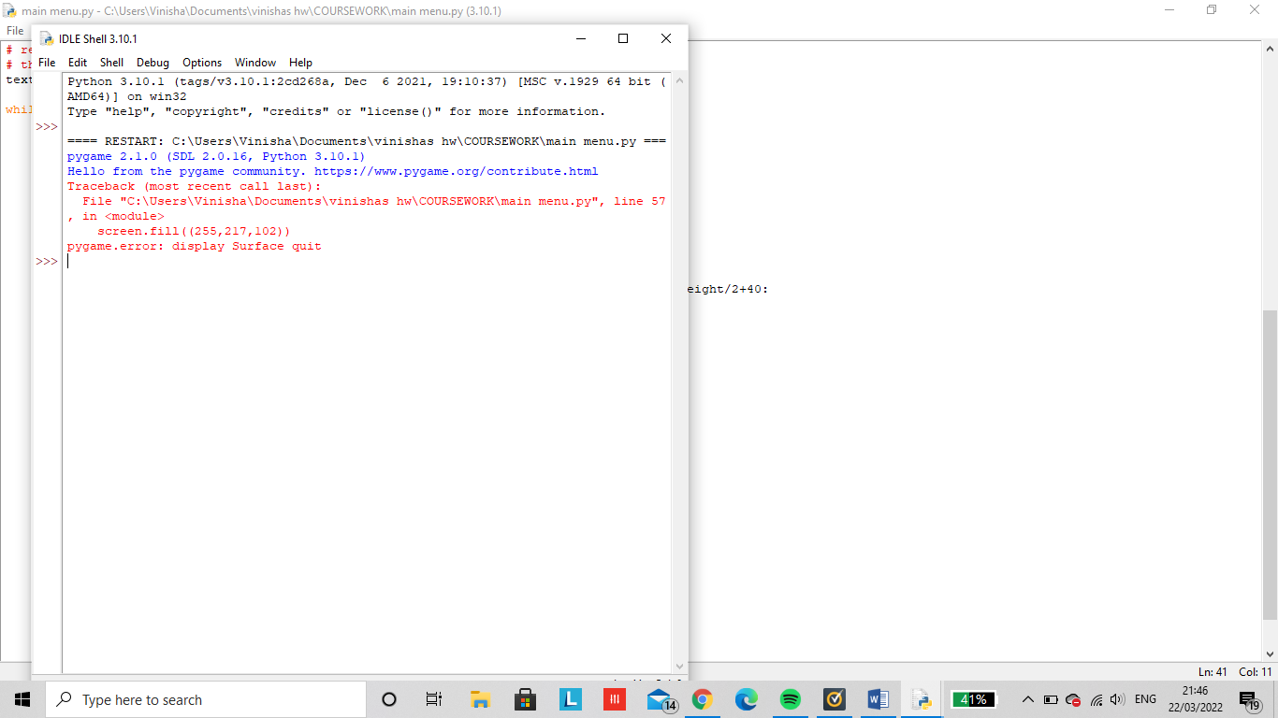

Adding the rest of my main menu opponents:

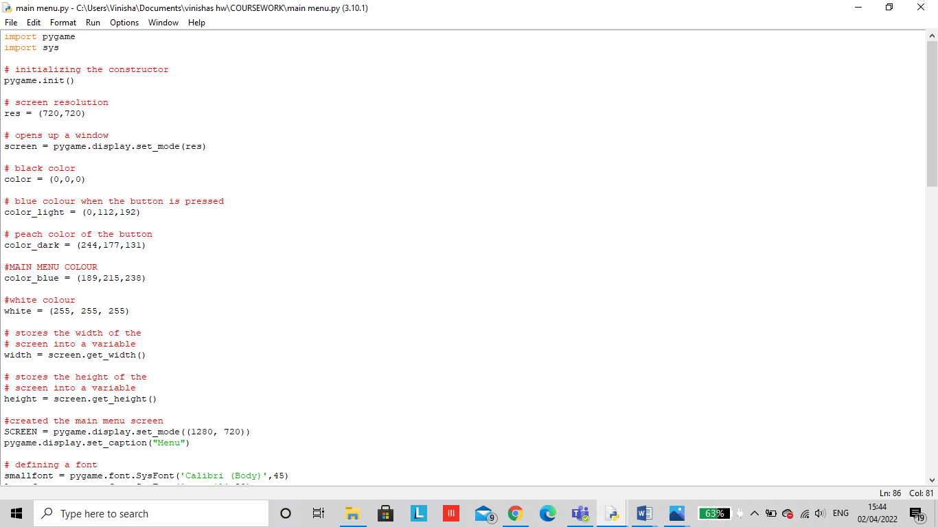

These global variables in the program are variables declared outside the subroutine or function. It has a global scope means it holds its value throughout the lifetime of the program. Hence, it can be accessed throughout the program by any function defined within the program, unless it is shadowed.

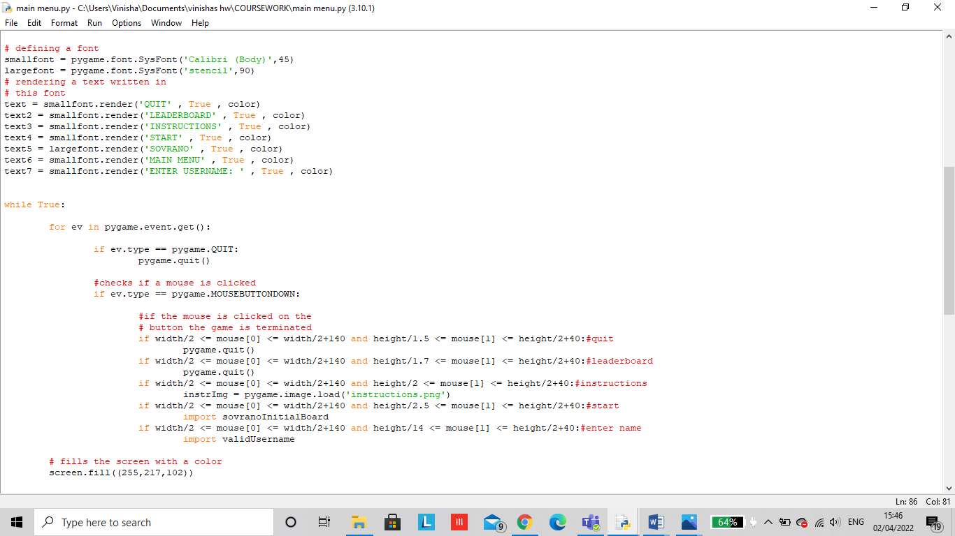

**These are local variables, it** is defined as a type of variable declared within programming block or subroutines. It can only be used inside the subroutine or code block in which it is declared. The local variable exists until the block of the function is under execution. After that, it will be destroyed automatically.

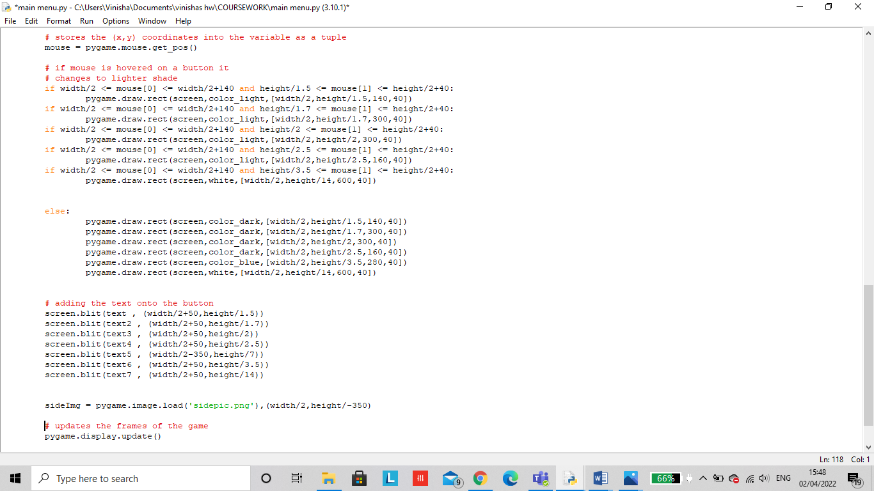

Output:

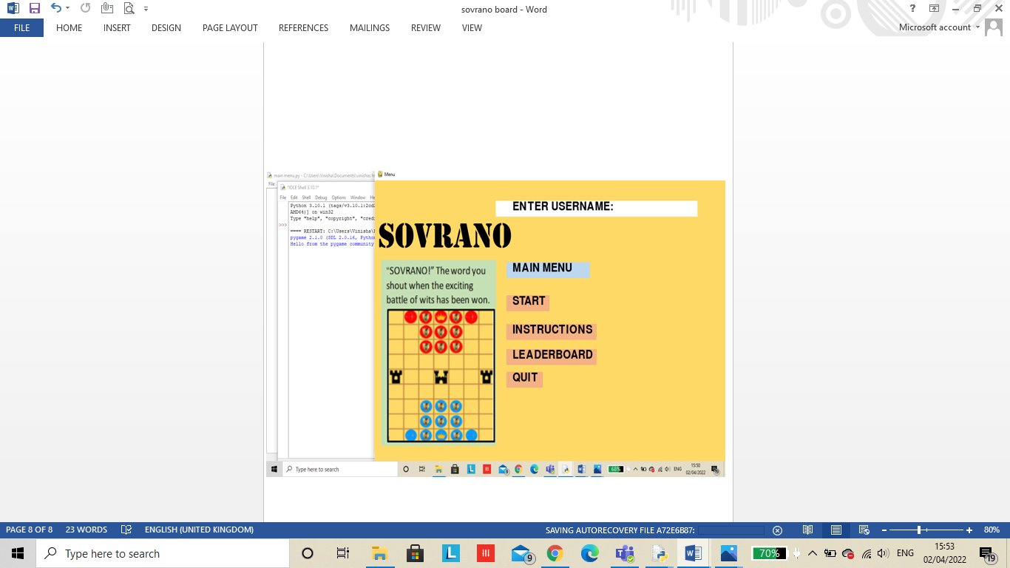

Once the start button has been clicked I imported my sovranoInitialBoard module created to go straight to the game. However a problem I came across is that I have to make alterations such as the user should only be allowed to play and press the start button once they have entered a username.

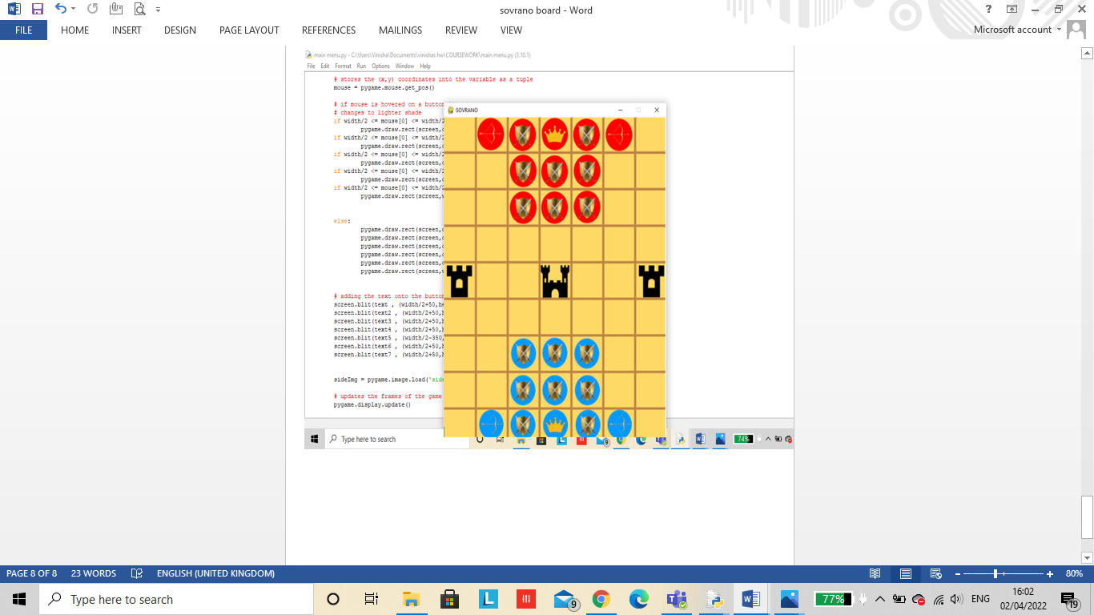

The instruction button loads an image (png) of the instructions for sovrano that I created (page 30)

The leaderboard button wouldve imported an sql module howver due to timing issues I wasn’t able to get around to this.

The quit button exits out of the main menu screen and back onto the python shell

The enter name button uses my previous username validation code to ensure the user enters a correct username (page 32)

The picture on the left I imported as a png file already made so its easier to place onto the board without having to create a another background colour and border.

Creating a chess board to receive an idea on how to create the initial board:

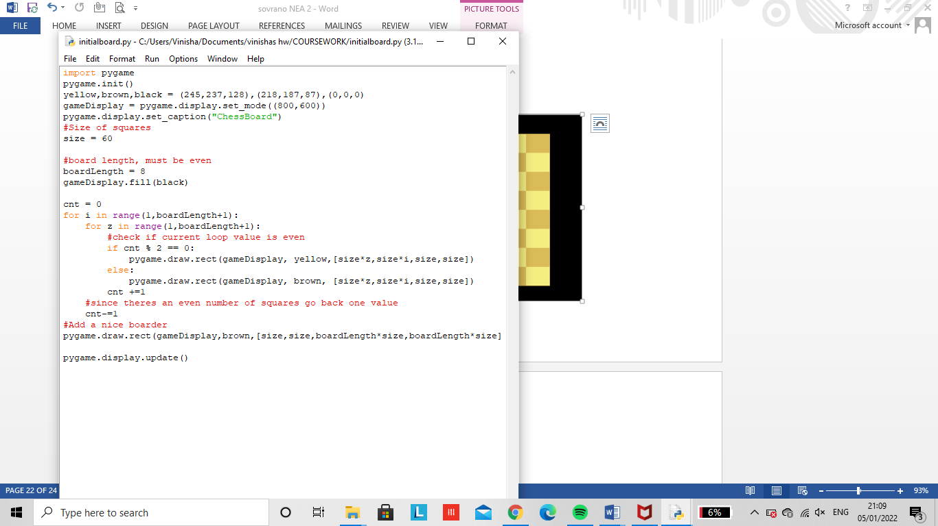

*Tim, T. W. (2019) 24 hour coding livestream - creating an online chess game with python. Youtube. Available at: https://www.youtube.com/watch?v=HvjsMrR51lg (Accessed: March 22, 2022).*

The output for the pygame code:

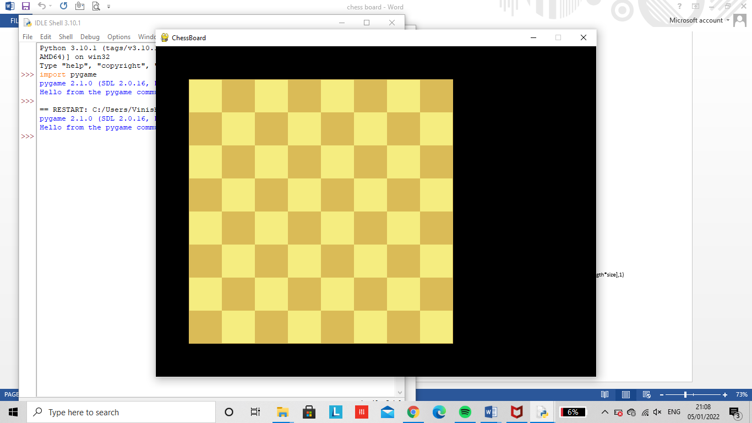

The initial board for my game I created was for a chess board. However the problem I came across was that creating alternate coloured squares was only possible due to having even dimensions in a square shape such as a chess game which is made up of a 8x8 board. However my game sovrano includes an odd dimensional rectangle board, which makes it difficult to code alternate coloured squares. Therefore I had to adjust this code for a rectangular shaped board that would also fit the screen.

Creating the board

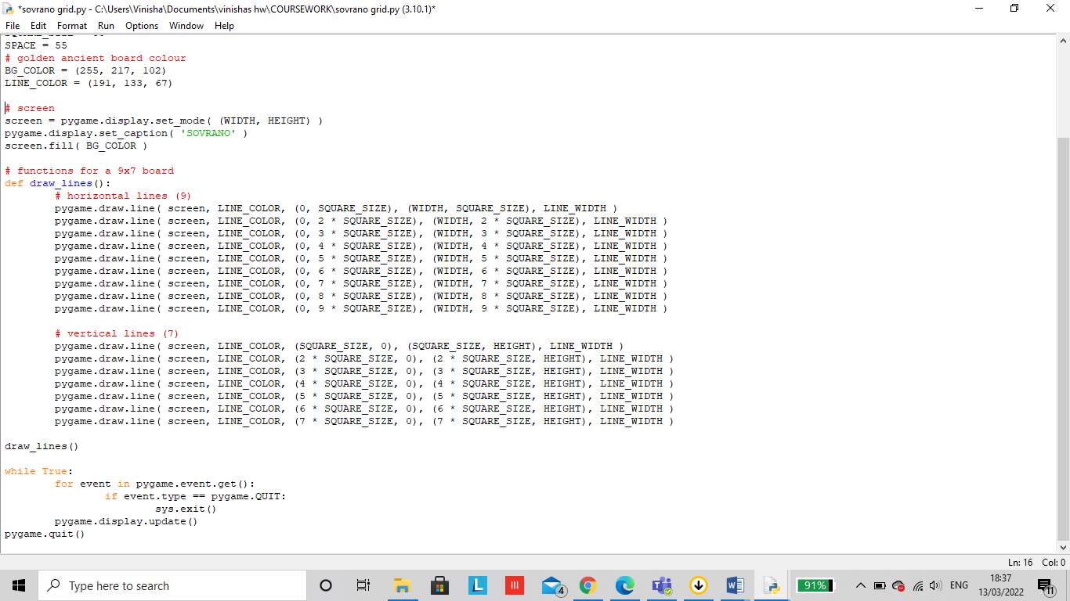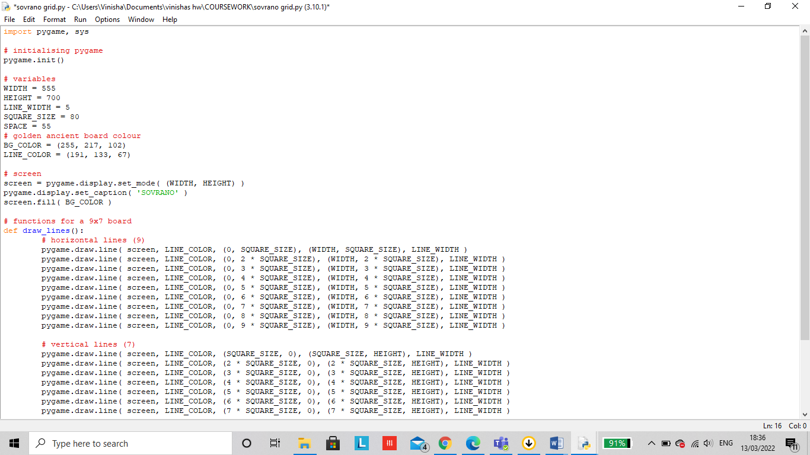Better suited alternative:

The new board includes a 700x555 screen in order to fit all 63 squares on the board without it being crammed.

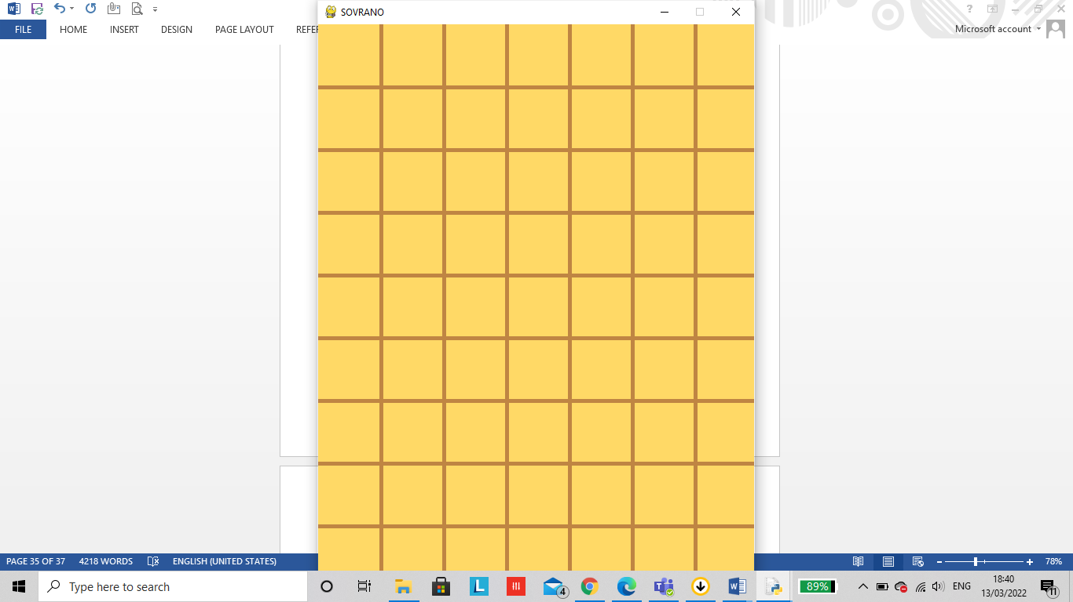

Adding the game pieces onto the board:

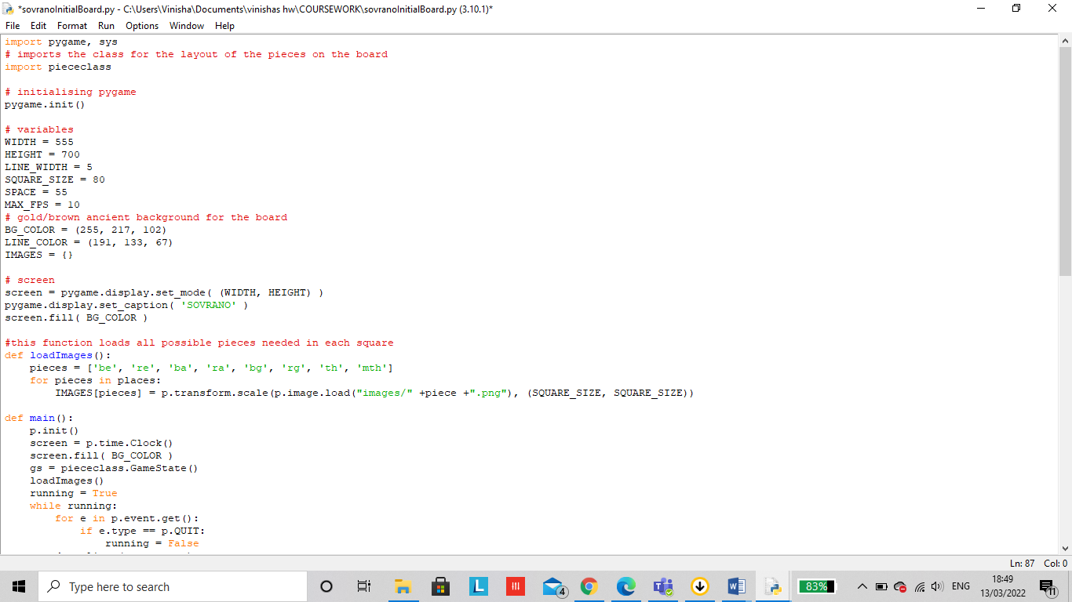

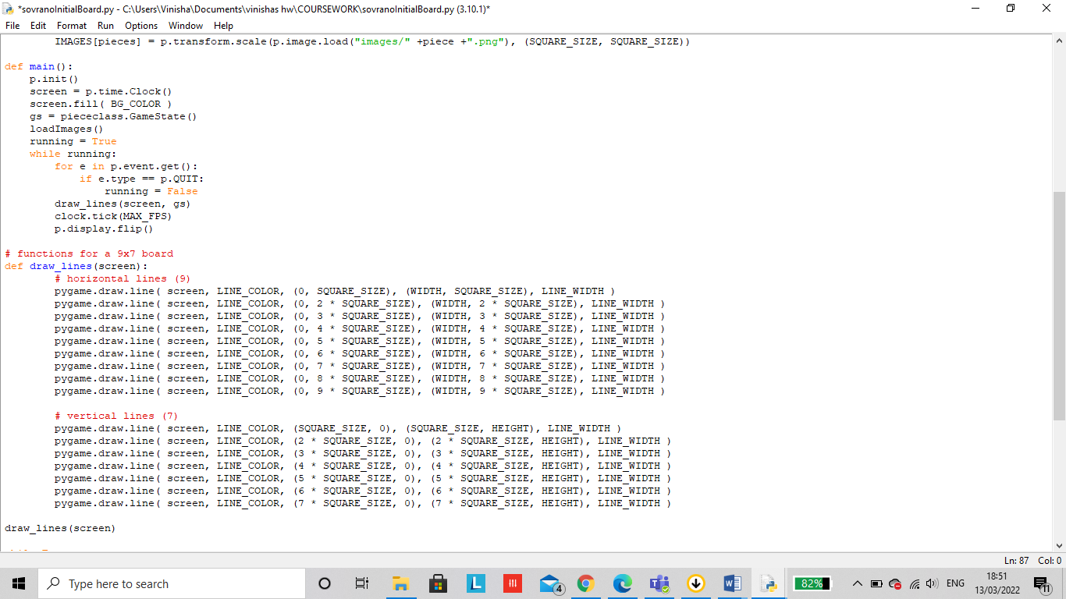

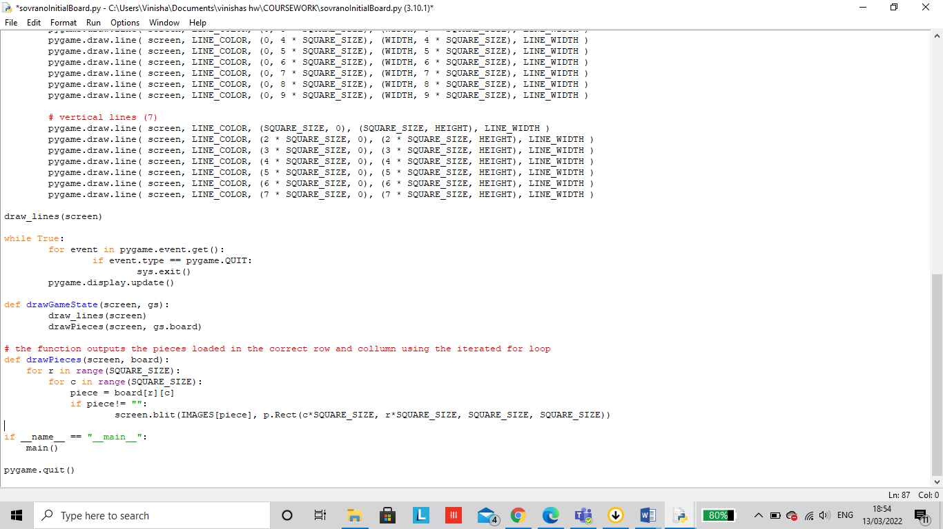

The load images and draw piece function allows my downloaded png pictures of the board pieces to be allocated into the correct column and row within the square size.

What is being tested?

The code above tests if a 7x9 board can be created with equal sized squares. The board is also filled with a background colour of gold to give its ancient aspect. Similarly, the pieces must be already placed on the board in its given position. The images are imported from this main module but its position is imported from the 2d array in the piece class.

When executed the pieces are put into its position as well as the thrones in the middle of the board, and I have also used colour to give a colourful and more catching aesthetic which is achieved from my success criteria.

Piece class file imported to show where each position on each piece is allocated:

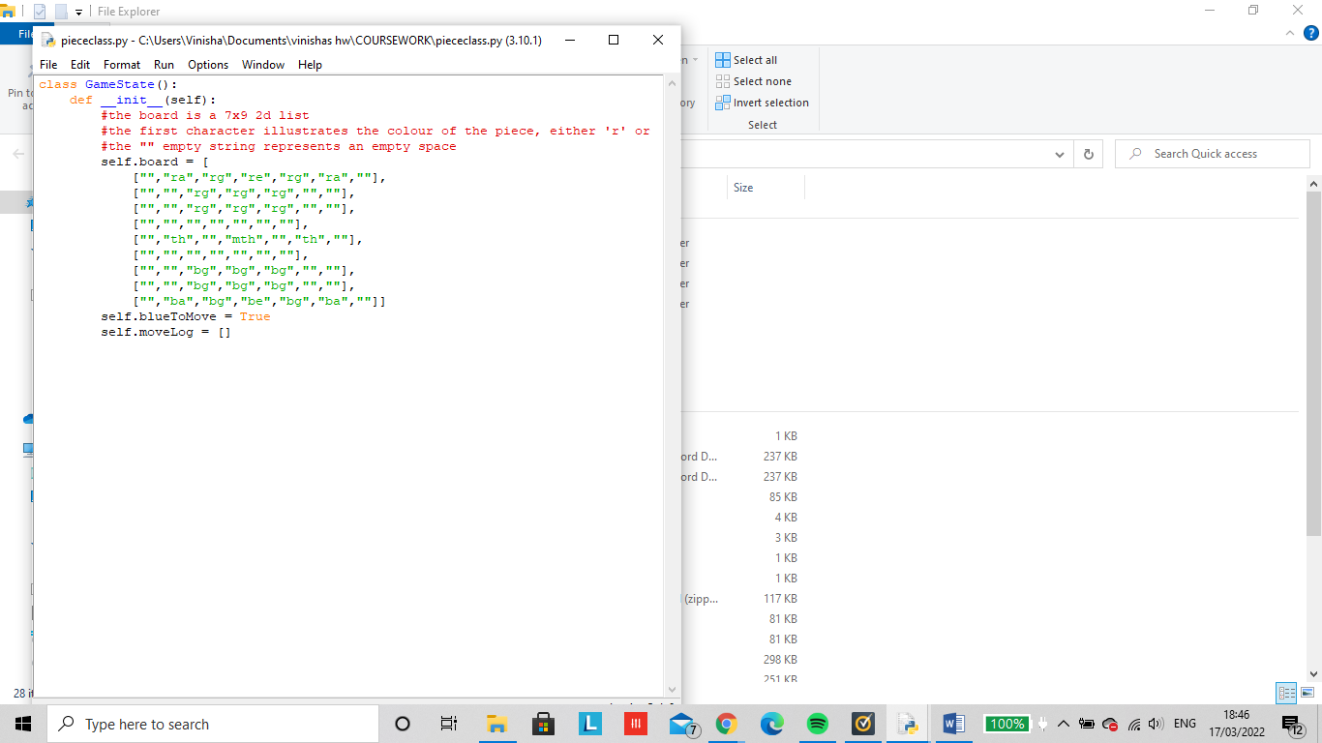

At first when I ran my code only my empty board outputted without my pieces on there.



This is when I realized that my downloaded png picture was too big to fit upon the 80 x80 square. I had to make adjustments to my game pieces for it to fit in each square by reducing the picture size.

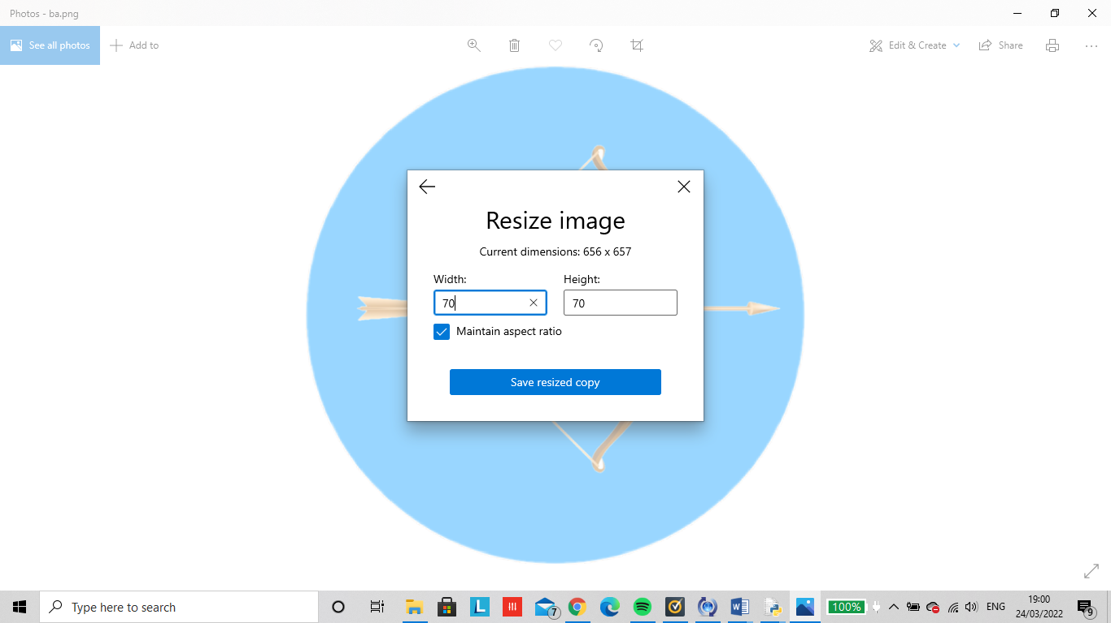

I reduced each image from 656 x 657 to 70x70

After making these adjustments the above code outputted all my pieces being placed in its correct positions allocated from the GameState class 2d array.

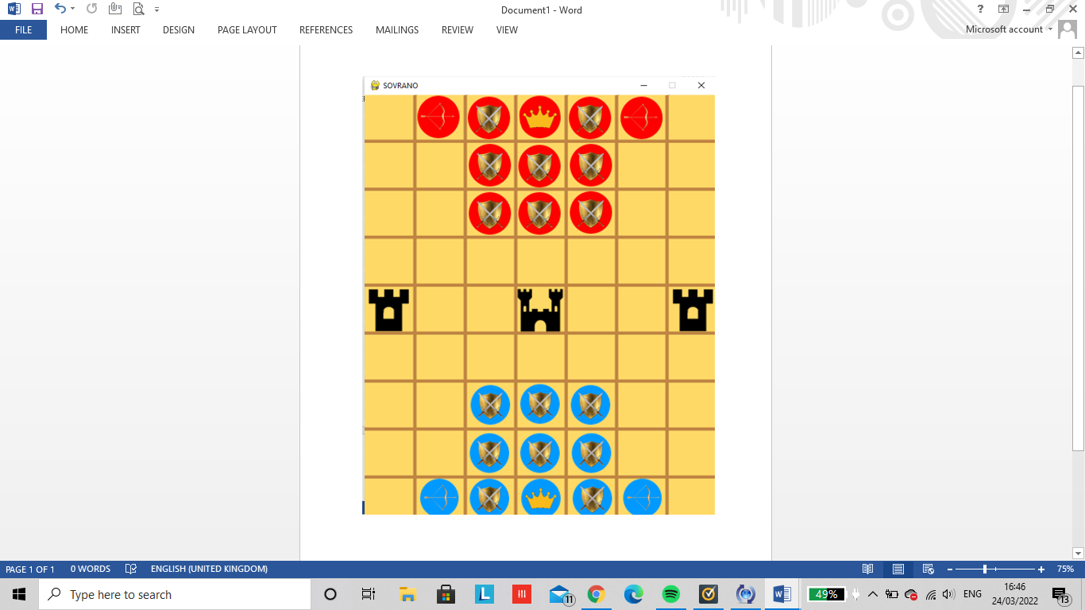

Game pieces

All game board pieces created by me using Photoshop:

Guards (x 16):



Figure 6 Red teams guard (x8)- rg

Figure 5 Blue teams guard (x8)- bg

Archers (x4):





Figure 8 Red teams archer (x2)- ra

Figure 8 Blue teams archer (x2)- ba

Emperor (x2):





Figure 9 Blue teams Emperor (x1)- be

Figure10 Red teams Emperor (x1)- re

Thrones (x3):





Figure 11 the throne on both center ends of the board (x2)- th

Figure 12 the center throne in the middle of the board 9x1)- mth

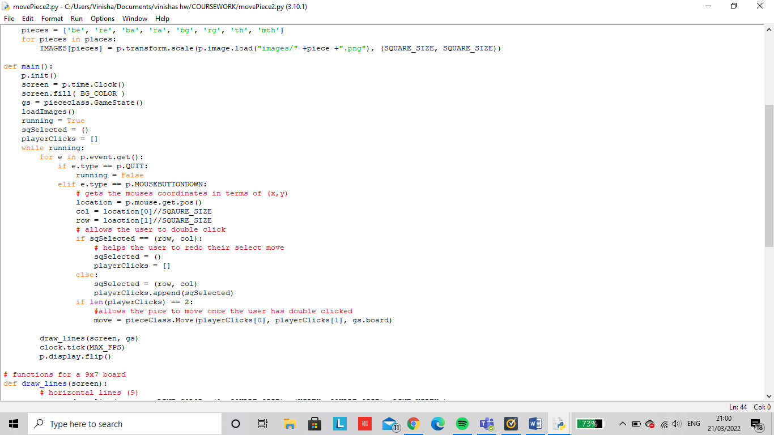moving a piece

What is being tested?

Checks to see if a user is able to select a piece as well as move a piece by selecting the square to where they

Updates the full display surface to the screen

Gets the state of the mouse button

Gets event from the queue

Initialises all imported pygame modules

Creates an object to help track time

would like to move it to. This ensure easy to use navigation for the user with simple game controls. This is also emphasized in being able to undo a move giving the users more control when making a move.

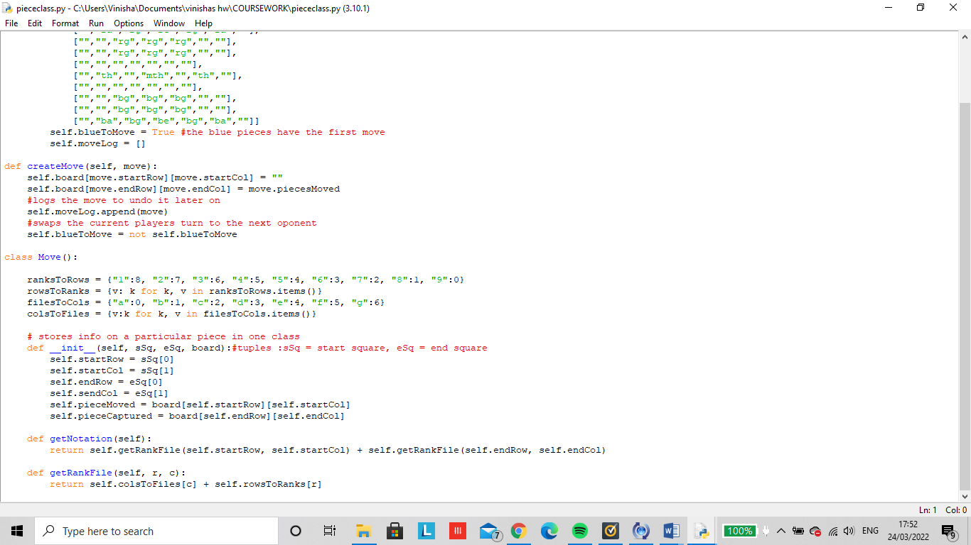

*// Python ranking dictionary return rank (no date) Stack Overflow. Available at: https://stackoverflow.com/questions/30282600/python-ranking-dictionary-return-rank (Accessed: March 24, 2022). //*

**(line 27)** #The class moves uses a dictionary to take the ranks(rows) from 1 to 9 then goes through the row notation (in terms of matrixes) of 8 to 0. The for loop is used to reverse the dictionary if needed such as the value: key to become key: value. Then the same thing is repeated for the files (columns) but instead is ordered in ascending letters to represent the column.

**(line 43)** #The function getNotation returns the rank file and allows us to see what the move will be.

**(line 46)** #The function getRankFile takes a row and column. This gets the rank and file for one square and will convert the files to columns and the ranks to rows.

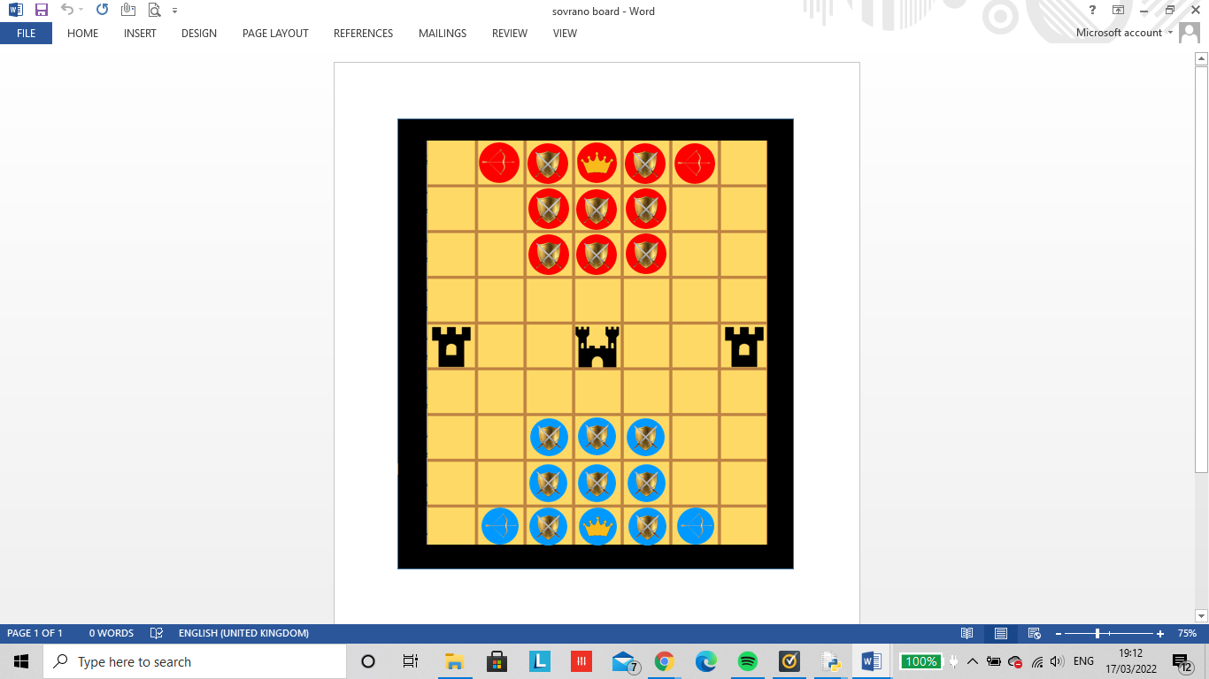

A B C D E F G

1

2

3

4

5

6

7

8

9

Ranks are called rows labelled 1-9

Files are called columns labelled A - G

Figure 9 The blue pieces are on rank 1, 2, 3 and the red pieces are on rank 7,8,9

Output:

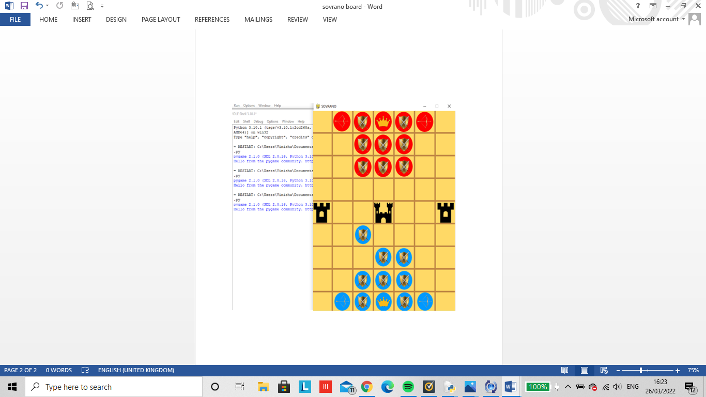By clicking on the guard I was able to move the piece one step forward. This function abover however allows any piece to move anywhere on the board as rules have not been oposed yet.

Previously I stated that to move a piece you have to use the letters ‘A’, ‘W’, ‘S’ and ‘D’ from the keyboard to move up ,down , left or right however this may be more confusing for the user and encourage them to move the wrong piece. Therefore I decided to change the method of input by using a mouse instead. This can be done by left clicking to select a piece then left clicking again to where you would like to place the new piece.

# undo a move

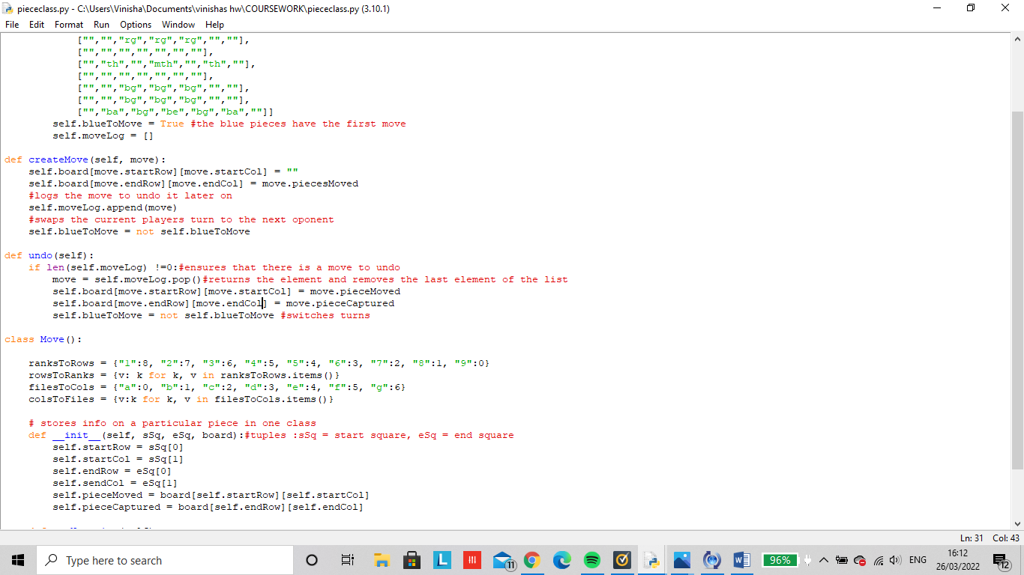In the ‘piececlass’ function:

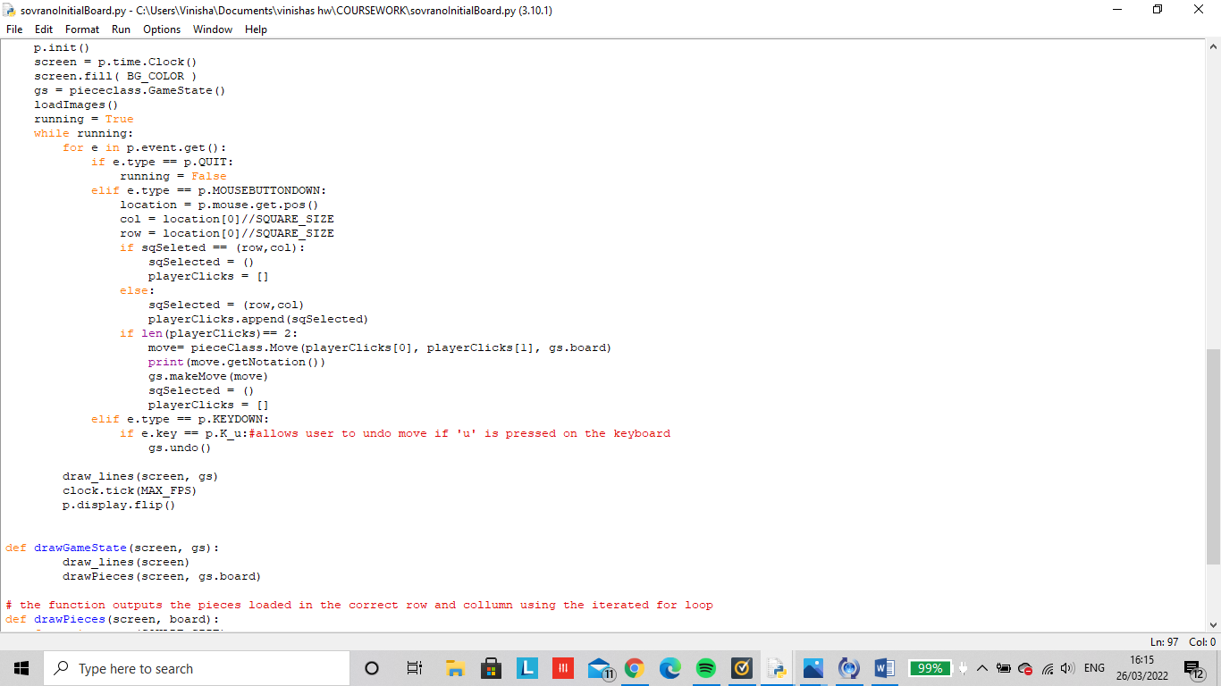In the main function:

What is being tested?

Checks to see if the user is able to implement simple game controls such as using input devices likes a keyboard to undo a move. This is seen where the ‘u’ button is pressed down, the move will go back into its original state allowing the users to make a mistake .

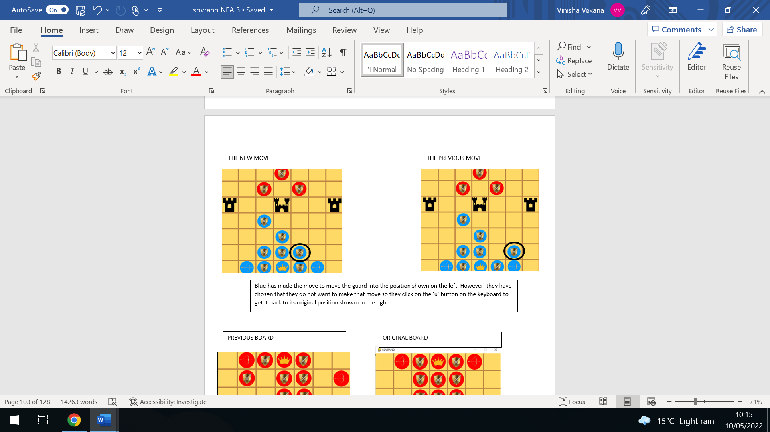

# testing moves:

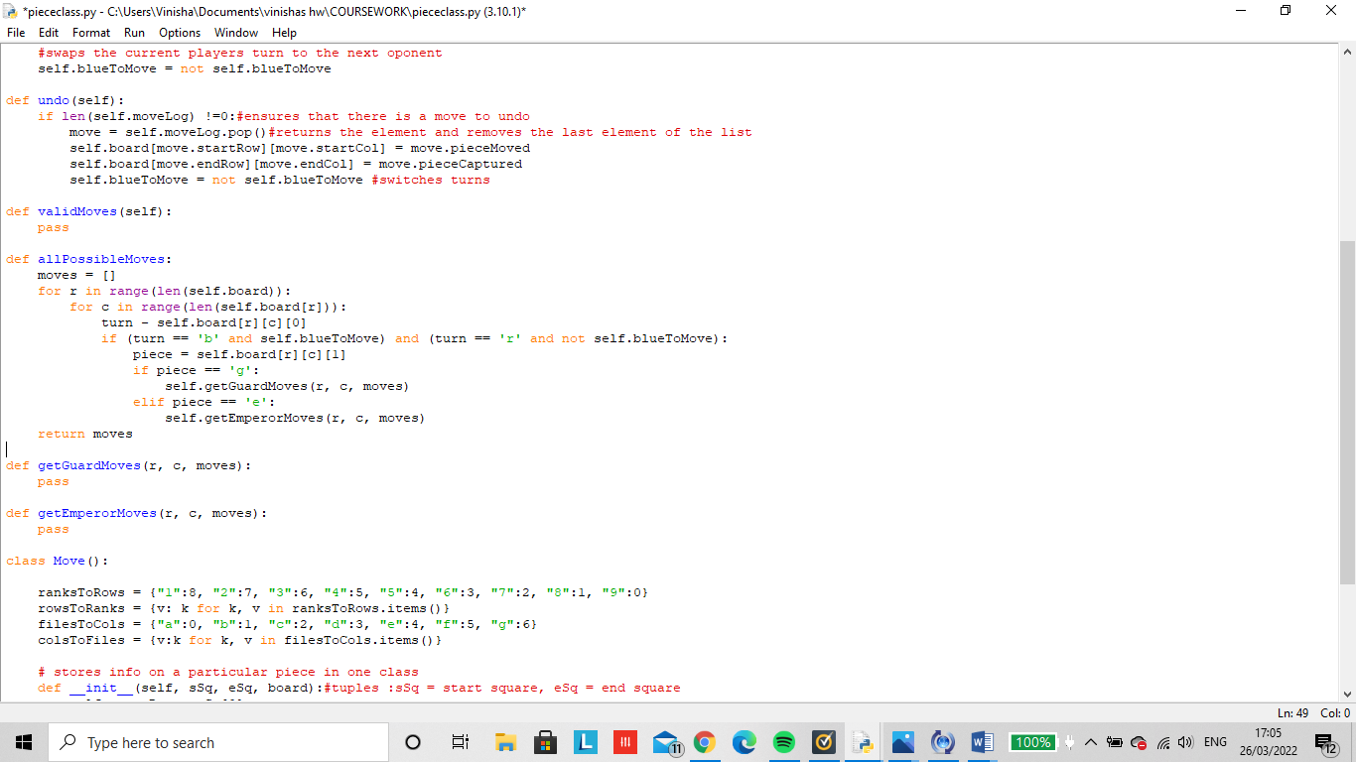

(self):

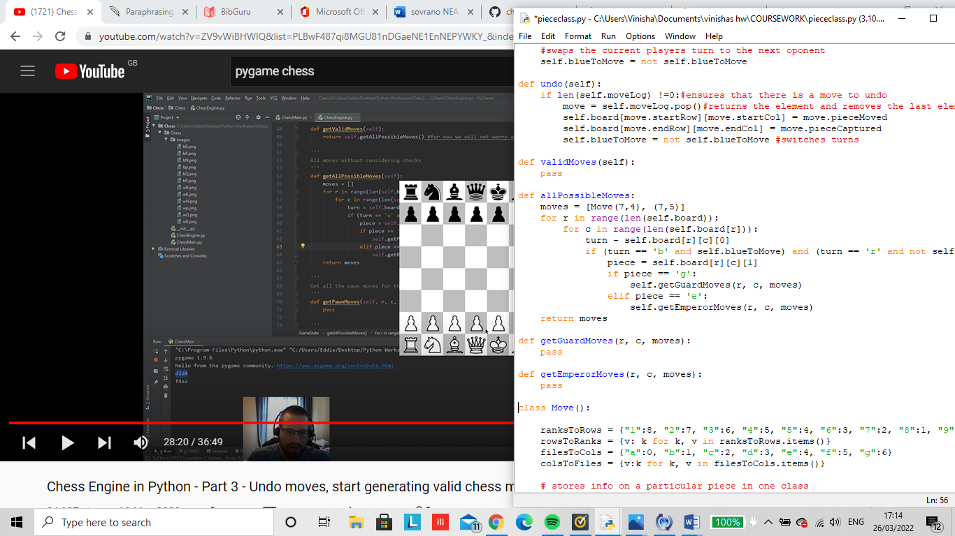When I output this, none of the pieces were able to move. This was because each move hasn’t been given any legal validated moves yet. In order to test this code I used black box testing by inputting the position of one guard, then also inputting the coordinates as to where I want to place it (in (r, c) notation.)

The new position I want the chosen guard to move to

The current position of the guard I want to move

# creating the guards first move:

What is being tested?

Checks to see if the guard is able to move in its valid positions only. I will know that my code works if the guard is only able to move up, down, left and right upto one space.

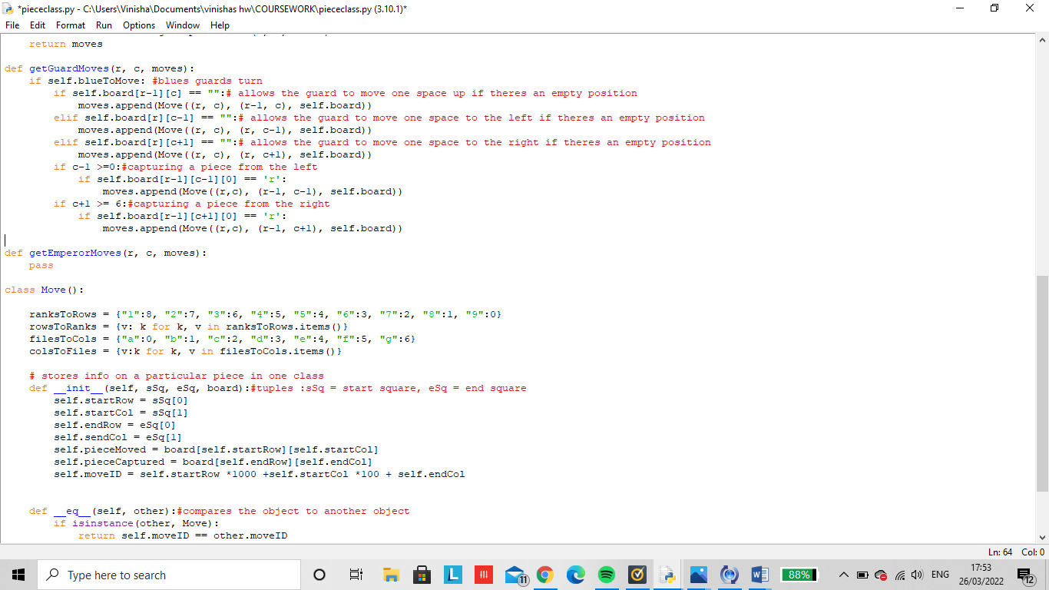

For a players first move, they are only allowed to move a guard. Making blue have the first move, the guard is able to move one space to the left, right, or upwards.

# Capturing a piece:

To test my function I added a red guard in my initial board layout, in position (5,6)

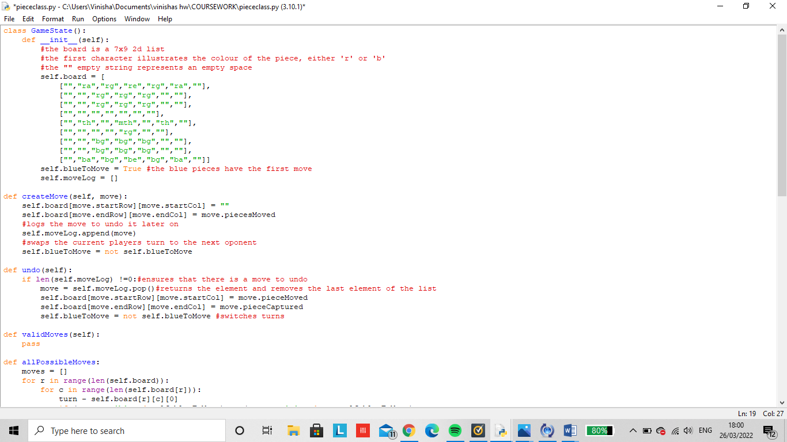

# 

This piece of code allows the red guard to be captured by the blue guard from either side .As the legal moves haven’t been made yet, the guard is also able to capture diagonally.

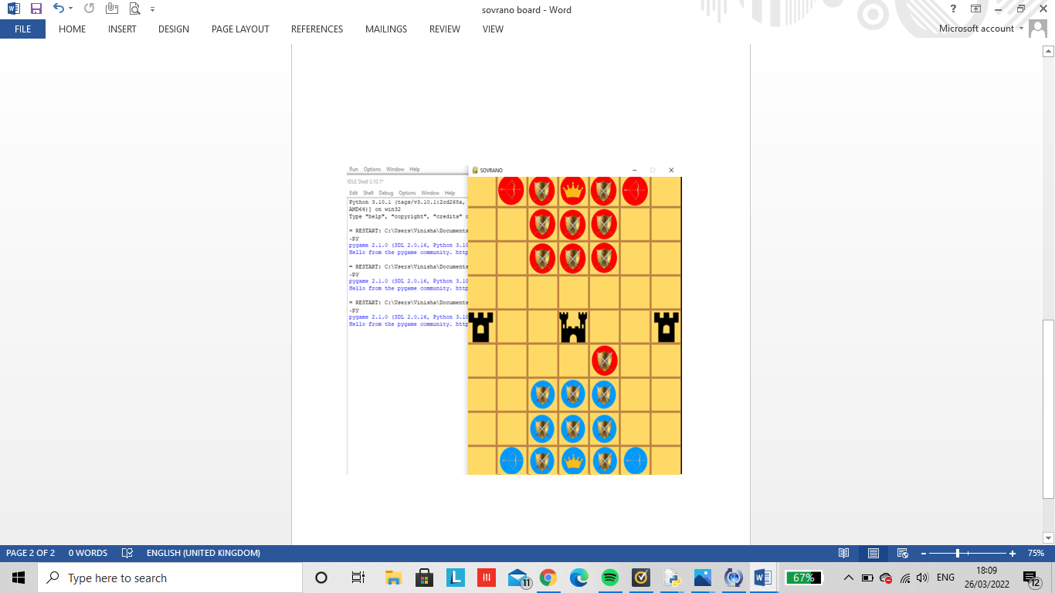

# 

As the blue guard has captured the red guard, the blue guard has taken its new position and the red guard is removed of the board.

What is being tested?

When executed I wanted to check if a guard is able to capture a piece upwards, downwards, on the left or to the right. I had to also make sure that the archer is able to capture a piece in the same way as the guard but also capture from up to two spaces diagonal. Then the emperor has to be able to capture a piece upwards, downwards, left, right or one space diagonally.

After capturing I had to ensure that the oppositions piece that has been taken is removed off the board completely to destroy any confusion.

# Valid all possible moves:

An archer can move up, down, left and right as well as capture a piece diagonally from 1 or 2 spaces.

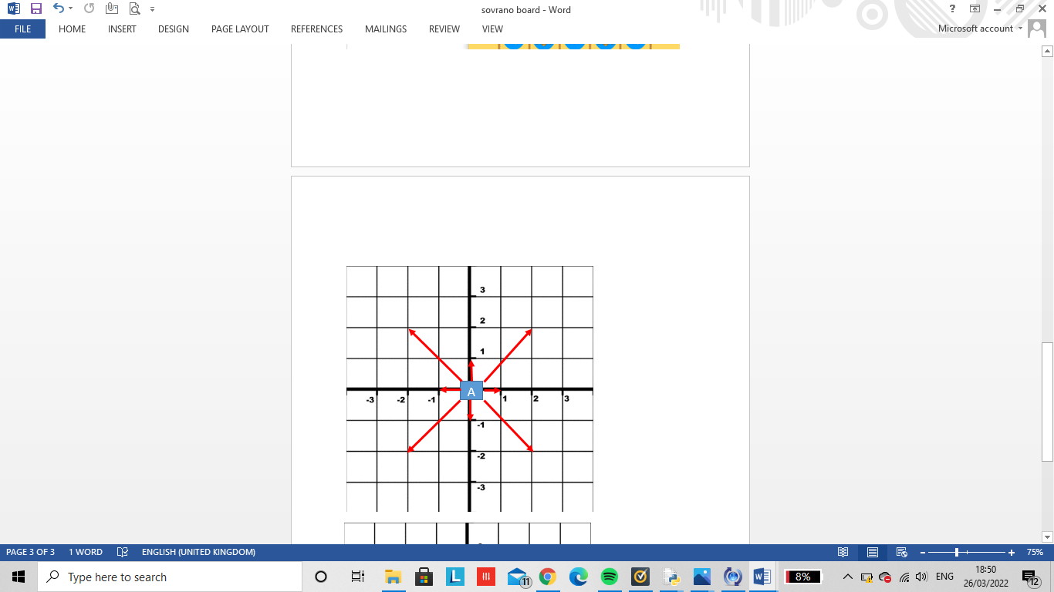

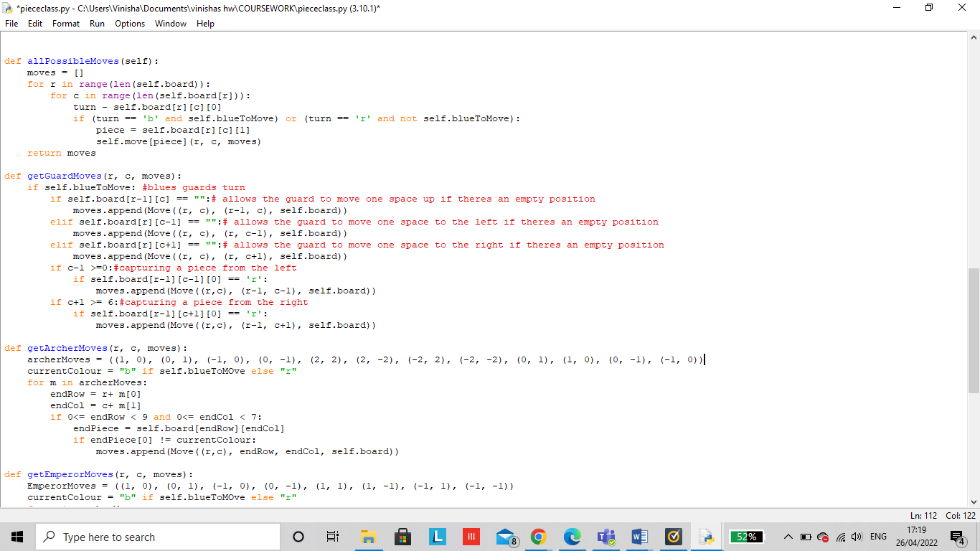

An Emperor can move up, down, left and right and only capture from one space.

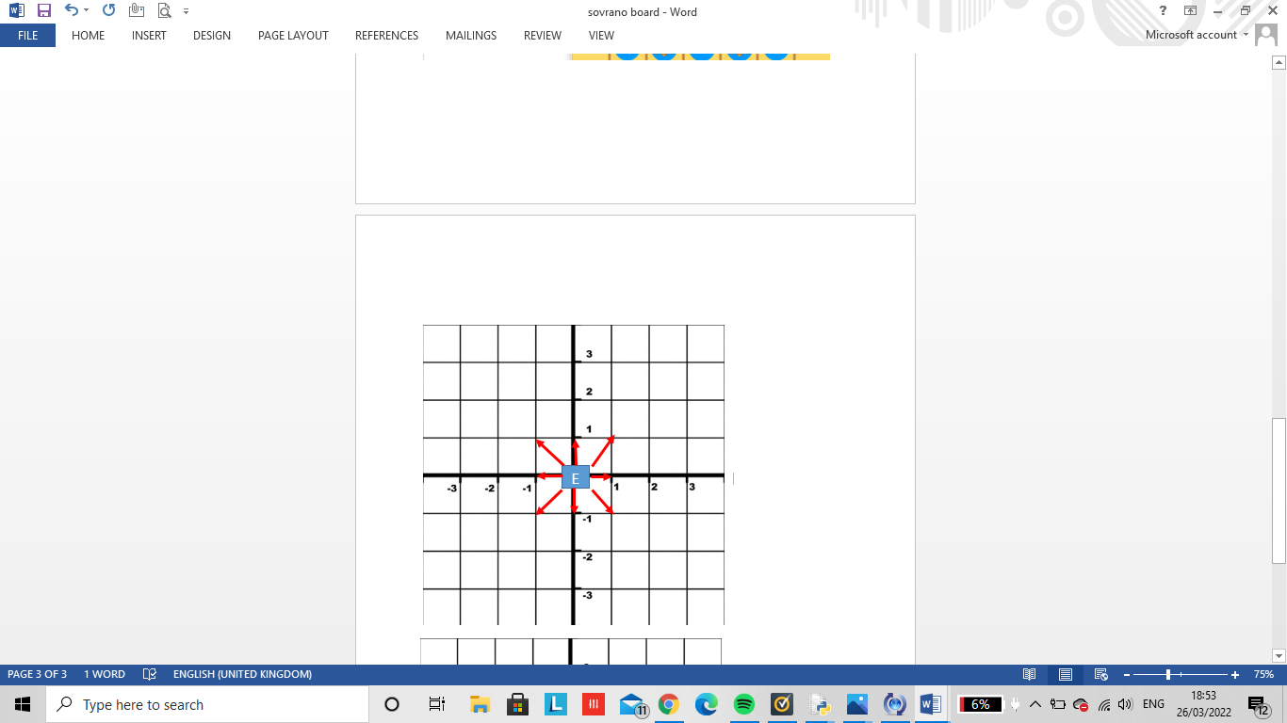

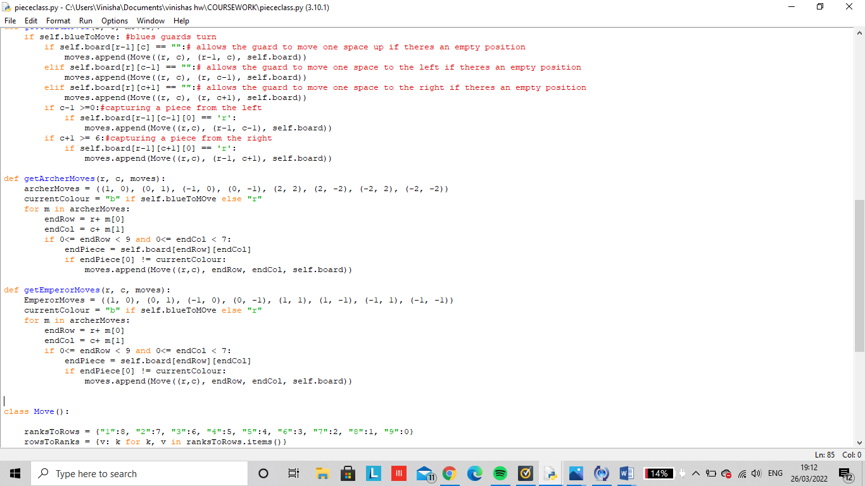

These getter functions will return the valid position the user plays for each piece by placing their selected piece upon the chosen position.

All pieces are able to make valid moves in the correct direction. If a user is trying to make an illegal move, the piece will just stay in its position. In addition if the user plays a piece into a sqaure that’s already occupied by another piece, the users piece will also stay in its own position until a valid move is made/ timer runs out.

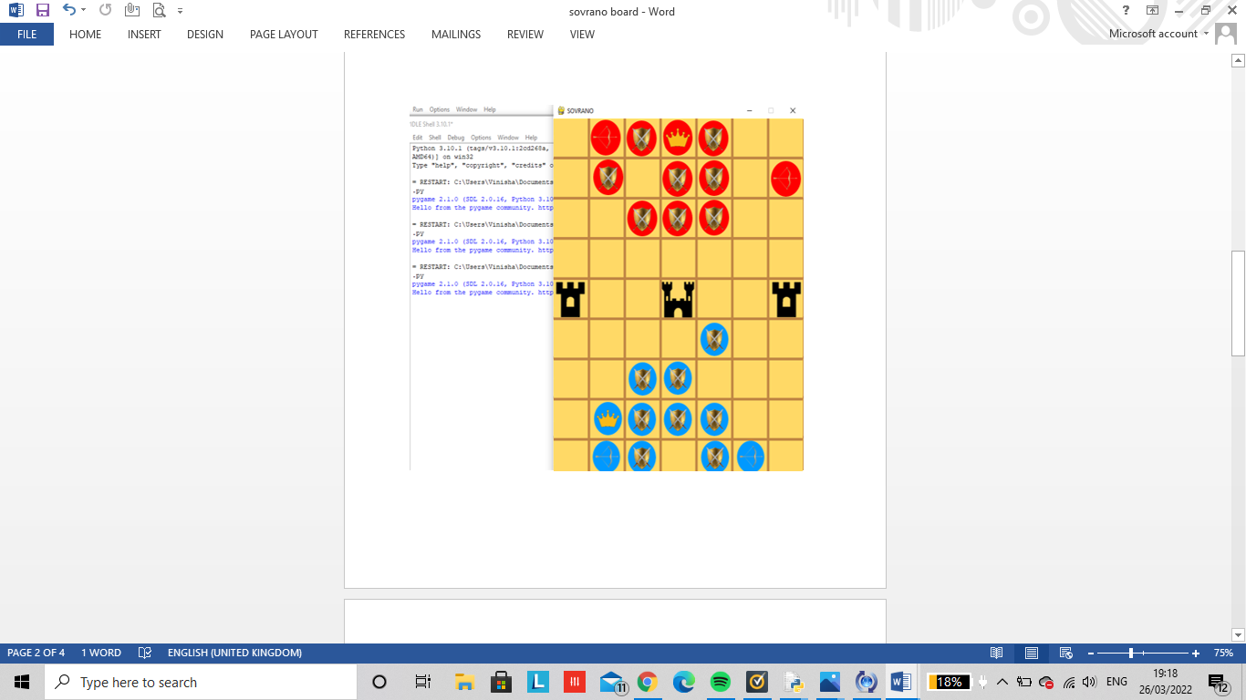

# 

# 

# A capture or draw:

A capture occurs when an emperor is attacked by the enemy’s pieces. This means that it is impossible for the current player to attack the enemy’s opponents, block the capture or more the emperor to safety.

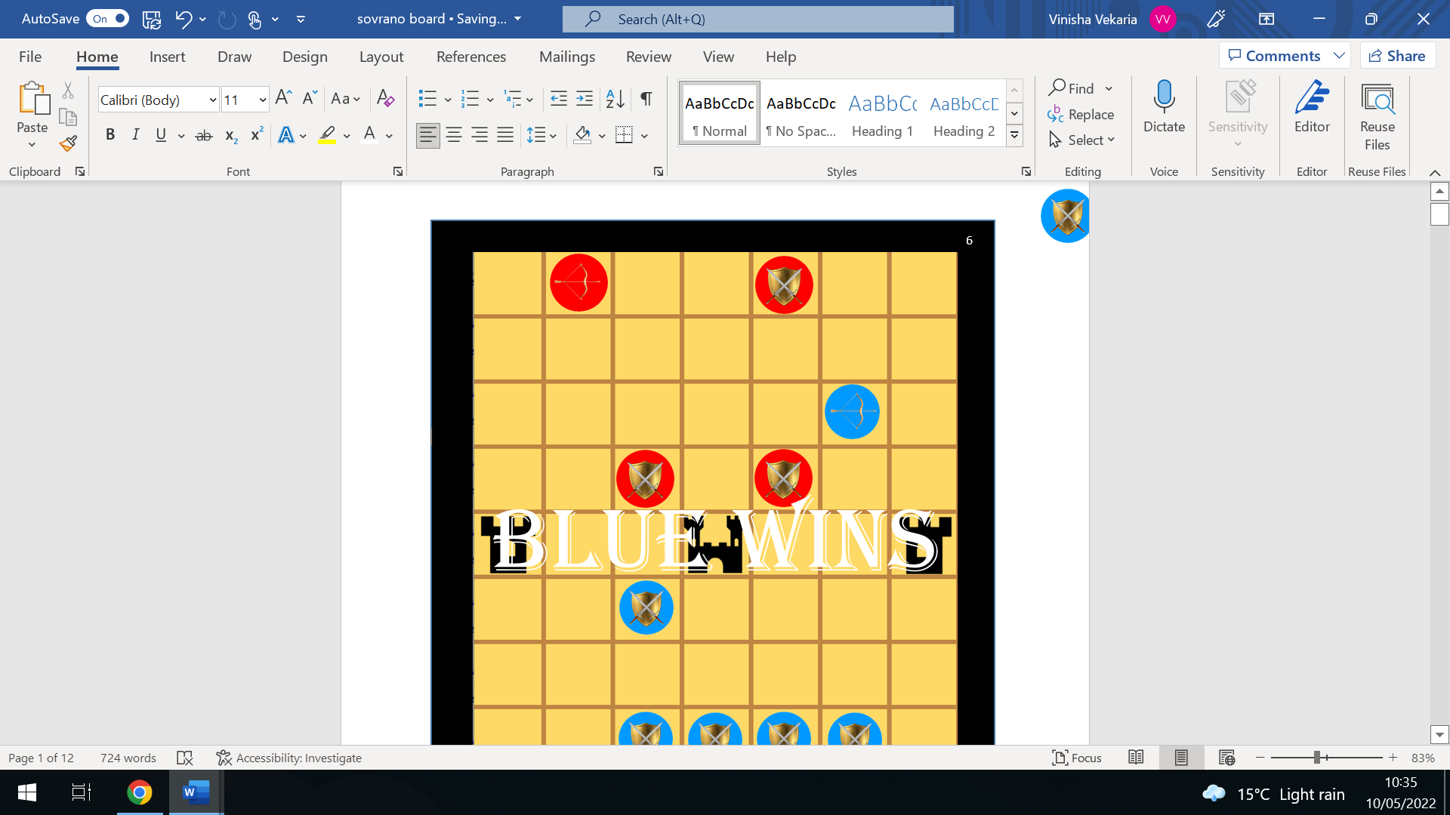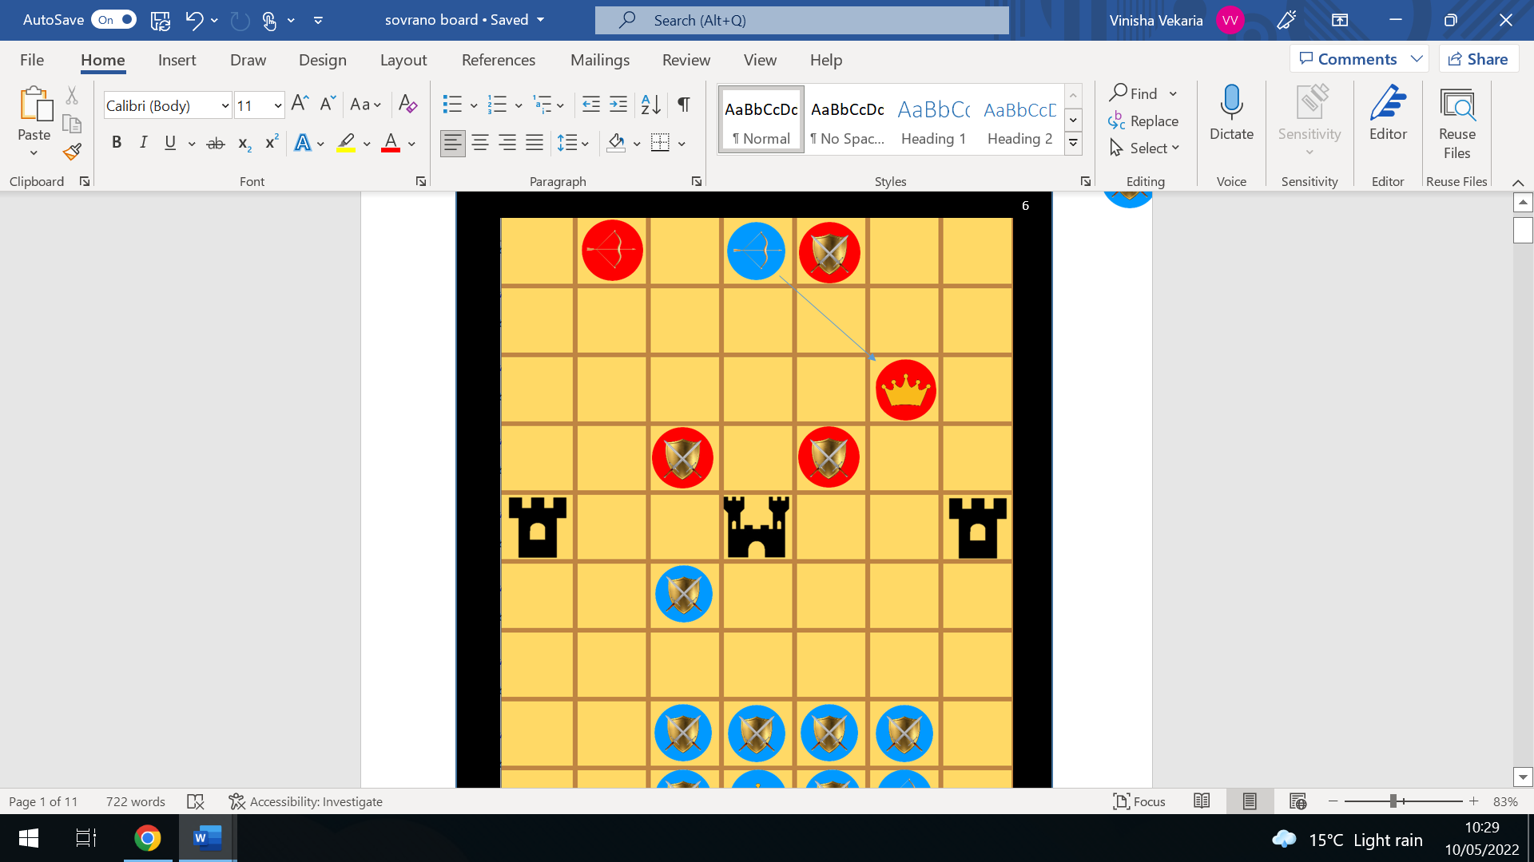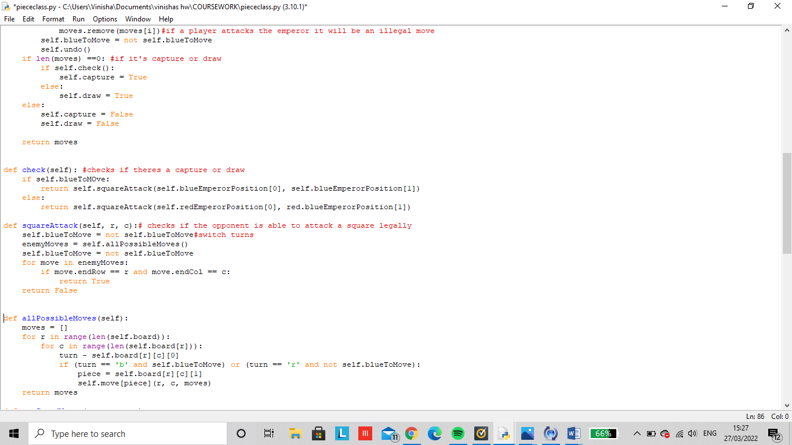A draw occurs when the emperor is not attacked, however no pieces including the emperor are able to move anywhere.

# 

What is being tested?

The code above is testing that if the oppositions emperor gets captured, the game will end up in a loss as that is one of the main winning objectives. Similarly, the game checks for a draw which occurs when the game is ending up in a stalemate and neither player can do more to win.

In blues turn, the archer can capture the the emperor from 2 spaces diagonally leading to a loss for blue.

# Using colour to generate possible moves:

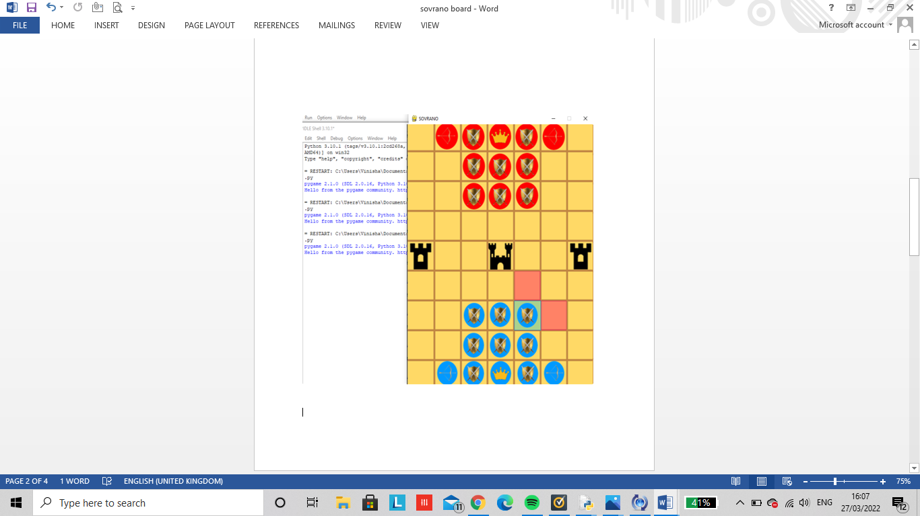

Once a player has selected a piece they want to move, the square background will turn a transparent green colour.

When a piece has be selected, the pink transparent square shows the possible moves the player can place the piece.

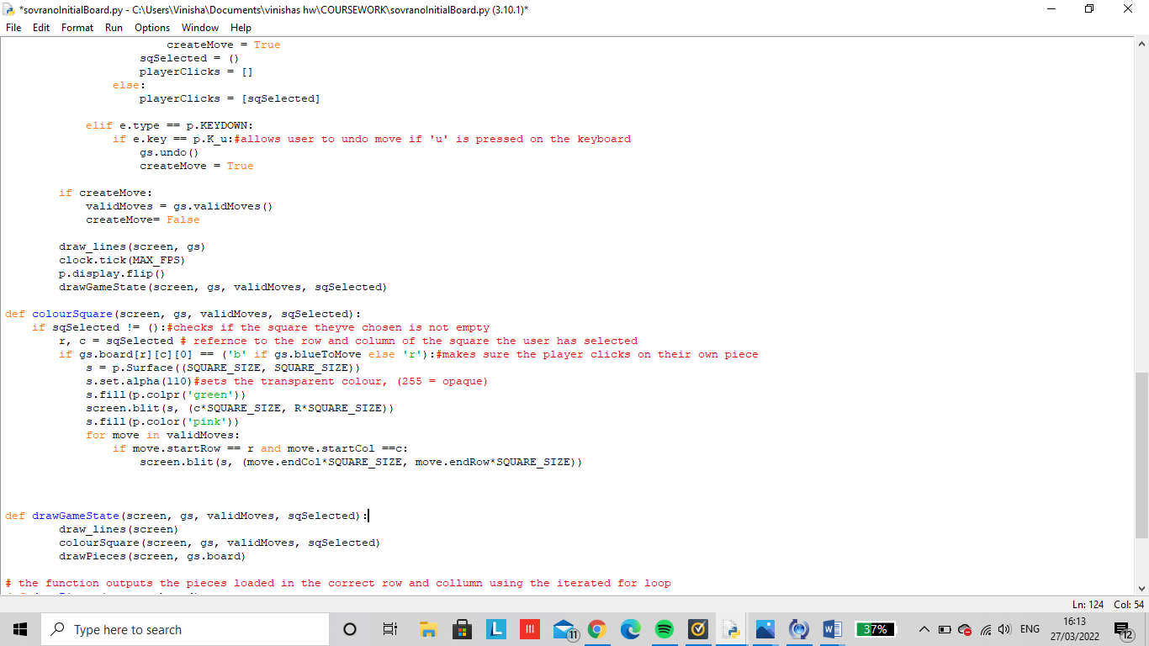

What is being tested?

If the computer is able to generate each possible move for a piece when selected by a user. The computer should bale to highlight the square where a valid move can be made.

# RESET AND EXIT THE GAME:

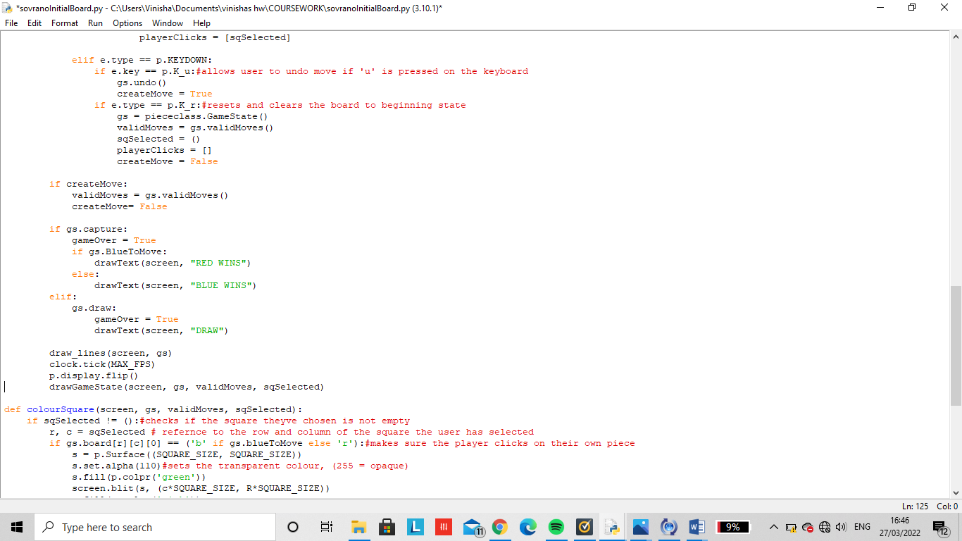

When ‘r’ is pressed on the keyboard, the game is reset and goes back to its original game layout

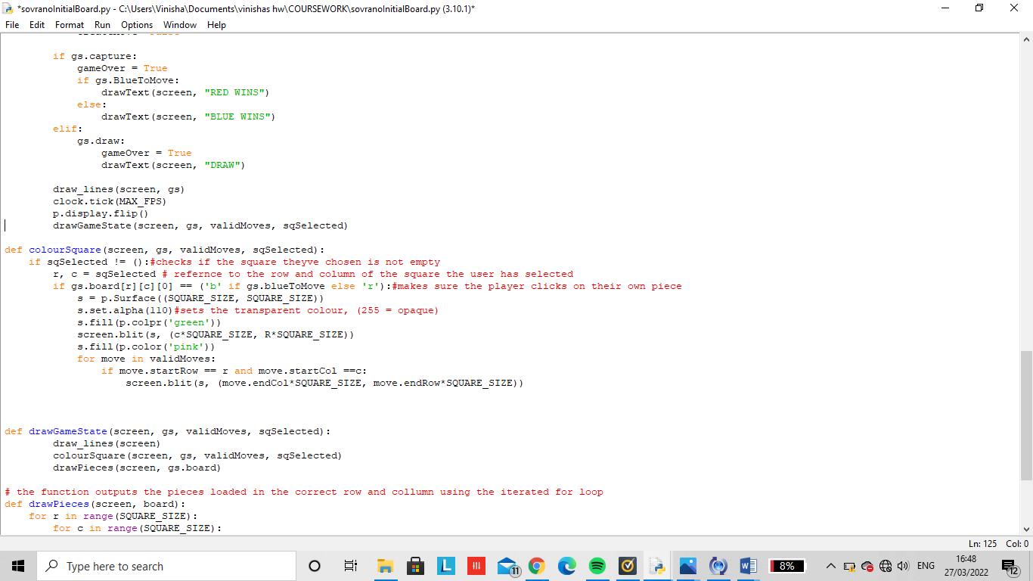

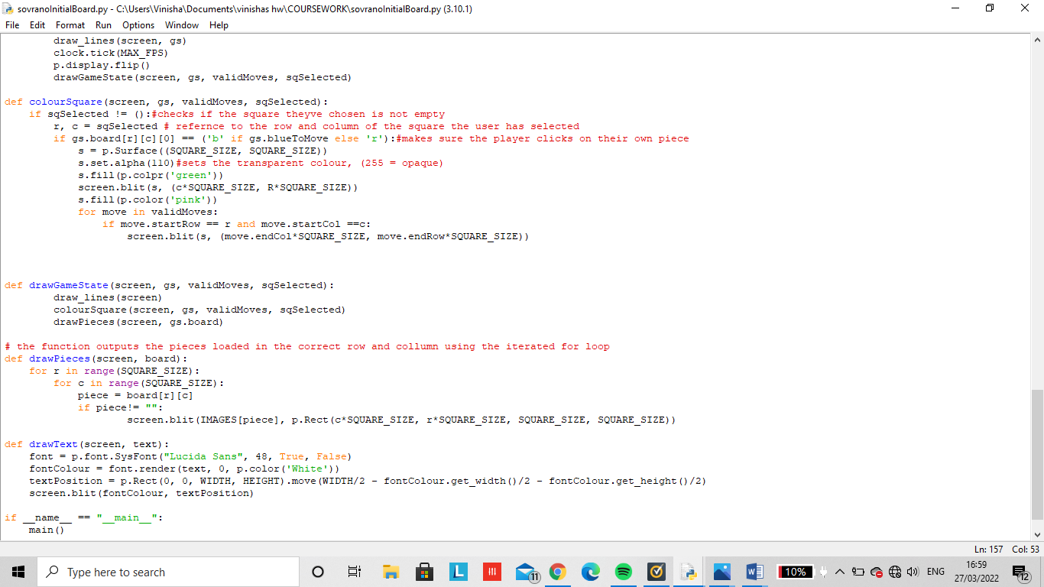

Once there has been a capture or draw, the game will end in either a win, loss or draw.

In a draw, there are no available spaces to move so no one will win. However this also can only occur if both players have collected the same amount of gems.

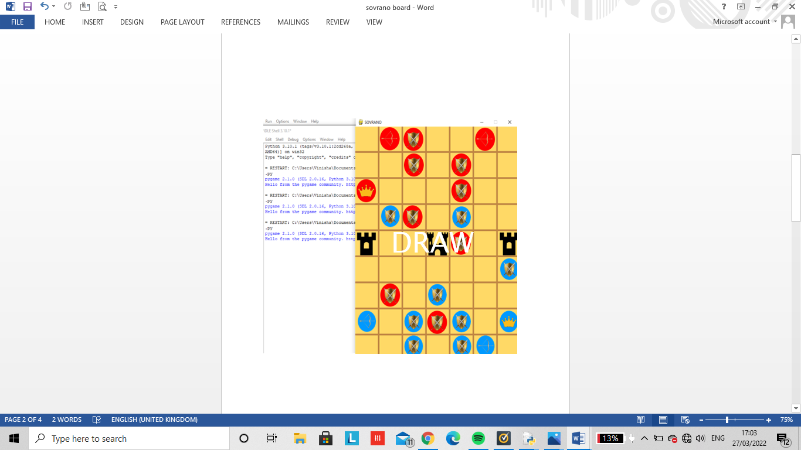

When there’s a capture, there will either be a win or loss .This is one way this can occur, another way would be by getting to the middle throne or collecting the most gems.

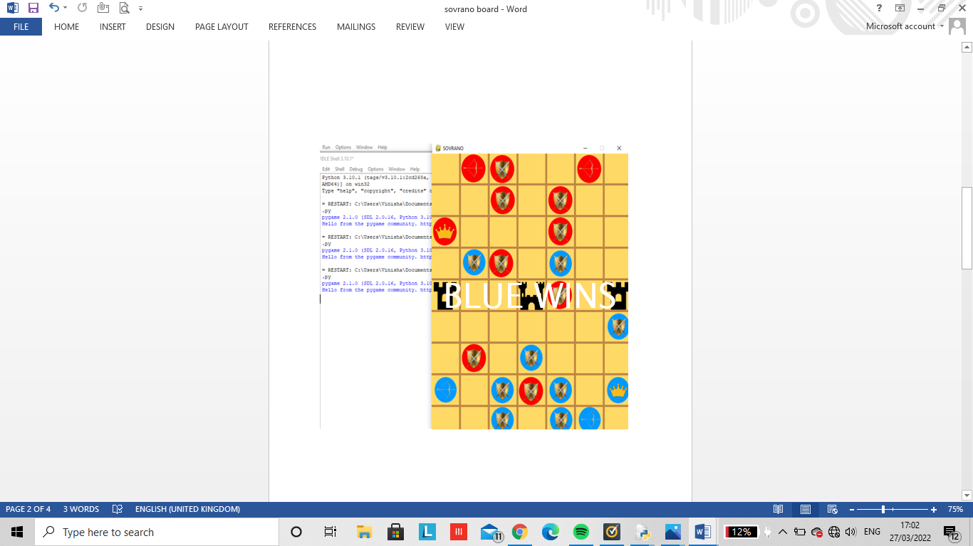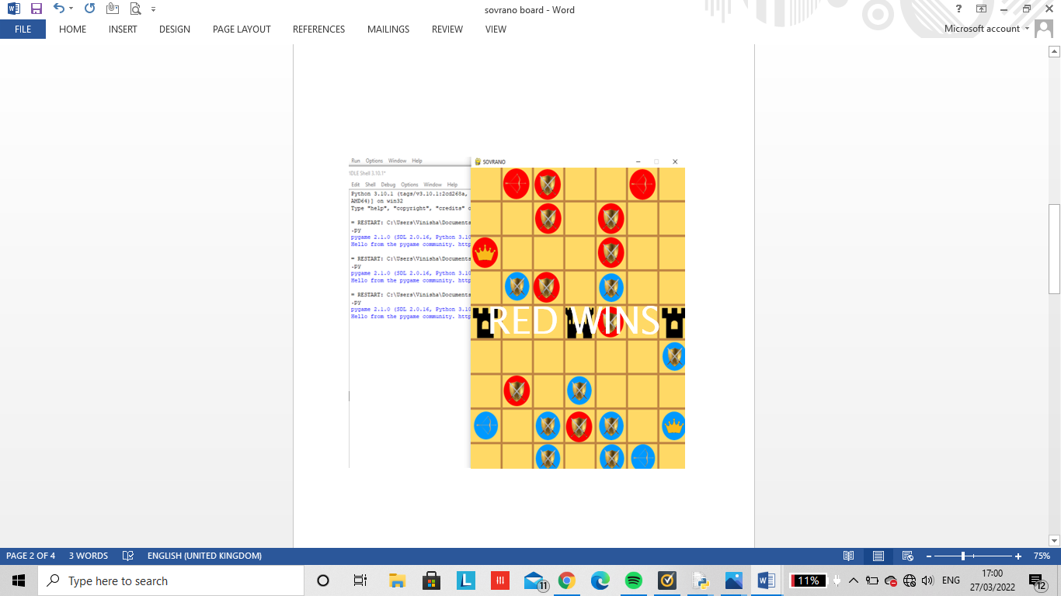

# ARTIFICIAL INTELLIGENCE:

AI is used in sovrano to generate the best possible moves against a human user. However, this would be impossible to implement due to the endless possibilities of considering what the user’s next move could be as well as the time complexity this would take to code. Alternatively, AI can still be implemented within my project through generating the next best possible move for the next 3 plays. Similarly, I will also create an easy level where the computer can create a legal move using the ‘import random’ module.

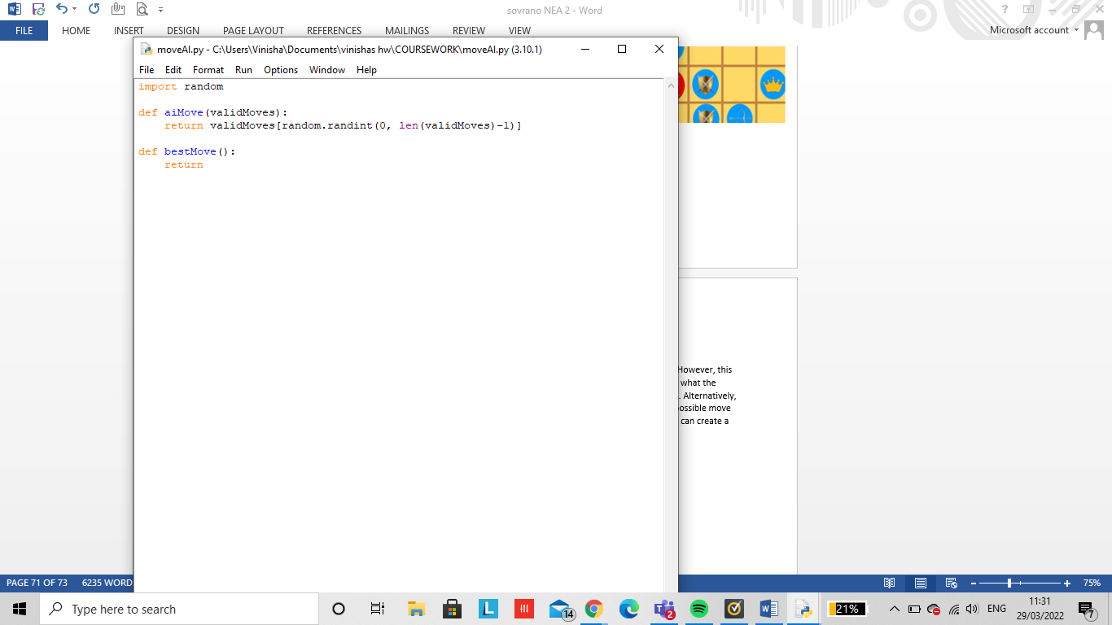

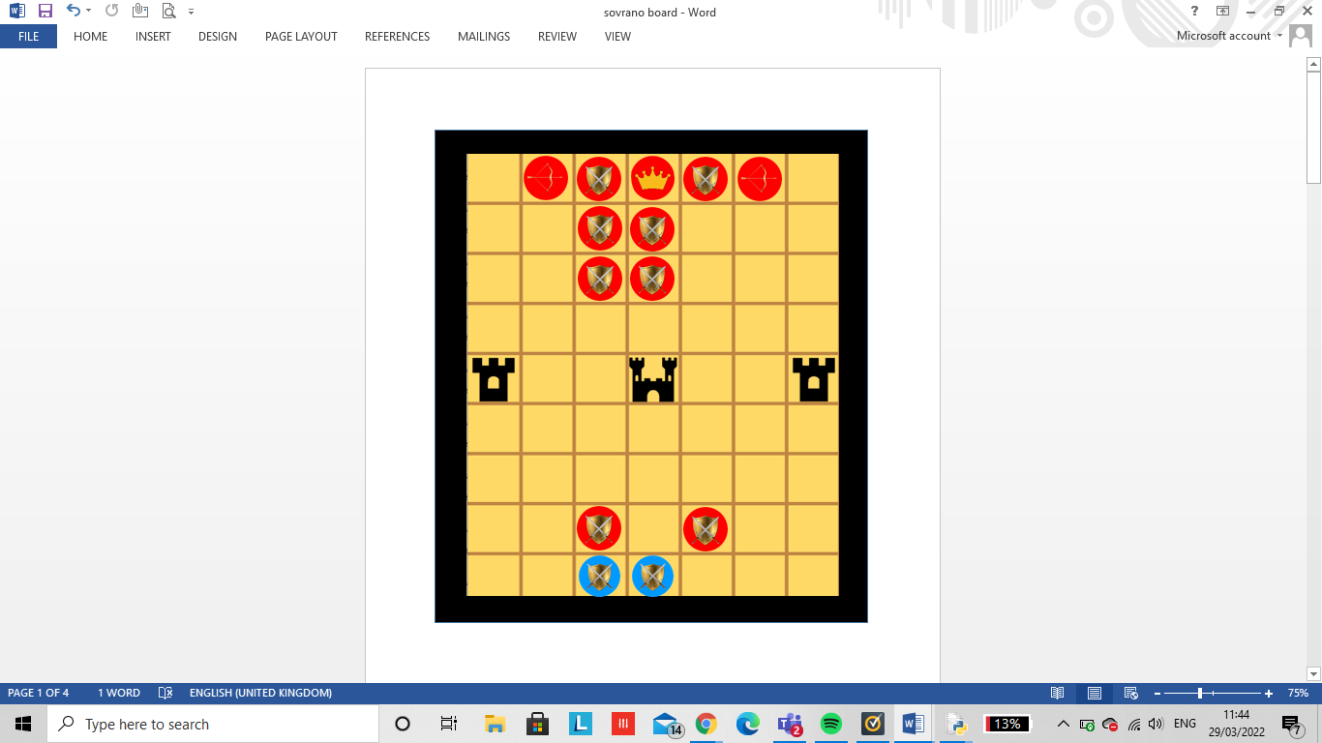Example:

4

3

2

1

If this was the current board play and it is blues turn (human), they’ll have 3 possible moves. If the user plays optimally they would have 2 possible moves and chose to move piece 1 to the left. However, if they choose not to play optimally they’ll move piece 2 either up or to the right. This would lead to the red player (AI/ computer) to capture the piece.

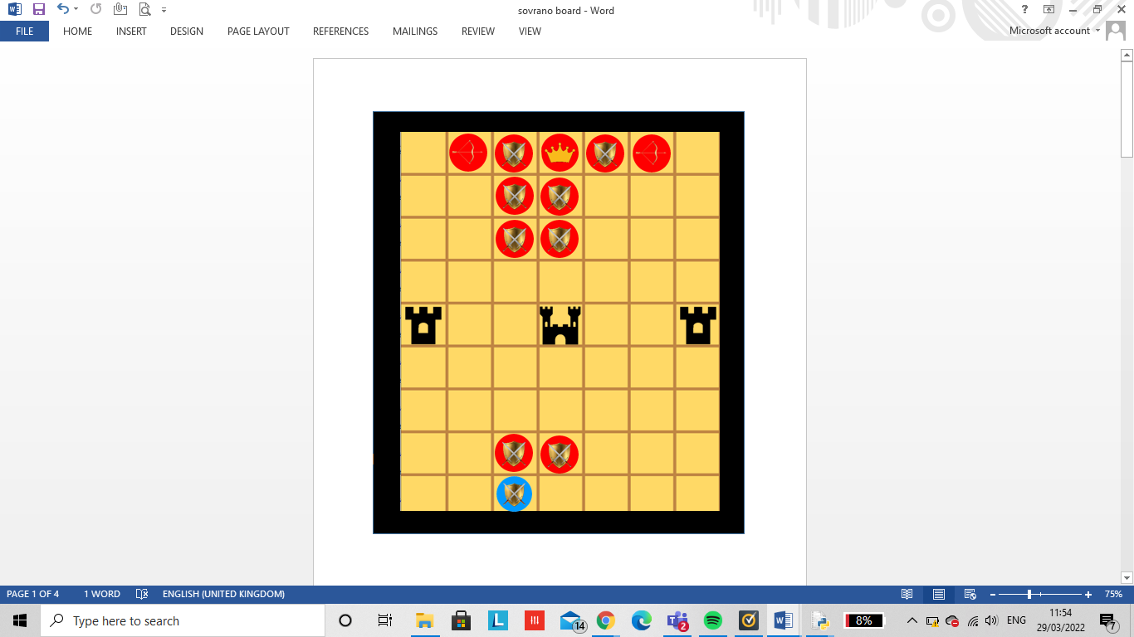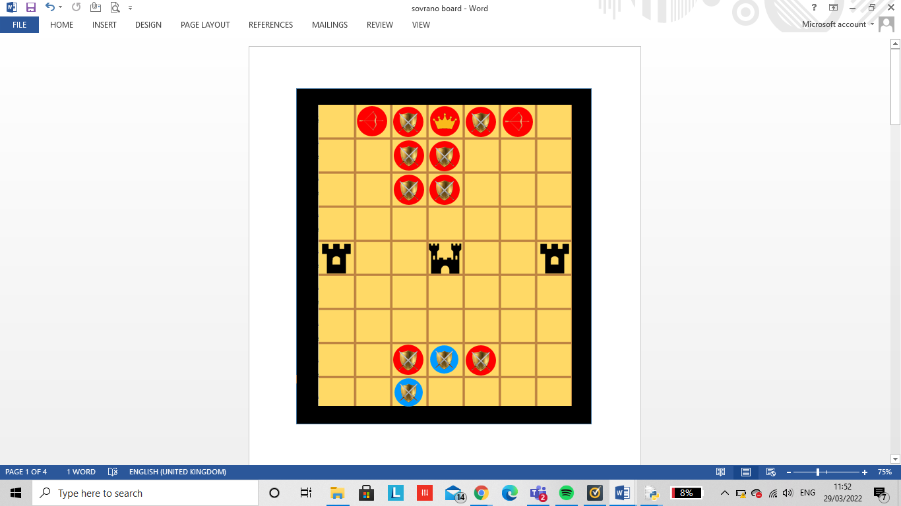

Using the greedy algorithm, I created an algorithm where the AI thinks only one move ahead. By creating a point score table, the AI will be able to capture the piece that is worth the most points in its legal move and will always take the opponent if they have the opportunity to.

Point system:

|  |  |
| --- | --- |
| **Winning objectives:** | **Points** |
| Seize Emperor | 10 |
| Seize Archer | 5 |
| Seize Guard | 1 |
| Get to Throne | 3 |
| Get to Middle Throne | 15 |
| Capture | 15 |
| Draw | 0 |

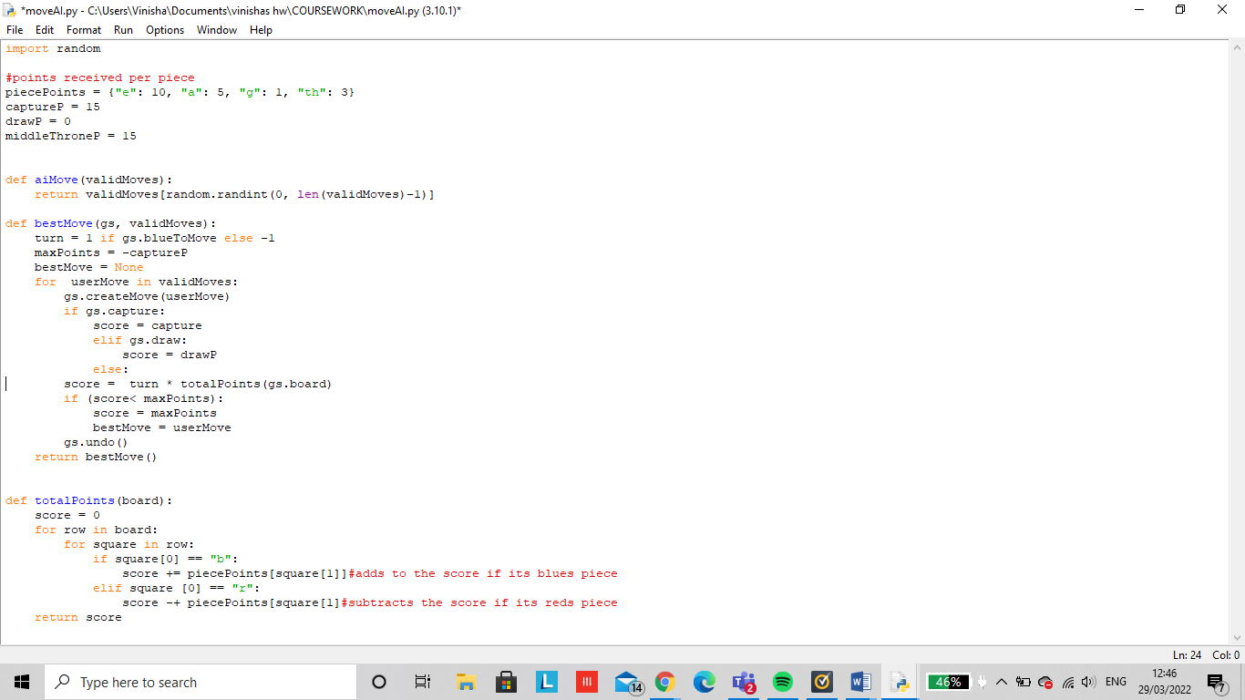

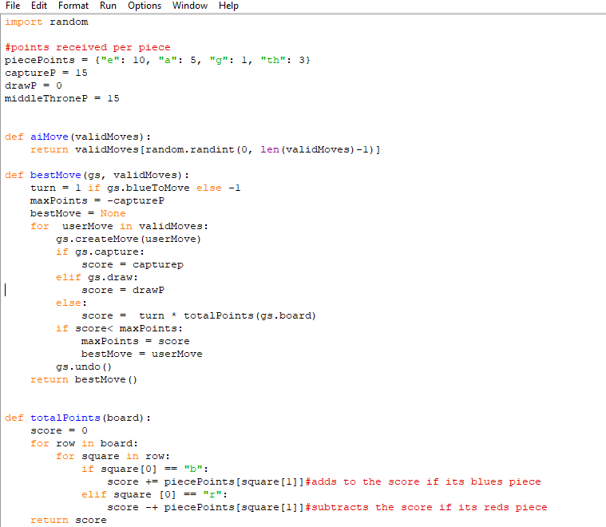Greedy algorithm: (moveAI)

Main function:

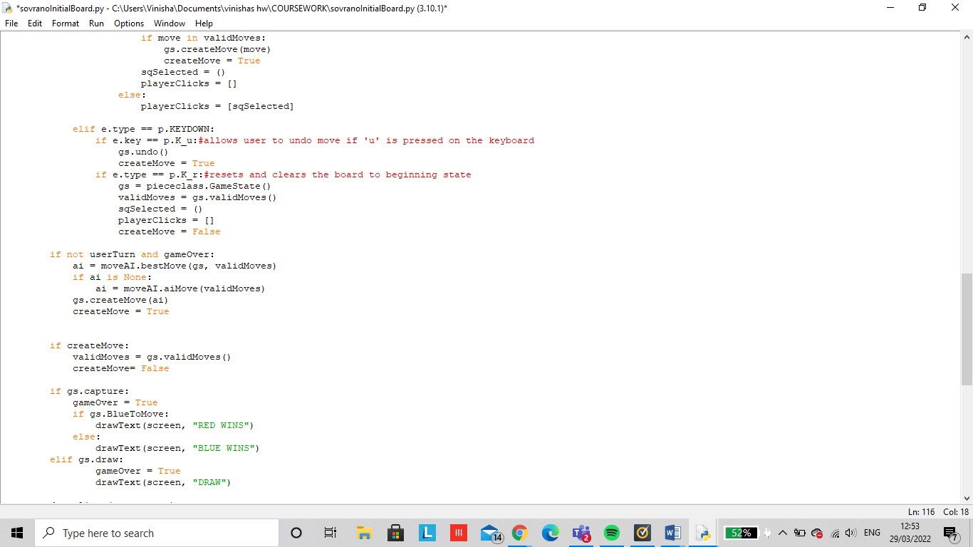

The above code was able to use AI and capture all the pieces that were worth the most points.

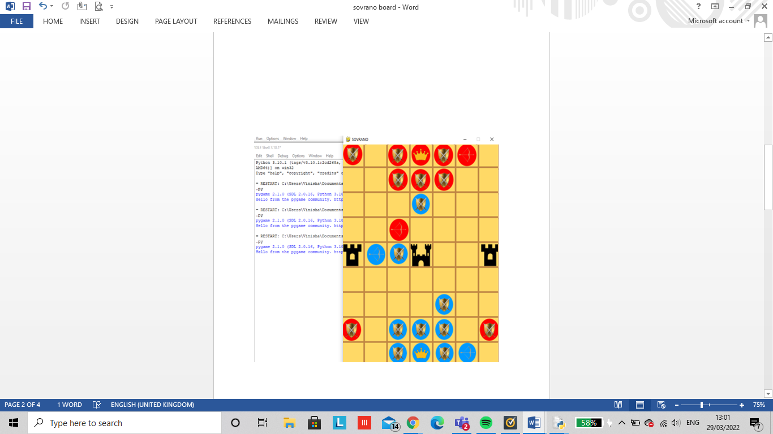

Figure 10 AI thinking one step ahead

Currently it is the AI (reds) turn.

They have a choice between 3 possible moves they can make. The black circles moves show the capture of the guard which is one point and the white circled move shows the optimum play to capture the archer which is worth 5 points.

Using the greedy algorithm, AI would chose to capture the blue archer. The problem with this is that this code only considers the current best move and isn’t able to think of future optimum moves. Therefore once the red archer captures the blue archer, on blues next go, if the user plays optimally, they will capture the red archer on the next play.

# TESTING:

|  |  |  |  |  |
| --- | --- | --- | --- | --- |
| **MAIN MENU OPTIONS** | **TEST DATA** | **ACTION** | **OUTCOME** | **HAS THE CRITERIA BEEN MET** |
| START | VALID | Click on the start button with a mouse and select the start option | The sovrano game board is loaded onto the users screen | YES |
|  | INVALID | Selecting the ‘s’ or ‘1’ button on the keyboard | The sovrano game board wont load | YES |
|  | EXTREME | Clicking on the enter button when the mouse is hovered upon the option | The sovrano game board is loaded onto the users screen | YES |
| LEADERBOARD | VALID | Click on the leader board button with a mouse and select the leader-board option | The leader board is loaded onto the users screen. | NO |
|  | INVALID | Selecting the ‘L’ or ‘2’ button on the keyboard | The leader board screen wont load | NO |
|  | EXTREME | Clicking on the enter button when the mouse is hovered upon the option | The leader board is loaded onto the users screen. | NO |
| INSTRUCTIONS | VALID | Click on the instructions button with a mouse | The instructions will load onto the users screen | YES |
|  | INVALID | Selecting the ‘L’ or ‘3’ button on the keyboard | The instructions wont load on the users screen | YES |
|  | EXTREME | Clicking on the enter button when the mouse is hovered upon the option | The instructions will load onto the users screen. | YES |
| QUIT | VALID | Click on the quit button with users mouse | The game will exit and leave the sovrano game screen | YES |
|  | INVALID | Selecting the ‘Q’ or ‘4’ button on the keyboard | The game screen will still appear to the users as the user wont be able to quit | YES |
|  | EXTREME | Selecting the ‘ESC’ button or clicking the ‘X’ button in the top right to exit a tab. | The game will exit and leave the sovrano game screen | YES |

|  |  |  |  |  |
| --- | --- | --- | --- | --- |
| **USER MOVEMENTS** | **TEST DATA** | **ACTION** | **OUTCOME** | **HAS THE CRITERIA BEEN MET** |
| SELECTING A PIECE | VALID | Click on the piece you want to move by using the mouse | The piece selected will be highlighted when clicked on. | YES |
|  | INVALID | Using arrows or ‘a’,’d’,’s’,’w’ keys on the laptop to get to the piece you want to move | The piece will not be selected/ get highlighted. | YES |
|  | EXTREME | - | - | - |
| MOVING A PIECE | VALID | Click on the square you want to move the piece to but the box has to be highlighted to show that it’s a valid move. | The piece selected will move into the position inputted by the mouse | YES |
|  | INVALID | Drag a piece into the position you want it to go or use the arrows or ‘a’,’d’,’s’,’w’ keys | The piece selected will not be able to move in its given position so will stay in its original position. | YES |
|  | EXTREME | - | - | - |
| CAPTURING A PIECE | VALID | Selecting the square with the oppositions piece already on there. | The piece will be removed off the bored and removed of the list. | YES |
|  | INVALID | Clicking on the piece you want to capture. | The opponents piece will not be removed off the bored. | YES |
|  | EXTREME | - | - | - |
| PAUSING GAME | VALID | Click on the PAUSE button on the game menu option | The current playing game will be paused until they press resume again | NO |
|  | INVALID | Pressing the space bar to stop the running game temporarily | The game will not pause. | NO |
|  | EXTREME | Selecting the ‘p’ button on the keyboard | Selecting the ‘p’ button on the keyboard | NO |
| RESUME GAME | VALID | Click on the RESUME button on the game menu option | After being paused, the game will continue to play from its previous game state. | NO |
|  | INVALID | Pressing the spacebar to resume play. | The game will not be unpaused/ resumed. | NO |
|  | EXTREME | Selecting the ‘r’ button on the keyboard. | After being paused, the game will continue to play from its previous game state. However ‘r’ is also stored as reset so it may reset the bored instead. | NO |

As part of my user interface, the main menu has been tested for valid, invalid and extreme inputs. I have been able to meet the requirement of implementing the valid and extreme methods into my coded solution for the start, instructions and quit options. However, the requirement has not been met for the leader-board option as I was unable to implement SQL language due to timing issues.

If I had been given more time, I would’ve created another menu called the game menu which consists of pause/ resume/ quit. This will allow a more simple control for the users to navigate around the game instead of having to remember keyboard letters to commit to these tasks. This would lead to confusion and more difficulty to adjust to the game if you’re a beginner.

Testing my overall efficiency of my final code solution:

In the start the user is introduced with the main menu screen providing the options of start, leader-board, instructions and quit. Along with this screen the user in able to input a valid username ensuring it meets all the requirements to move along to the next stage. Once the start button has been selected the sovrano game board is loaded onto the screen with the pieces already in its given position. The user will always be the first to move a piece which is the followed by the AI computer as shown by the screenshot below. Red is unable to start off first.

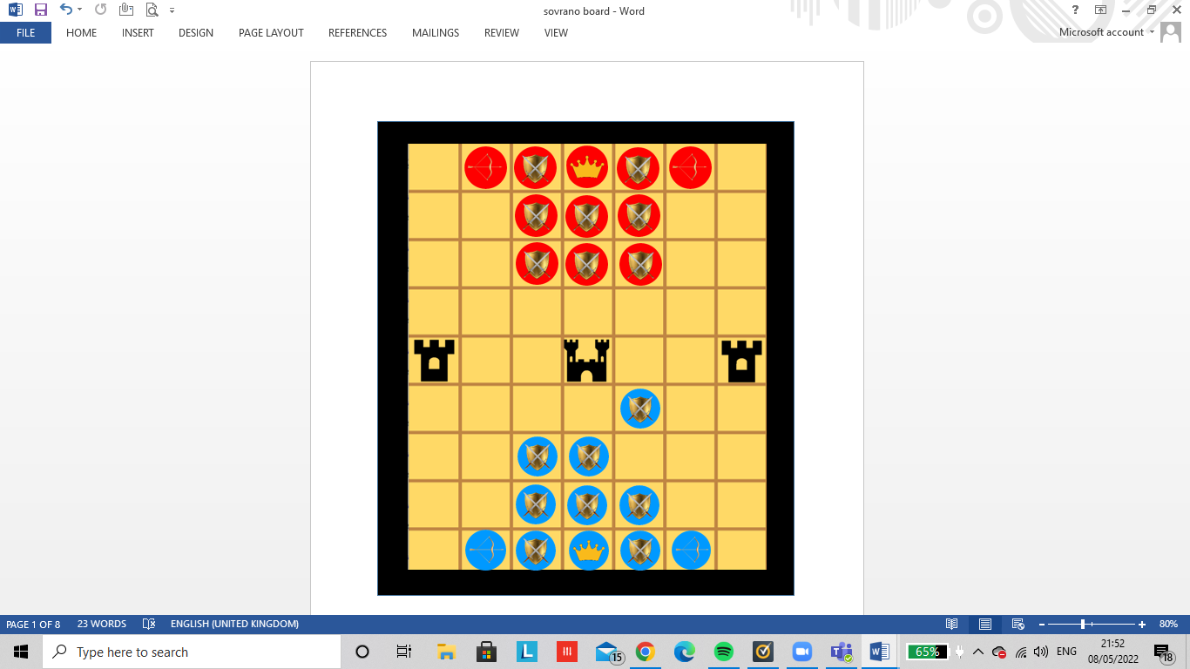

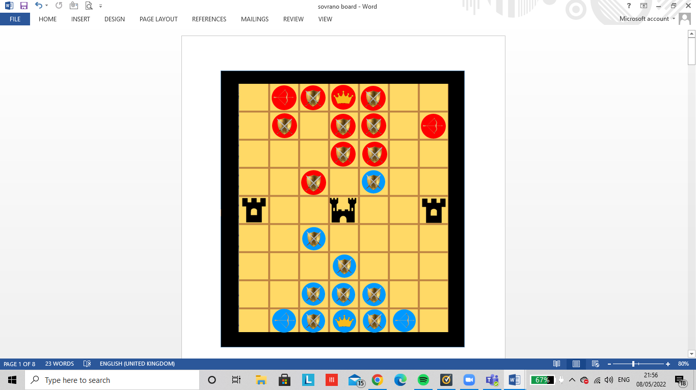In the 5th play its reds turn to move a piece. Due to the greedy algorithm, the AI will acknowledge that a guard is worth 1 point so will capture the piece straight away in its next turn and take blues place.

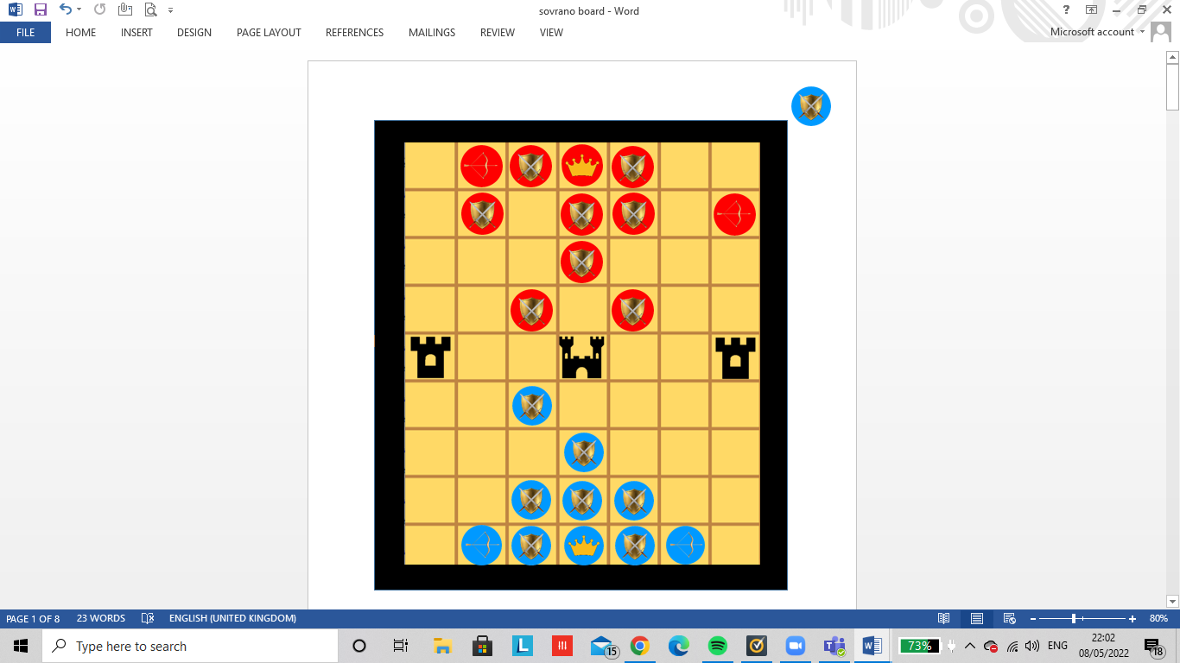

---------→

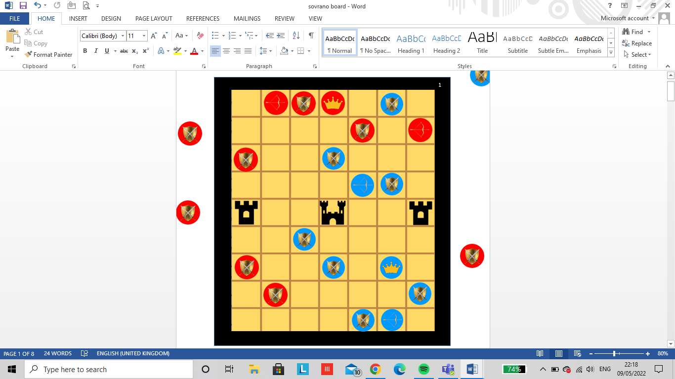

It is reds go and has the option to either capture the blue guard or the blue archer. As the blue archer is worth the most, the AI captures the blue archer diagonally from 2 spots. This suggests that the AI is able to recognise when to capture the pieces worth the most points.

# EVALUATION:

Has my success criteria been met?

* **For the user interface:**

|  |  |
| --- | --- |
| **Success criteria** | **Has it been met?** |
| Main menu | **YES-** the main menu is able to first load onto the players screen with the options to start, quit, leaderboard, instructions and the user is able to enter their game play name. |
| Clear user interface | **YES-** The game works and does what the player thinks it will do. The user is also able to easily navigate around the game. |
| Instructions | **YES -** A screen appears for the player to help them gain a clear understanding on how the game works as well as the sovrano rules so the player is able to acknowledge when making an invalid move. |
| Leaderboard | **NO-** due to time complexity I was unable to add the players current scores into a leaderboard and allow them to compete against other players. |
| Start | **YES -**Once clicked, The initial sovrano board is loaded onto the players screen with the pieces put into position. |
| Quit | **YES-** The quit button closes the running application. |
| Easy to use game controls | **YES-** Keyboard buttons are used to undo a move, navigate through main menu options or move a piece left, right, up or down. The mouse is also applicable to navigate through the main menu and to allow a player to select a piece that they want to move. |
| Win / loss/ draw | **YES-** A clear message is outputted when the player wins, loses or draws against the opposition. |

For my user interface the only requirement that hasn’t been met is to add a leaderboard onto my main menu. This isn’t an important thing to add into my project as it wouldn’t stop my game from working, however it would’ve been a good addition too have. In my interview 60% of the people I interviewed stated that they would compete to be on the leaderboard meaning that it could’ve added a competitive aspect into my game to encourage more players to play against eachother. Apart from this slight issue, I was able to accomplish a clear user interface as well being able to implement simple hardware controls to make sure the users are easily able to navigate through sovrano.

* **For the game logic:**

|  |  |
| --- | --- |
| **Success criteria** | **Has it been met?** |
| Functional Artificial Intelligence | **PARTIALLY MET-**The AI is able to make a move against the player as well as being able to capture a piece leading to the best outcome to gain the most points. However, in some cases the AI doesn’t make the best move by being able to think one step ahead. |
| Pieces meet its game rule | **YES-** Each piece has been assigned its own rules on how they are able to move and is able to make a valid move to capture an opponent’s pieces. |
| Player is able to select a piece | **YES-** The player is able to click on the piece they want to move. |
| Player is able to move their piece | **YES-** when a player has selected their piece they are able to click on the square for where they want to place their piece. |
| Pieces are able to be removed off the board | **YES-** When the opposition captures a piece, the piece is removed off the game board to increase the total score. |
| The game can result in a capture | **YES-** A capture occurs when an emperor is attacked by the opposition’s pieces. This means that it is impossible for the current player to attack the enemy’s opponents, block the capture or more the emperor to safety. |
| The game can result in a draw | **YES-** A draw occurs when the emperor is not attacked, however no pieces including the emperor are able to move anywhere. |
| Win | **YES-** The win screen appears if the opposition’s emperor is captured, if a players’ emperor has reached the middle throne or if a players has gained the most points. |

For the game logic most of my success criteria has been met I order to achieve a functional artificial intelligence as well as being able to move pieces around the board in an easy manner. The issue I come across is that my AI is unable to think more than one step ahead so the game is quite easy to play against. However, this may be more fun to play for a beginner who doesn’t quite understand the rules and is just getting to know the game. This can be further developed as shown towards the end of my evaluation.

# Unmet criteria and how it can be fixed:

* I was unable to add background music/ songs whilst the user is playing the game. In addition this could’ve been implemented when a win/ loss/ draw has occurred by using a drumroll/ cheering/ booing sound effects. This would've added extra entertainment and excitability engaging the users to play more. This was not met due to me prioritising other factors such as creating a colourful and more engaging board to attract the users instead.

This could be fixed in further development through downloading the music I want, then importing the mixer module to play the music in pygame. Using the music.load function, the music will load where the music file is passed as a parameter.

* As part of my schools learning aspects I was able to learn how to write and interpret basic SQL language. I was going to implement this for my leader-board to allow users to compete for points against eachother. However, once doing my research I found it quite complex to create a leader-board table in the way I wanted it. Continuing this wouldve wasted my time where my time could’ve been used in other parts of my project. Statistically 4/10 stakeholders stated that including a leaderboard may not be that much of an important aspect.

Using PHP MySQL, I will name my entity leaderboard. The attributes (fields) would be: position, username and score. The username will be the primary key which is a unique identifier for each record in a table. The data type for username will be string, whereas the data type for position and score will be an integer. The file will need to be saved inside my xampp server in the htdocs directory, to open the file I will have to use phpMyAdmin or MySQL.

* In the design stage I described how all gems collected by a player will be displayed at the top of the screen as shown below:

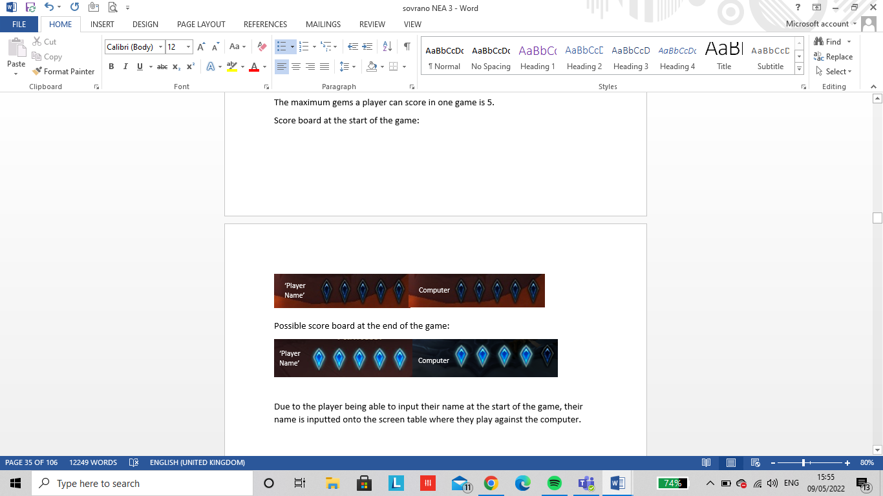

Although this wouldve made it easier for the user to see how many gems they’ve calculated in a round, this may have added some confusion as the user can also earn points from capturing pieces, ending up in a capture or a draw. So instead the total points scored is outputed on the top right of the screen which is the score that shouldve been loaded onto the leaderboard.

* Including a timer- in the questionnaire I stated how there would be a timer. I was unaware of the difficulty it would be to give the users a choice of how long each play should last then to easily implement this into the game.

# Usability features:

* Visibility of the system status- The system will keep users informed on what is occurring during the game through giving appropriate feedback within a reasonable time. For instance in sovrano when you or the opponent captures a piece, the score board will increment to inform the user a piece has been removed of the board.

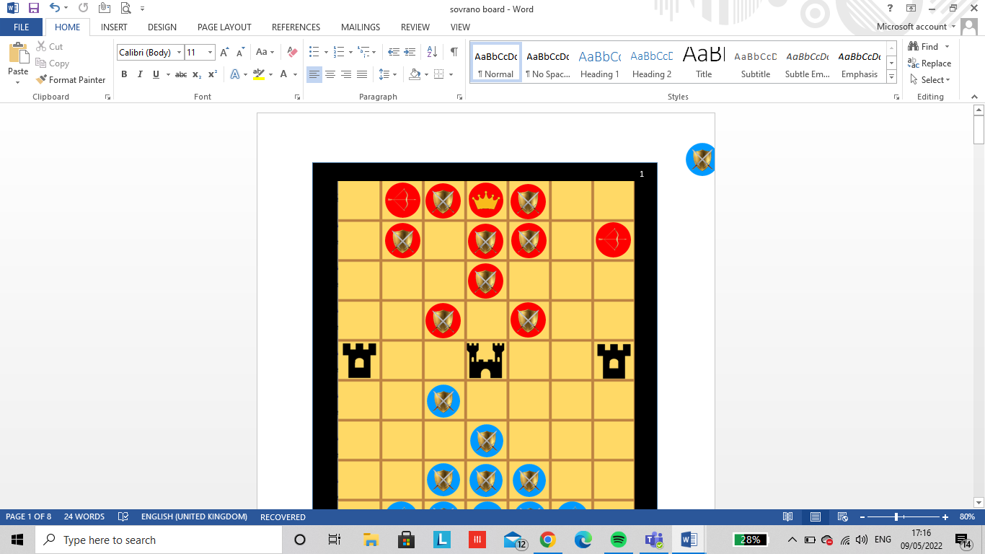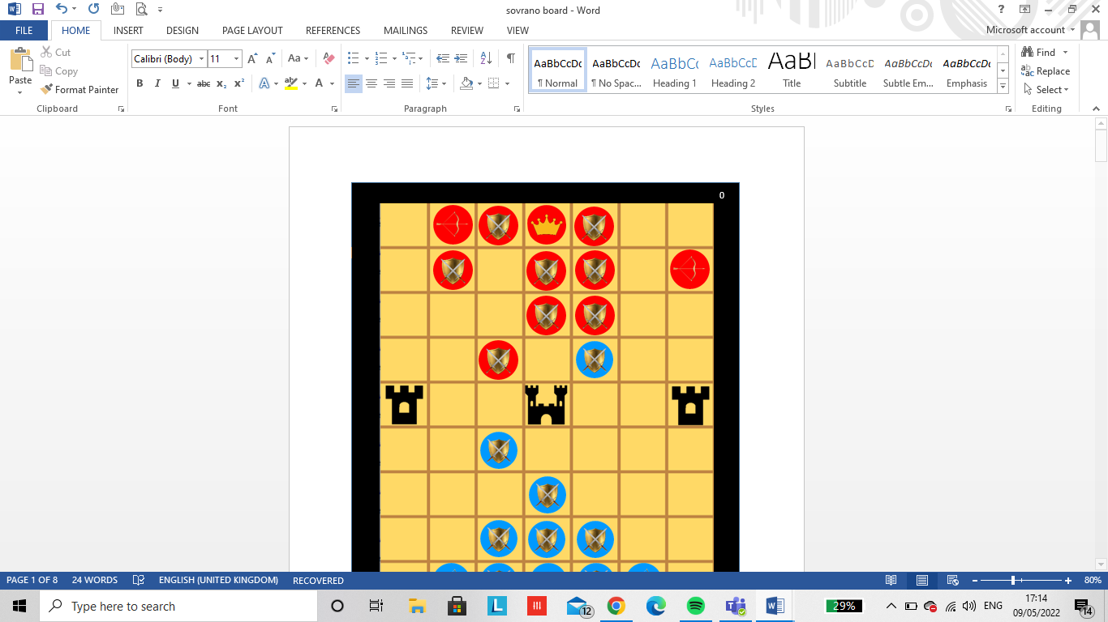

Here the score is 1 as the red player (the AI) has captured the blues guard which is worth one point.

Here the score is 0 after the 5th play as no player has been able to capture a piece yet.

* Users controls- If a player accidently moves the wrong piece, they are able to undo their move through pressing the ‘u’ button on the keyboard. The user is also able to reset the board whenever they want if they want to start over by pressing the ‘r’ button on the keyboard. This will allow the board state to back to its initial state.

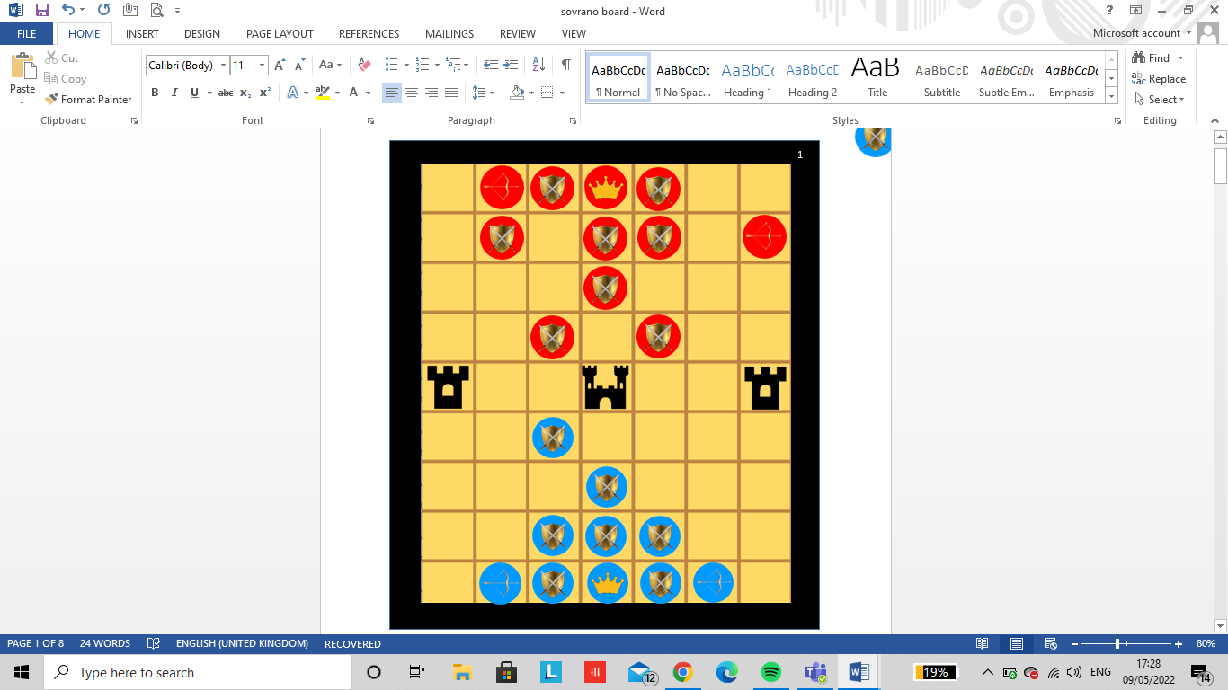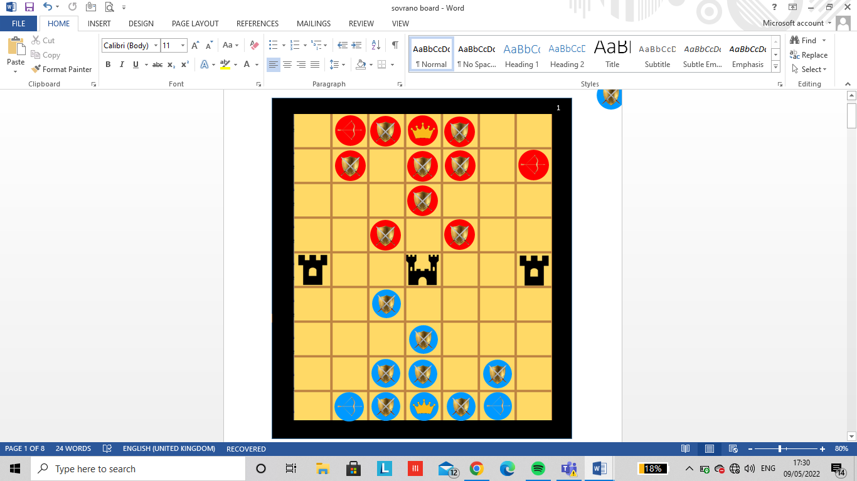

THE PREVIOUS MOVE

THE NEW MOVE

Blue has made the move to move the guard into the position shown on the left. However, they have chosen that they do not want to make that move so they click on the ‘u’ button on the keyboard to get it back to its original position shown on the right.

ORIGINAL BOARD

PREVIOUS BOARD



Blue decides to reset the board on the left as they want to start over. So as soon as the letter ‘r’ is inputted from the keyboard, the board will go back into its original state as shown by the image on the right.

* Aesthetics and minimalistic designs- Each piece contains a picture so the user is able to differentiate from each piece. Such as the archer having a bow and arrow, the guard having a shield and the emperor having a crown This clear design helps to limit the confusion the user may have when wanting to move a piece. The simplicity of the user interface and layout of the game helps to save memory as well as time from having to code more.

# Maintenance issues and limitations:

* If 2 or more users are accessing the game at the same time, the gay has a high chance of crashing as itll only calculate the score of the first player accessing the game. If I had a leaderboard the database will be record locked until the first user is finished and leaves the game. Only then will the leaderboard get updated. To reduce this for now, sovrano will only be able to be played with two users at a time. In my further development process, I’ll make sure that this game can be available for many users to play simultaneously perhaps by using concurrent processing.
* Pause button feature- if I had included a functioning timer it would be effective for the user to have the option to pause the current game state if they wanted to improve the overall game quality. Pause is a would use the selection computational method and will be implemented when the user presses ‘p’ on the keyboard.
* Adding all the captured pieces off the board but still being shown on the screen so the user is able to see all the pieces that they have collected.
* From my questionnaire I asked which aesthetic the stakeholders enjoy the most however, I wasn’t able to include this in the background due to perhaps making the screen look more complicated. However this aesthetic could’ve been added onto my main menu screen to give it its ancient/ historic aspect.
* My AI is functioning but doesn’t work at its best ability yet. The greedy algorithm only allows the AI to think one move ahead so is unable to make a fully informed decision on how to move a piece to win a game. To test the artificial intellegence of thinking 2 moves in advance, I wanted to implemement a minmax algorithm to find the players optimal play. The AI would consider the move they make and maximise the amount of points they can receive instead of just capturing the closest piece and having the opponent capture you straight after for more points.

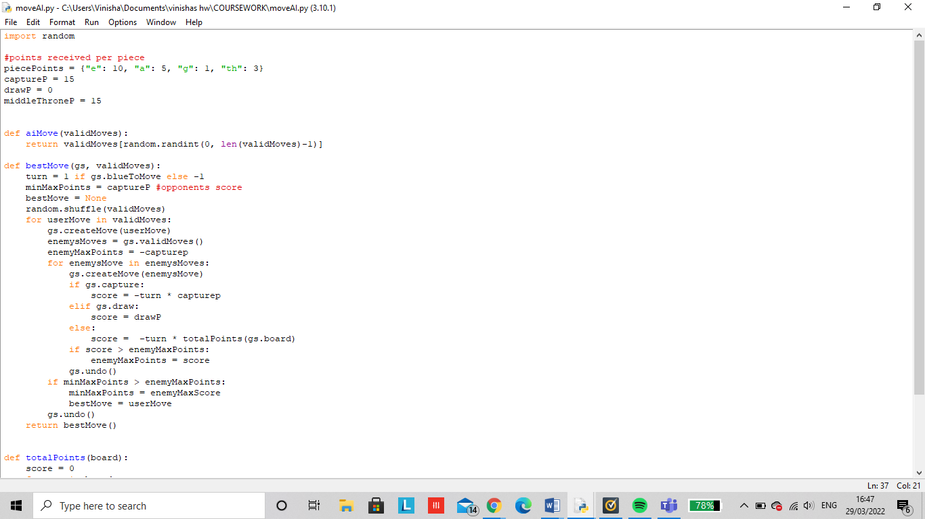

In order to test this algorithm I used the ‘random. shuffle’ method which takes a sequence, like a list, and reorganises the order of the items. This will generate random valid moves the computer can player. Although this may not be the most efficient method as it won’t always pick the best move, this will illustrate more interesting moves.

In the situation above for figure 8, this new code will ensure that the computer wont pick the white circled option as on the second play blue will gain the advantage and capture the red. So instead whilst using the minmax algorithm, the computer will chose not to capture any pieces but move into a more secure position.

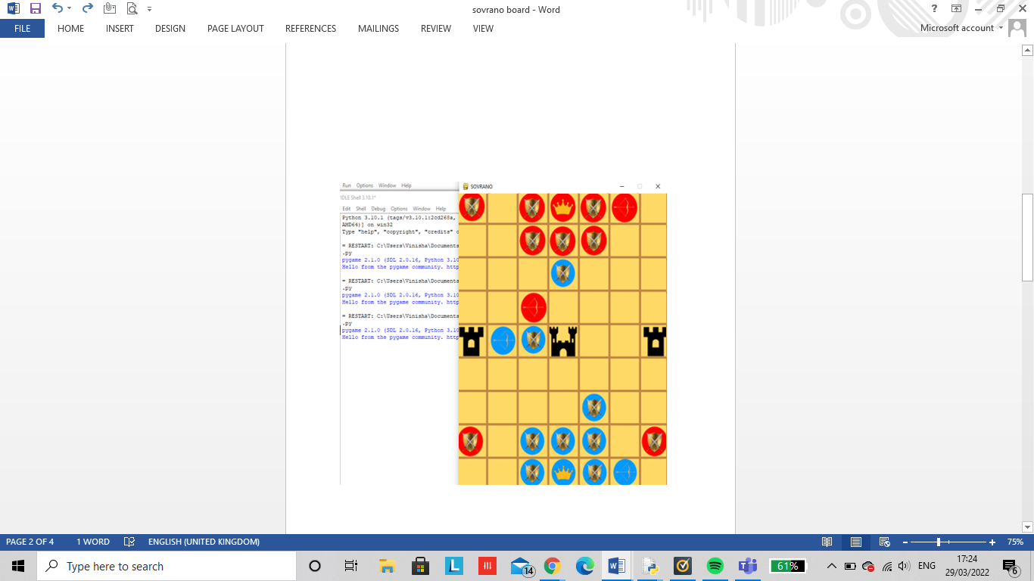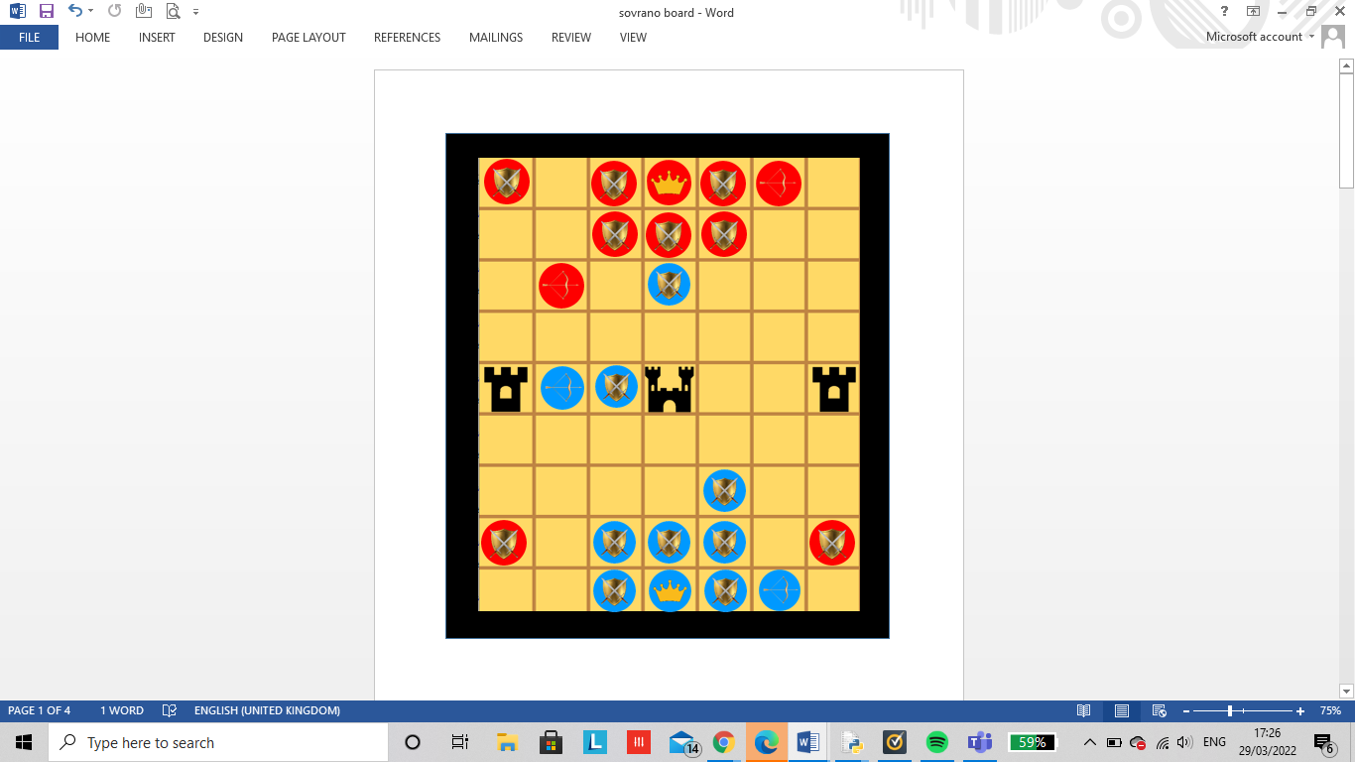

Using recursion instead of iteration to code my minmax AI:

The AI code above uses iteration however is not fully optimized so recursion would be a much better alternative. Recursion is where a function or sub-routine calls itself as part of the overall process. Some kind of limit is built in to the function so that recursion ends when a certain condition is met.

Disadvantages of using recursion:

* A misused recursive function won’t have an ending and would continuously run out of memory or result in a stack overflow therefore causing the computer to freeze.
* Can be difficult to debug as it can fail many levels deep in the recursion
* Makes heavy use of the stack, which is a very limited resource compared to normal memory.

Advantages of using recursion:

* Recursion adds clarity and (sometimes) reduces the time needed to write and debug code (but doesn't necessarily reduce space requirements or speed of execution).
* Reduces time complexity.
* Performs better in solving problems based on tree structures.

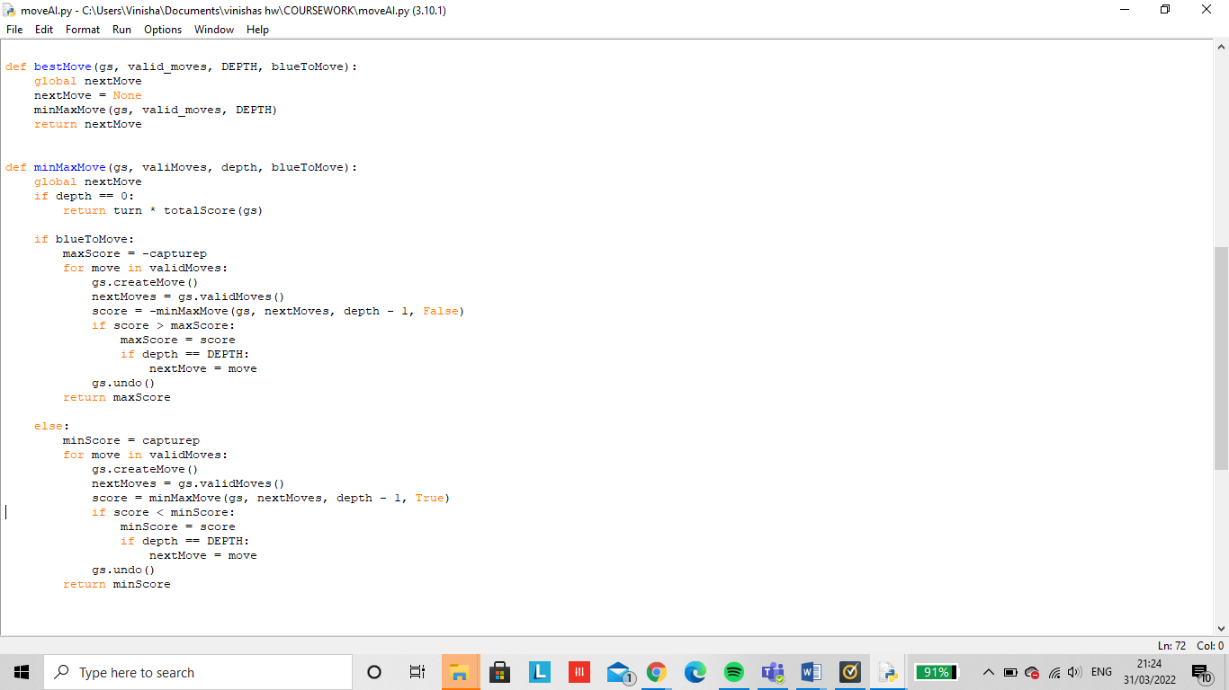

However after executing this code the output illustrated a blank screen.

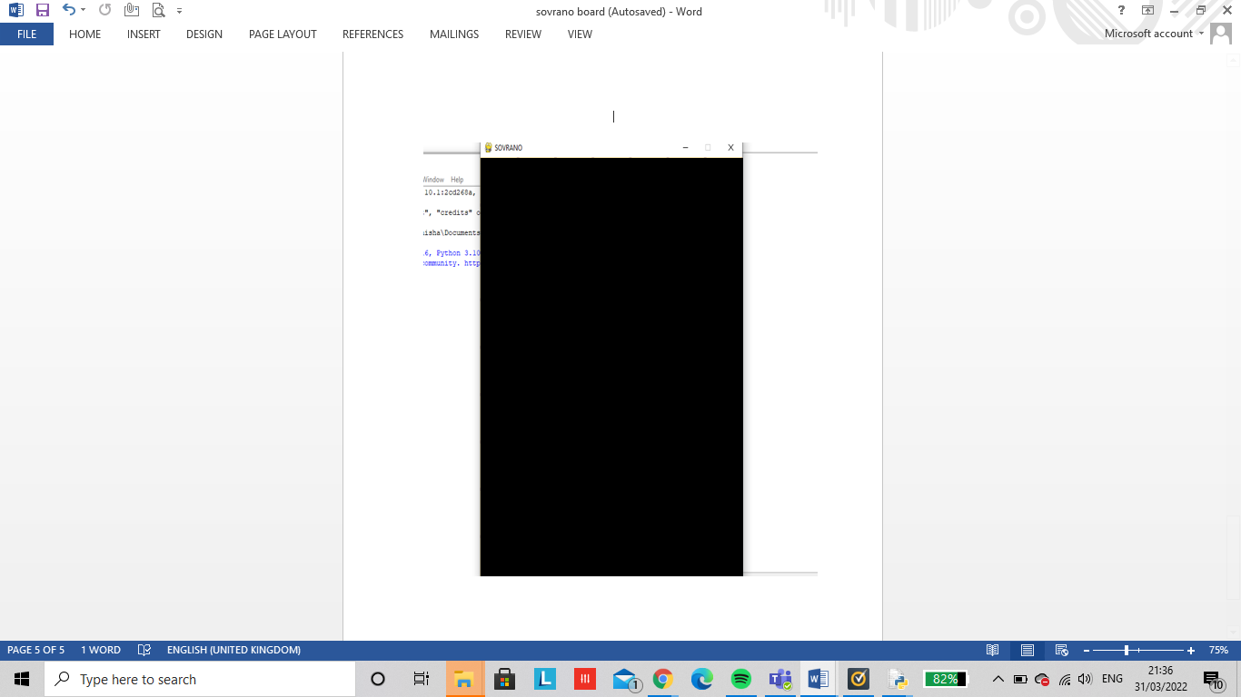

This could have possibly occurred due to the depth value I set it to.

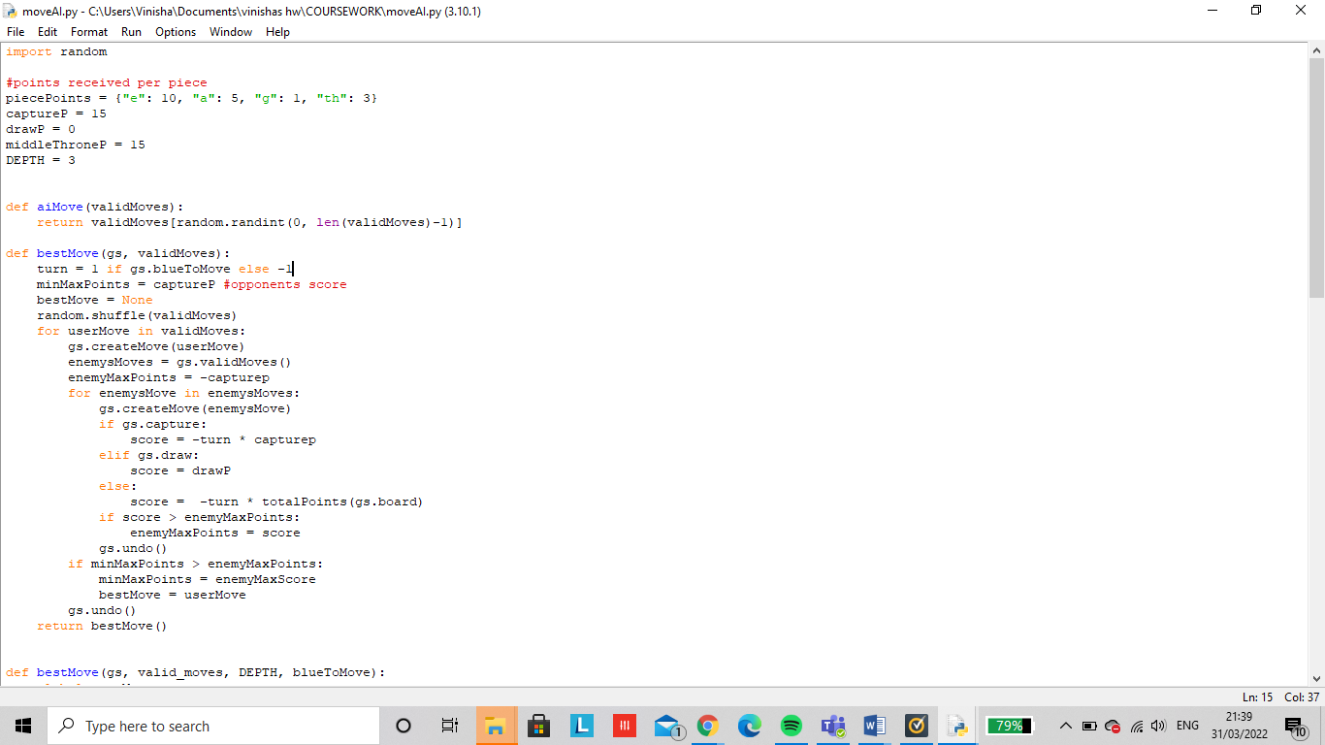

The variable ‘depth’ demonstrates how many steps ahead the artificial intelligence can think before making a move against a user. This crashed my computer and only seemed to work when the depth was at 1 or 2. To resolve this problem I would have to prune my tree to help improve the efficiency of my program. However, due to time complexity I was unable to complete this part of my project and debug my code for errors.

# Final overall code:

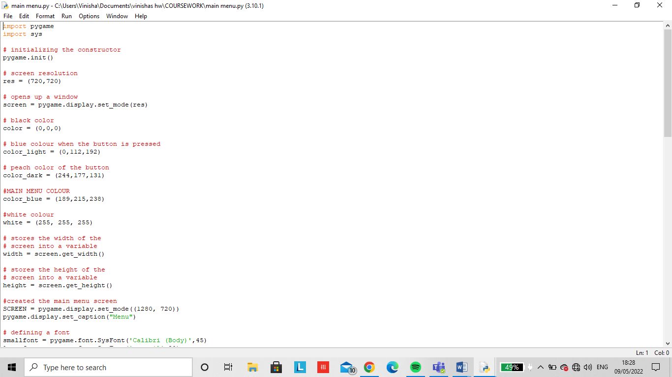

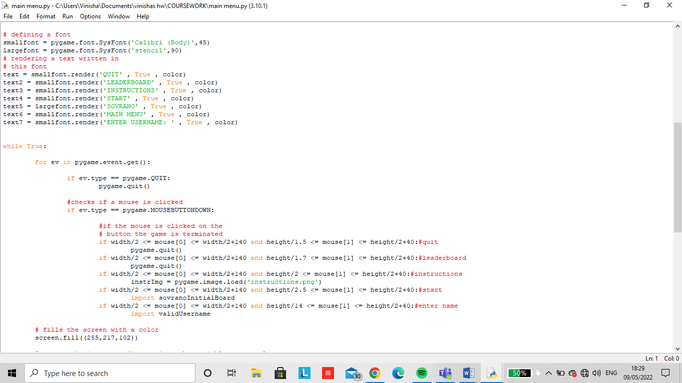

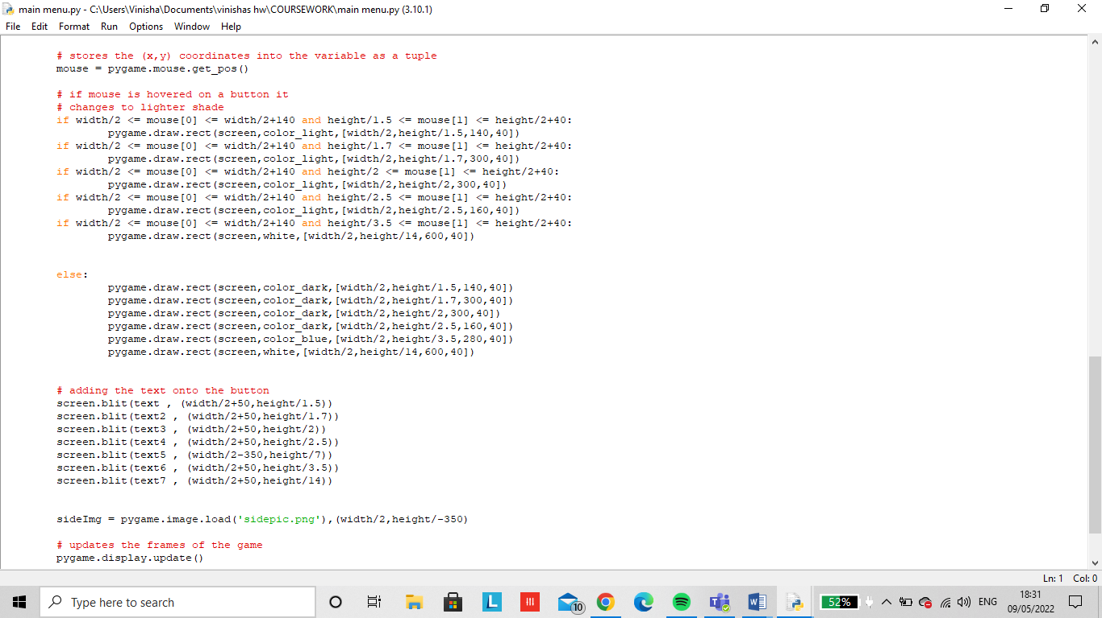

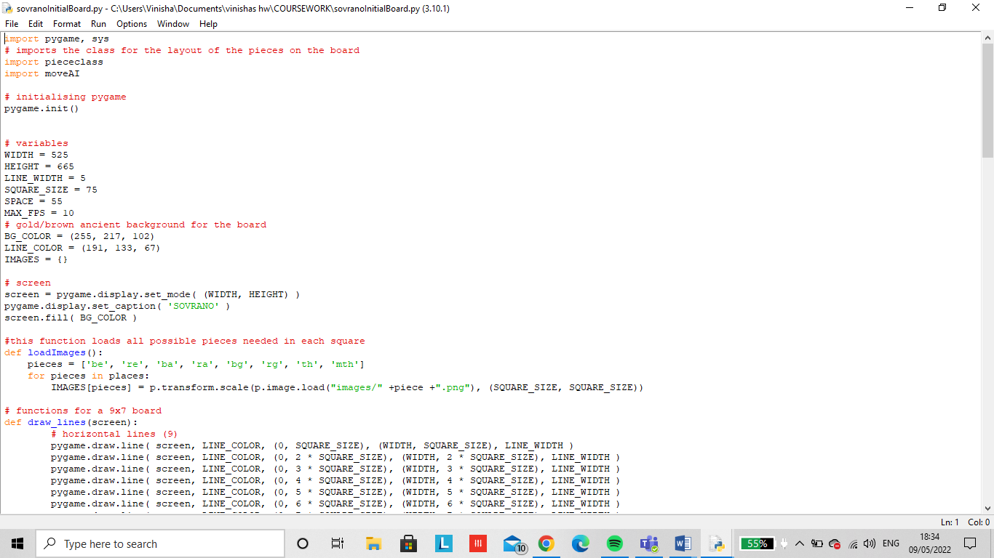

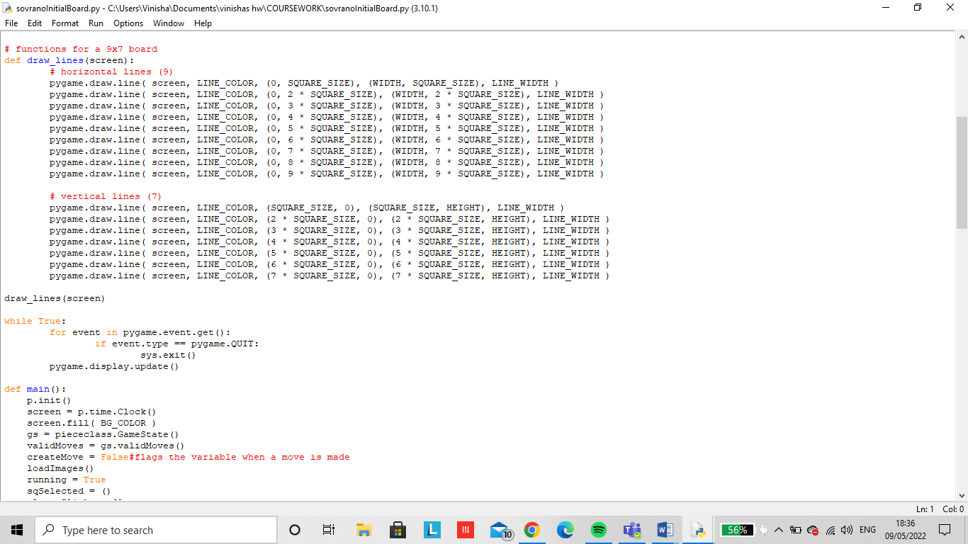

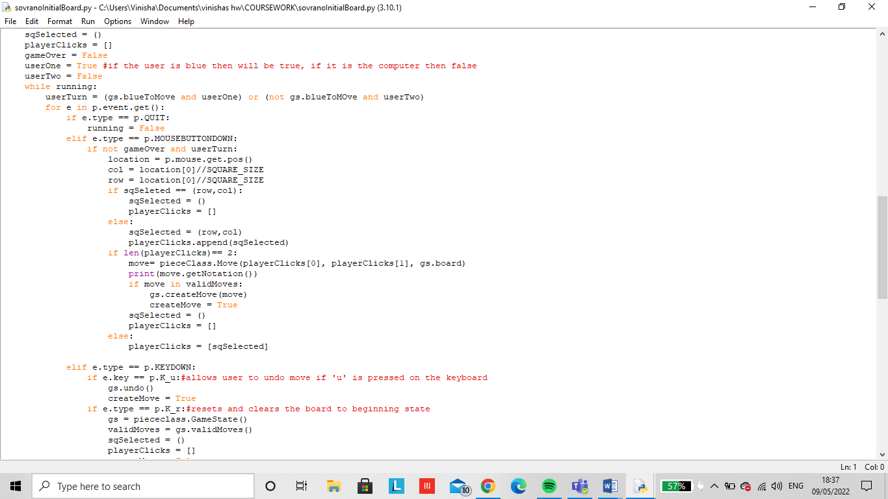

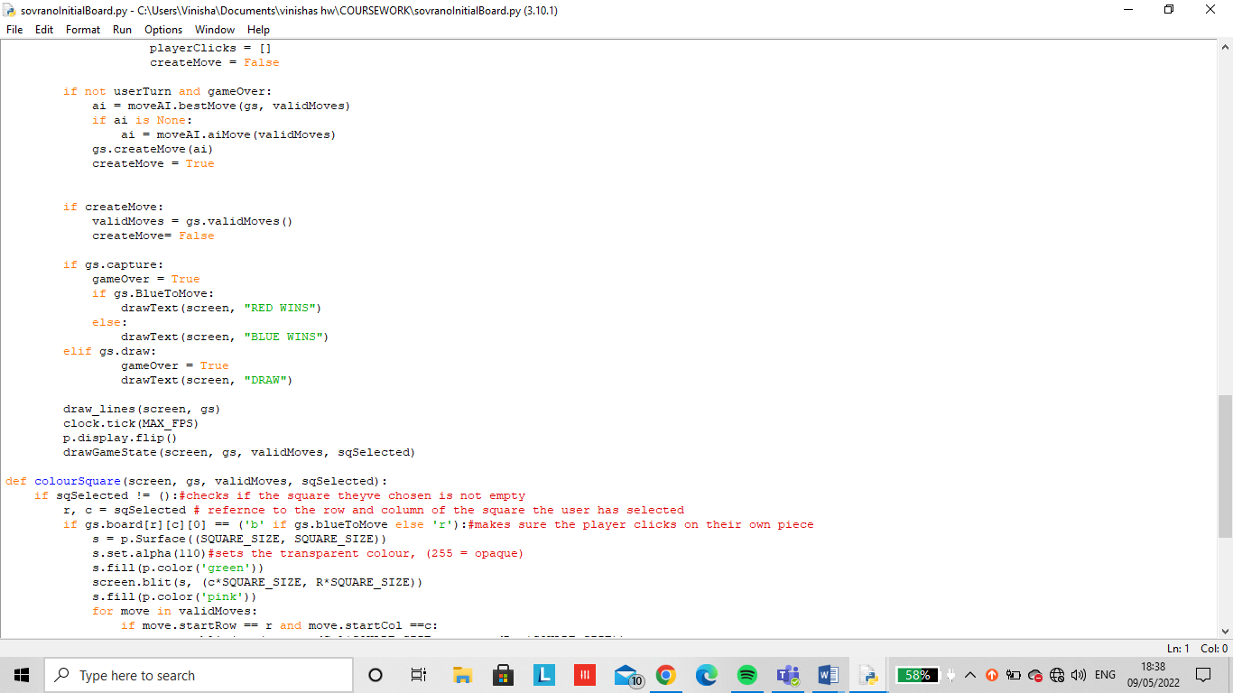

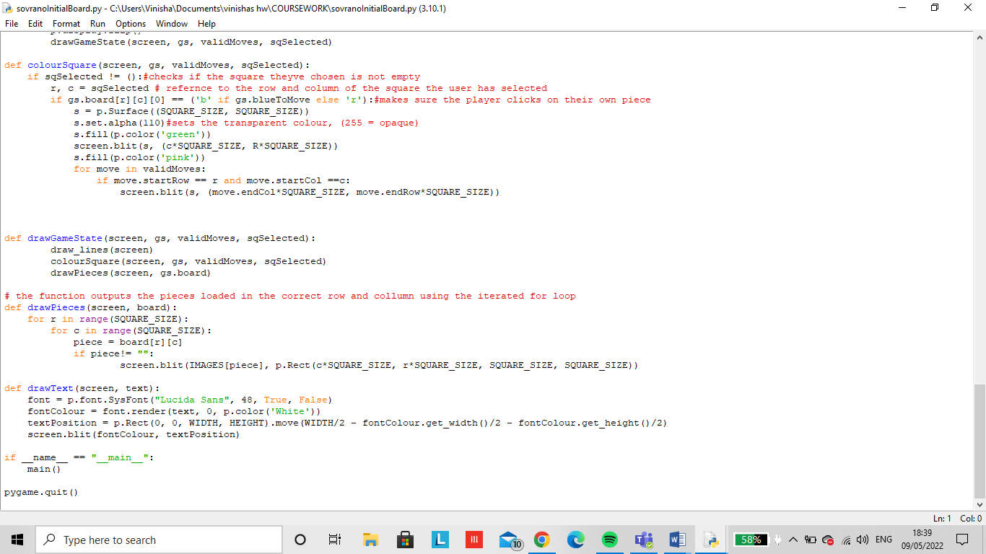

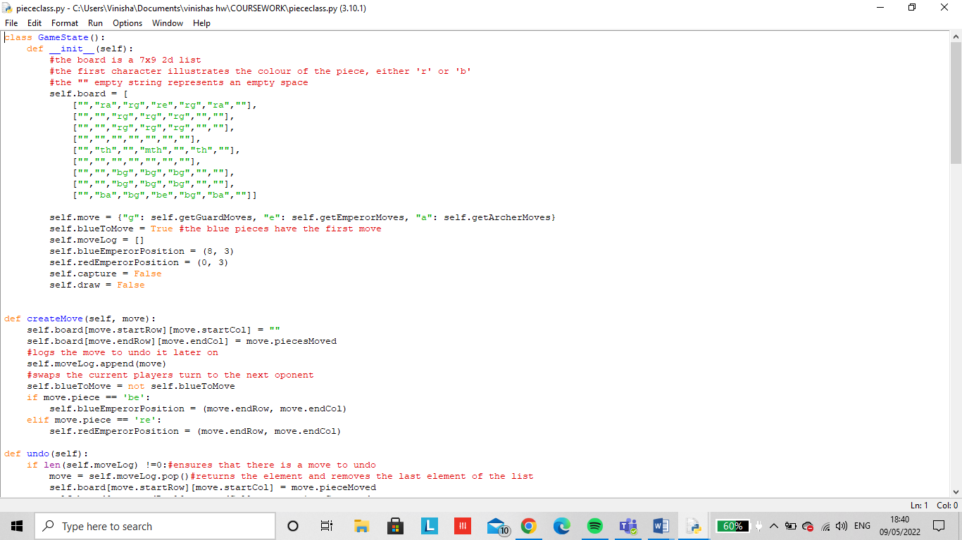

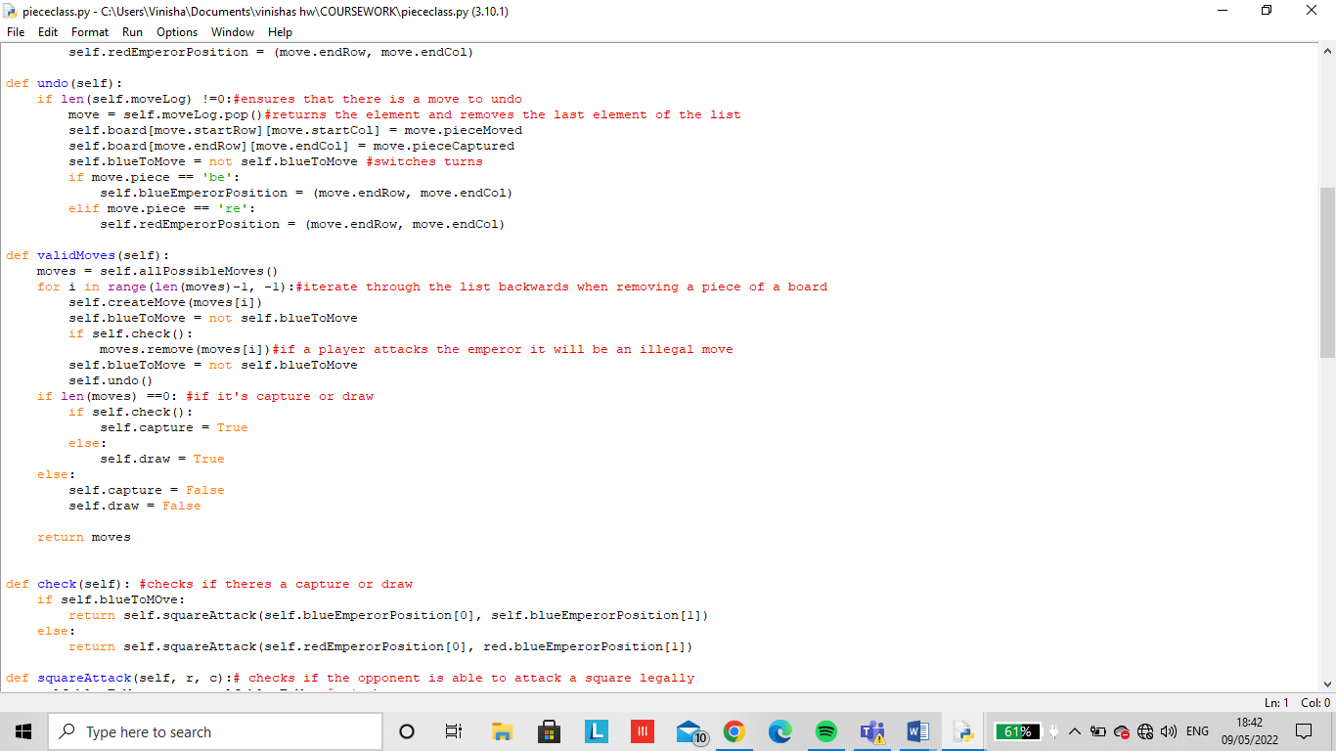

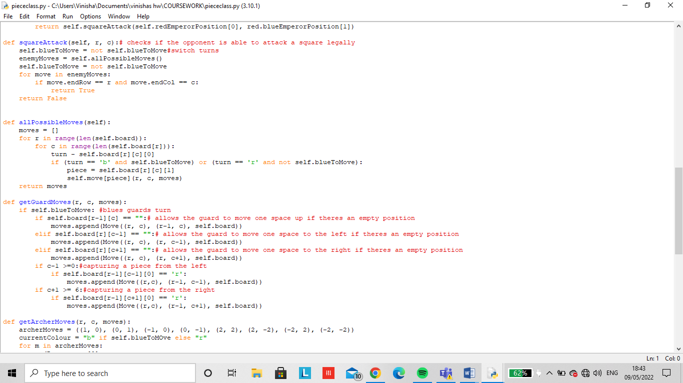

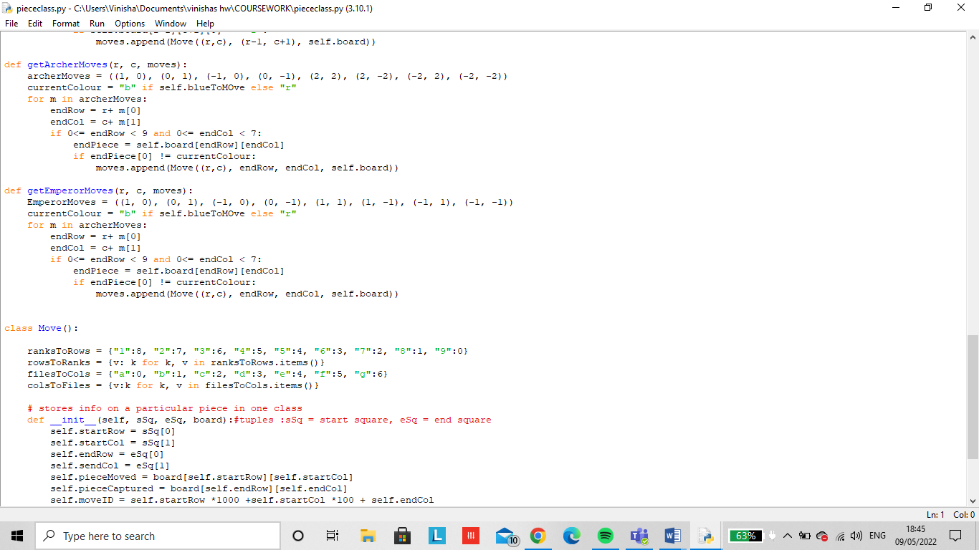

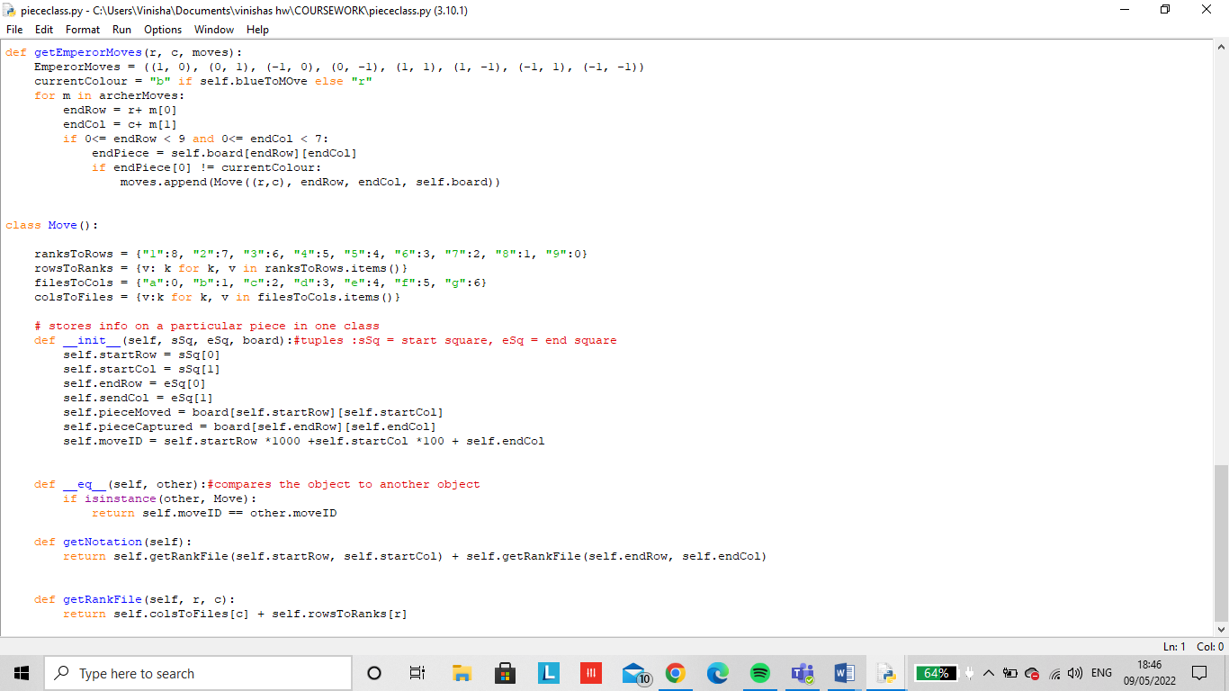

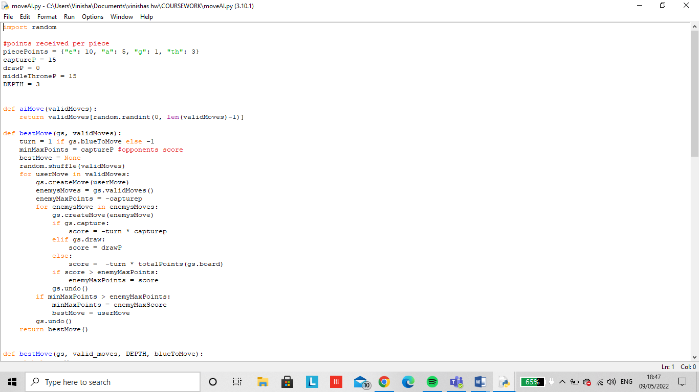

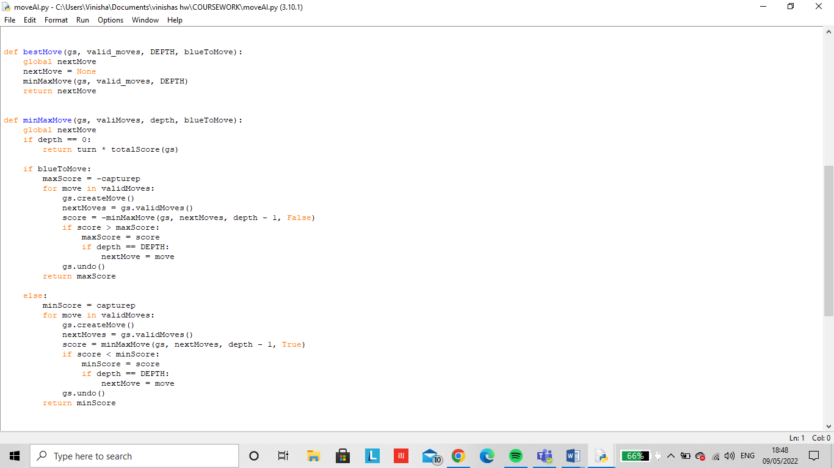

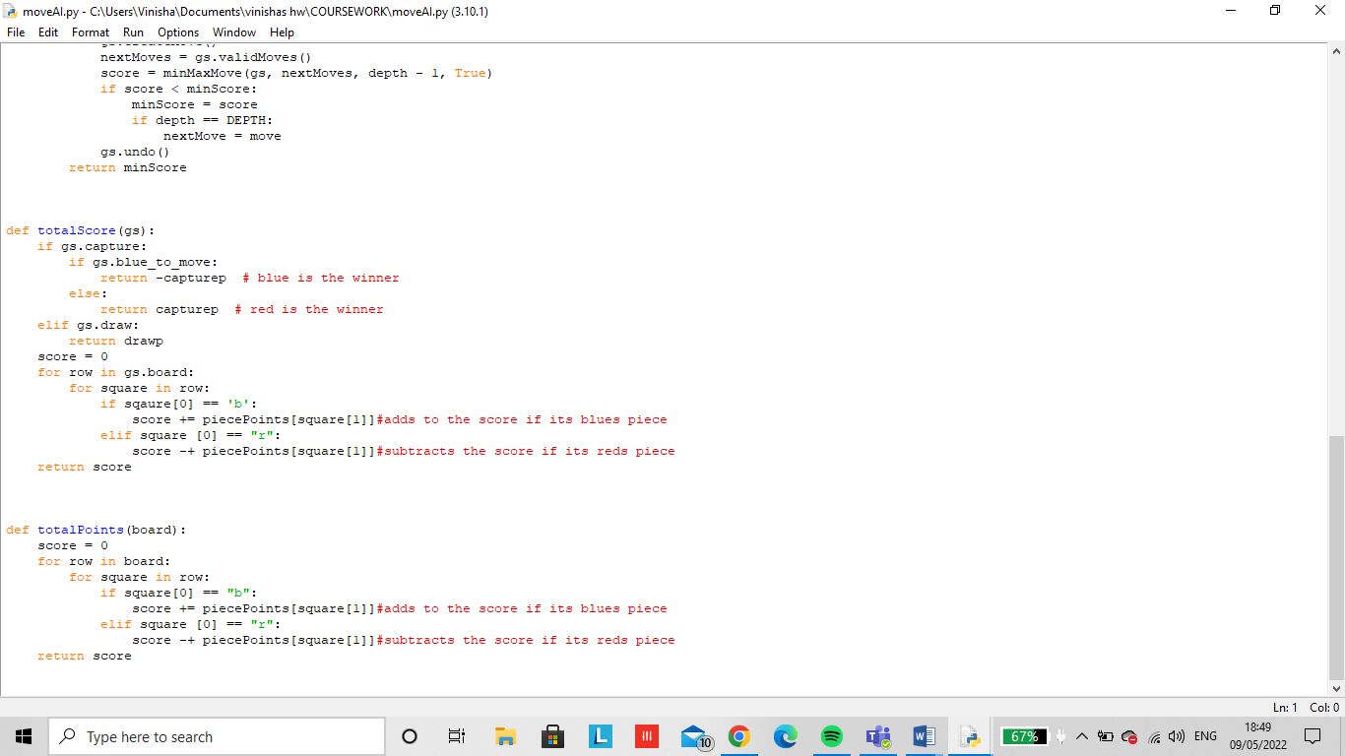

# References:

* *www.youtube.com. (n.d.). Sovrano Rules. [online] Available at: https://www.youtube.com/watch?v=Pjh2rBpfDVg [Accessed 21 Apr. 2021].*
* *Analog Games. (2016). A father-son project produced with 100% wooden components. [online] Available at: http://www.analoggames.com/story/a-father-son-project-produced-with-100-wooden-components/ [Accessed 21 Apr. 2021].*
* *Beyondsolitaire.net. (2021). [online] Available at: http://www.beyondsolitaire.net/uploads/4/9/4/6/49468733/7427979.png?310 [Accessed 21 Apr. 2021].*
* *‌2022. [online] Available at: <https://wallpaperaccess.com/ancient> [Accessed 9 January 2022].*
* *(No date) Researchgate.net. Available at: https://www.researchgate.net/figure/Abstract-task-decomposition-for-the-game-of-chess_fig2_221098890 (Accessed: March 22, 2022).*
* *PasiduPerera (2020) Making chess in python, Level Up Coding. Available at: https://levelup.gitconnected.com/chess-python-ca4532c7f5a4 (Accessed: March 22, 2022).*
* *pygame.time — pygame v2.1.1 documentation (no date) Pygame.org. Available at: https://www.pygame.org/docs/ref/time.html (Accessed: March 22, 2022).*
* *pygame — pygame v2.1.1 documentation (no date) Pygame.org. Available at: https://www.pygame.org/docs/ref/pygame.html (Accessed: March 22, 2022).*
* *pygame.font — pygame v2.1.1 documentation (no date) Pygame.org. Available at: http://www.pygame.org/docs/ref/font.html (Accessed: March 22, 2022).*
* *Python ranking dictionary return rank (no date) Stack Overflow. Available at: https://stackoverflow.com/questions/30282600/python-ranking-dictionary-return-rank (Accessed: March 24, 2022).*
* *Wikipedia contributors (2022) Minimax, Wikipedia, The Free Encyclopedia. Available at: https://en.wikipedia.org/w/index.php?title=Minimax&oldid=1076761456.*
* *Greedy algorithms (no date) GeeksforGeeks. Available at: https://www.geeksforgeeks.org/greedy-algorithms/ (Accessed: March 29, 2022).*
* *What are the advantages and disadvantages of recursion? (no date) Stack Overflow. Available at: https://stackoverflow.com/questions/5250733/what-are-the-advantages-and-disadvantages-of-recursion (Accessed: March 29, 2022).*
* freeCodeCamp.org (2019) *Pygame tutorial for beginners - Python game development course*. Youtube. Available at: https://www.youtube.com/watch?v=FfWpgLFMI7w (Accessed: April 3, 2022).
* *agile methodology - Google Search* (no date) *Google.co.uk*. Available at: https://www.google.co.uk/search?q=agile+methodology&sxsrf=APq-WBtx4X_L3mxw8uDVG5PU5NZBUi86dg:1649017341689&source=lnms&tbm=isch&sa=X&ved=2ahUKEwinxoSn3Pj2AhUIY8AKHWrXB8gQ_AUoAXoECAEQAw&biw=1517&bih=730&dpr=0.9 (Accessed: April 3, 2022).